EARTH AND SPACE SCIENCE  431 PRINCIPLES OF GLACIOLOGY  505 THE CRYOSPHERE | Autumn 2018  4 Credits, SLN 14855  4 Credits, SLN 14871
Homework 3 – Due Friday, October 19th

1) To experimentally validate the saturation vapor pressure of carbon dioxide, you have built four boxes, each of a difference size (with square tops of side length D). These boxes are sealed by a platform on top, which can be held down using different weights to change the pressure inside.

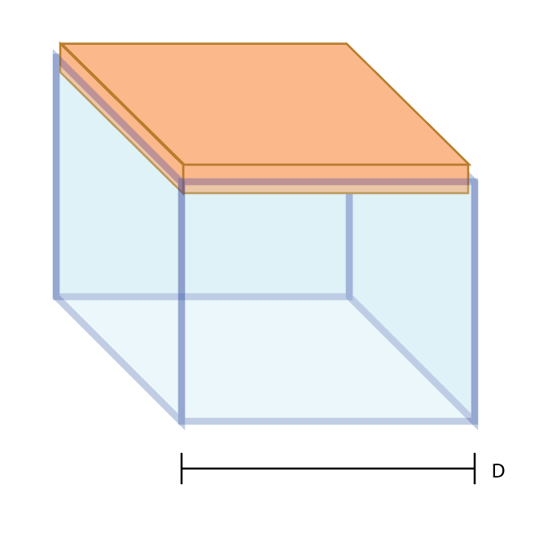 | Inside each box you place a block of dry ice, the solid phase of CO₂. Your textbook tells you that at room temperature, the equilibrium vapor pressure of CO₂ is 6 MPa. To test the accuracy of your textbook, you have balanced an animal of known mass on the top platform of each box and pumped out the gas around the dry ice. The ice starts to sublimate, and as more and more mass enters the gas phase, the pressure inside the box rises.

- (2.5 points) Given the following box sizes and animal weights, which animals will be able to sit comfortably as their box stays sealed, and which animals will be forced off their pedestal as the seal is overcome (show your work):

Box Size (D) | Animal and Mass (kg)
0.1 m | Mouse – 0.015 kg
0.1 m | Dog – 10 kg
0.1 m | Human – 70 kg
0.1 m | Elephant – 3000 kg
0.1 m | Blue Whale – 12000 kg

b) (2.5 points) Using the plot of equilibrium vapor pressure below, determine the temperatures at which the vapor pressure is in equilibrium with the weighted lid for the given box size.

c) (2.5 points) What sized box top is needed for each animal to perfectly balance the internal pressure with the animals’ weights at room temperature?
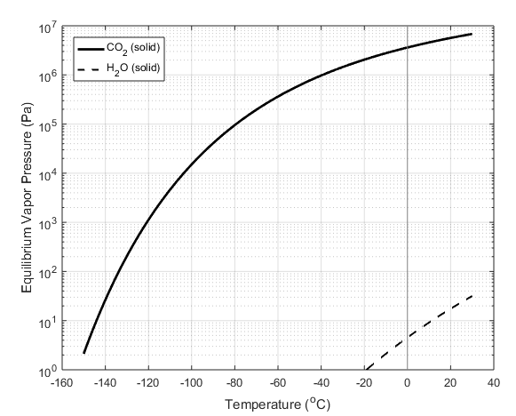

2) Imagine a hail stone of mass 0.001g falling through super cooled droplets of water. The hailstone starts with a temperature of -10 C. As it passes through the water droplets, they freeze in place on the hail stone, releasing heat and warming the ice.

- (2.5 points) What is the mass of rime that needs to be added to the hail stone to raise its temperature to the melting point? What percentage of the hail stone’s mass is this?

- (2 points) When the surface of hail reaches the melting point, riming on the surface fails to trap air pockets within the ice. With this in mind, describe the relative rates of riming for the hail stone pictured below. (Hint: while freezing ice to the surface adds heat, the hail stone is also conducting heat back out into the air. The balance of these two processes controls the hail surface temperature).

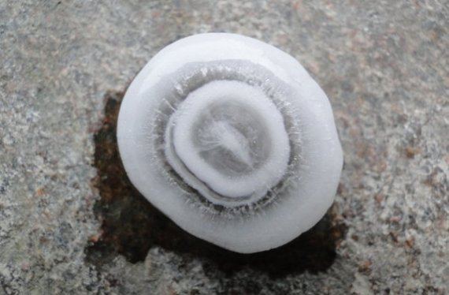

3) Colors of snow and ice.

The absorption coefficient for light traveling through ice depends on the frequency of the light. For reference:

Wavelength | Absorption Coefficient ($k_{abs}$ after passing through 1 m of ice, light will be reduced in intensity by $e^{k_{abs}}$)
470 nm | 0.005
600 nm | 0.12
700 nm | 0.52
1000 nm | 20.4
1800 nm | 824

Assume that all incident photons must pass through exactly 100 snow grains before they can re-emerge from the snowpack by solely successive refraction (i.e. ignore reflections at grain surfaces). Assume spherical grains, and assume distance traveled through each grain is equal to the diameter of the sphere. Calculate albedo for snowpacks of grain radius 50 µm and 1000 µm at wavelengths of 470 nm and 700 nm. If the incident sunlight is white, what will be the color of the light after it exits the snowpack?

  - (2 points) What is the total path length for grains with radius 50 µm and 1000 µm?

  - (2 points) Albedo is defined as the ratio of reflected light intensity to incident light intensity. For this problem, where no light is reflected at grain boundaries, only absorption diminishes light intensity, so albedo is defined as:
$$\frac{I_{R}}{I_{0}}=e^{-k_{abs}s}$$
where $s$ is the total travel path of the light. What is the albedo for both grain sizes for blue light and for red light?

  - (2 points) What is the color (red/blue ratio) of the light after existing the snowpack for both grain sizes?

  - (2 points) Based on the results from part c, use your intuition to determine what color of light is more attenuated with additional travel distance through ice. What color does light become as it travels through more ice?

