|  |  |
| --- | --- |
| **EARTH AND SPACE SCIENCE**  **431** *PRINCIPLES OF GLACIOLOGY*  **505** *THE CRYOSPHERE* | **Autumn 2018**  4 Credits, SLN 14855  4 Credits, SLN 14871 |
|  |  |
| **Homework Week 4 – Glacier Flow** | |

**Ice Flow Dynaimcs: Kinematic vs. Dynamic Calculations of Glacier Flow Speed**

Gwen and Harry are two glaciologists at a research station located 1 km from the head of a glacier. Satellite imagery provided to them shows that the glacier is 350 m wide everywhere. Together with historically collected ice-penetrating radar data, Gwen and Harry have deduced the 3D geometry of the system, and generated a longitudinal transect (Figure 1), as well as a cross section of the glacier immediately adjacent to the research station (Figure 2).

As they are leaving the station, Gwen and Harry were having an argument about which method can better predict glacier flow speeds – kinematic models or dynamic models. They decide to leave a pole in the center of the glacier over the winter and measure the flow speeds when they return the following year. Harry, who prefers kinematic models, bet Gwen $3000 that his measurements of surface accumulation could produce a better prediction than Gwen’s measurements of surface slope. They each went out and took a few measurements, and left for the winter.

|  |  |
| --- | --- |
|  | Fig. 1 – Longitudinal cross section of the glacier, generated using ice penetrating radar. |
|  | Fig.2 – Cross section perpendicular to flow, adjacent to the research station |

Harry’s Measurements:

Using a sounding probe, Harry measured the depth to last year’s summer snow surface along the center line of the glacier upstream of the station. Together with measurements of snow density, he was able to compute the total accumulation (in meters of ice equivalent) along the glacier.

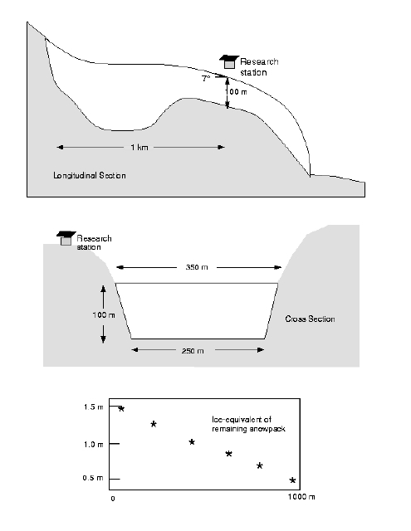

Gwen’s Measurements:

Using a tilt meter, Gwen steps out to the centerline nearest the research station and measures the surface slope. She finds it is 7o.

***Problem 1 (4 points)*** – How does Harry use the information he collected to estimate ice flow speed (describe both in words, and through any relevant equations)? What will his estimate of surface velocity at the stake be?

***Problem 2 (4 points) –*** Gwen assumes that, in the Cascades, about half of the motion at the surface is due to sliding at the bed. How does Gwen use her measurements and assumptions about basal sliding to estimate ice flow speed (describe both in words, and through any relevant equations)? What will her estimate of surface velocity at the stake be?

***Problem 3 (2 points) –*** Why might Gwen and Harry's answers be different? What are the strengths and weaknesses of the 2 methods?

**Hard-Bedded Glacier Sliding: Controlling Obstacle Size**

In class, we discussed why regelation is a more effective sliding mechanism for small obstacles and why enhanced creep is a more effective sliding mechanism for large obstacles.

As a reminder of the setup of this problem, a cartoon schematic of the bed obstacle is shown below.

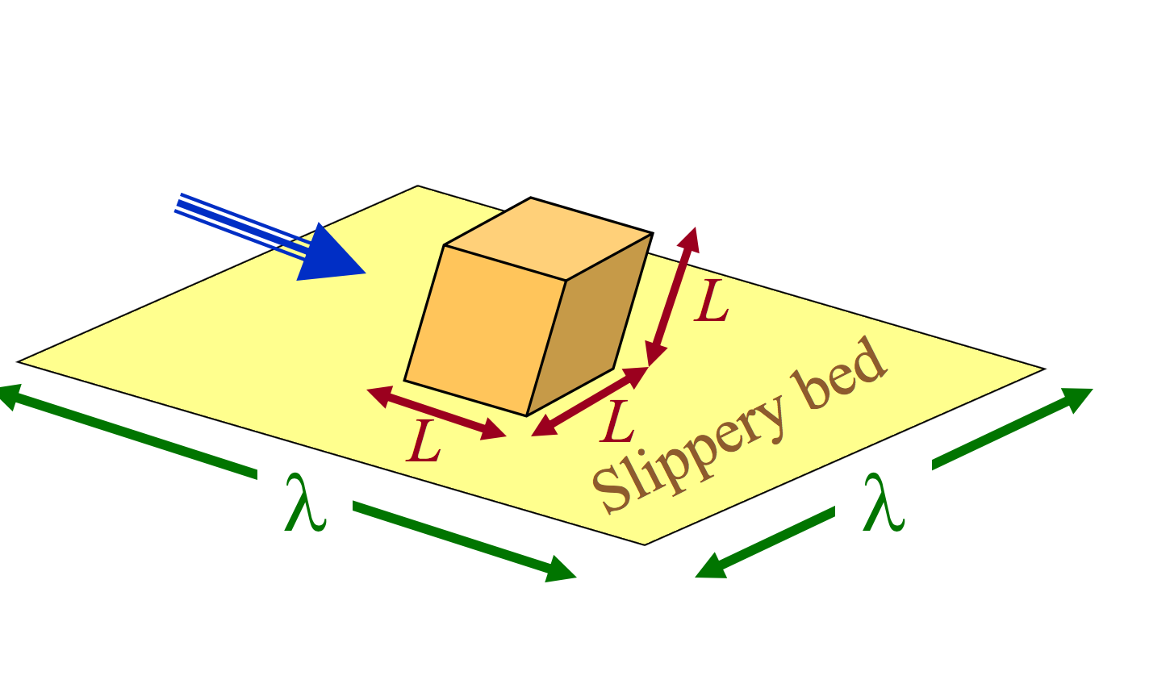

We derived the relationships for regelation basal sliding speed, which is:

|  |  |
| --- | --- |
| Regelation Sliding Speed: $u_{R}=\frac{kcτ}{ρHL}\frac{λ^{2}}{L^{2}}=\frac{kc}{ρHL}\frac{τ}{R^{2}}$ | k = Thermal conductivity (2.1 W m-1 deg-1)  c = Freezing point depression (Clausius-Clayepron) (7deg Pa-1)  H = Latent heat of fusion (3.34 kJ/kg) $ρ$ = density (917 kg/m-3)  =characteristic cube dimension (m) $λ$ = characteristic cube spacing (m) $τ$ = basal shear stress (Pa) $R=L/λ$ =bed roughness (dimensionless) |

Where we have introduced the ratio of bump size to bump spacing $R$, the bed roughness, as a separate variable as these two items often scale together.

In class, we also determined that each bump’s upflow face supports stress $\frac{τλ^{2}}{L^{2}}$. If we assume the stress anomaly is symmetric upflow and downflow of the bump (for a cube it would be), we have a compressive longitudinal stress anomaly on the upflow side of the bump that is $\frac{τλ^{2}}{{2L}^{2}}=\frac{1}{2}\frac{τ}{R^{2}}$. If we plug this stress anomaly into the relation for enhanced creep from class we have:

|  |  |
| --- | --- |
| Enhanced Creep Sliding Speed: $u_{c}=2{\left[3\right]}^{-\left[n+1\right]/2}LA{\left[\frac{τ}{2R^{2}}\right]}^{n}$ | n = Glen’s flow law exponent (generally 3)  L = characteristic cube dimension (m)  A = rheological constant for ice deformation ( s-1 Pa-3 at )  = basal shear stress (Pa) $R=L/λ$ =bed roughness (dimensionless) |

where the numerical factor prefactor is introduced because the stress is unixial.

***Problem 1 (4 points)*** – Determine a formula for the controlling obstacle size. That is, what size obstacle $L$ is equally inefficient for both sliding mechanisms outlined above? It is most useful to do this symbolically, i.e., do not plug in values for constants yet.

***Problem 2 (4 points) –*** Assume the controlling obstacle determine the glacier’s basal sliding speed. Under that assumption, derive a formula for the glacier’s basal sliding speed. Again, do this symbolically rather than plugging in values for any constants. (Hint: this should depend only on the basal shear stress, the bed roughness, and a bunch of constants, which can be lumped together into one constant).

***Problem 3 (4 points) –*** Using the values for constants given above, determine the basal sliding speed for a typical mountain glacier in the Cascades (bed roughness of 0.2 and basal shear stress of 100 kPa) and under a fast-flowing West Antarctic ice stream (bed roughness of 0.1 and basal shear stress of 10 kPa) using the hard-bedded sliding theory outlined above. Do these values surprise you?

Other measurements indicate that nearly all the motion of the West Antarctic ice streams is accommodated via basal sliding. What assumptions of hard-bedded sliding are likely violated in ice-stream systems? Why?

**Ice Temperature: Thermal Signature of Ice-Stream Shear Margins**

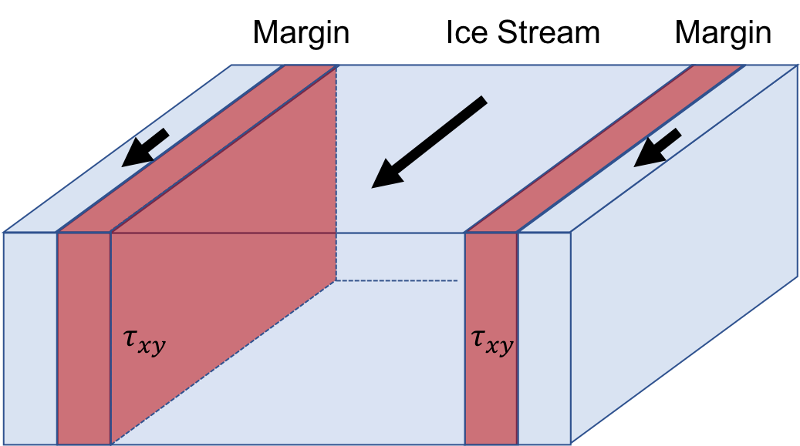

Most of the ice from the interior of ice sheets, like Greenland and Antarctica, drains to the ocean through fast-flowing “rivers” of ice, called ice streams. An ice stream shear margin represents the boundary between slow flow on the ridge outside the ice stream and fast flow inside the ice stream itself. The speed variation across this boundary strains the ice, and heat is created as a result of this strain, which warms the ice. This problem asks you to assess the magnitude of heat production in shear margins (which feeds back on ice dynamics through its effect on ice rheology).

1. (2 points) If ice is flowing at 1 km/yr inside the ice stream, 50 m/yr outside the ice stream, and the shear margin is 1 km wide, what is the shear strain rate, ${\dot{ϵ}}_{xy}$?
2. (2 points) If we assume Glen’s law,

$${\dot{ϵ}}_{xy}=Aτ_{xy}^{n}$$

with a viscosity $A=3.5*{10}^{-25}Pa^{-3}s^{-1}$ and $n=3$, what is the associated shear stress?

As we discussed in class, work is done on the ice as it deforms. The applied stress exerts a force per unit area over some distance defined by the strain rate. The rate of energy production for strain heating is

$$ϕ={\dot{ϵ}}_{xy}τ_{xy}$$

1. (3 points) Calculate the energy produced in the shear margin for (a) over 100 years.

The accumulation of energy calculated in (c) will persist in the ice sheet in the form of heat. What we want to know now is how long it will take for this thermal energy to ‘diffuse’ or spread away from its source. In order to address this, we will use the one-dimensional heat equation (considering diffusion only):

$$\frac{∂T}{∂t}=α\frac{∂^{2}T}{∂x^{2}}$$

The solution for the heat equation in this situation is analytic and problem takes the form:

$$T\left(x,t\right)=\frac{Q}{\sqrt{4παt}}e^{-\frac{x^{2}}{4αt}}$$

with Q being the source you calculated in (c) in units of K m (i.e. $Q=\frac{ϕ}{ρC_{p}}dt$).

1. (3 points) Show that the above is a solution to the differential equation.
2. (2 points) Using the diffusivity of ice, $α=34.4\frac{m^{2}}{yr}$, how spread out is the heat after 1000 years? Give a qualitative result by comparing the temperature at the source location, $x=0$, to that 0.1, 1, and 10 km away.