EARTH AND SPACE SCIENCE  431 PRINCIPLES OF GLACIOLOGY  505 THE CRYOSPHERE | Autumn 2018  4 Credits, SLN 14855  4 Credits, SLN 14871
Homework 5 – Glacier Variations
- Net Change of Glacier Length: A Simple Kinematic Approach
Consider a glacier with an x-axis that points along-flow and down-glacier. In its original steady state, the glacier spans from $x=0$ to $x=L_{0}$. We assume that the terminus is wedge shaped and that the glacier width is uniform (see Figure 1 for sketch of glacier terminus). Because the glacier is in steady state with its specific balance profile $\dot{b_{0}(x)}$, initially no ice passes through $x=L_{0}$. We will now consider what happens if the specific mass balance changes by amount $\dot{b_{1}(x)}$, so that the new specific balance is $\dot{b_{0}(x)}+\dot{b_{1}(x)}$. To reach a new equilibrium length, the ice flux per unit width at $x=L_{0}$ must be equal to to the net change in upstream ice flux, or attains $\int_{0}^{L_{0}}{\dot{b_{1}(x)}dx=〈\dot{b_{1}}〉L_{0}}$, where $〈\dot{b_{1}}〉$ is the spatial average of $\dot{b_{1}(x)}$. The terminus must advance by an amount $L_{1}$ to allow the additional ice to be removed by ablation. We will examine how much a glacier will advance in this scenario.
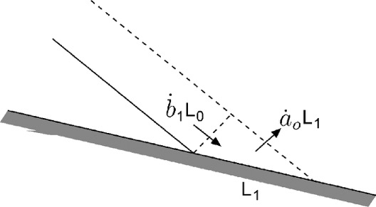
Figure 1: Schematic of the relation between increased ice flux and advance of the glacier terminus (from Cuffey and Paterson, 2010).

Problem 1 (4 points) – Derive a formula for $L_{1}$ based on mass (ice flux) conservation in terms of the initial length $L_{0}$, $〈\dot{b_{1}}〉$ average change in specific mass balance, and $\dot{a_{0}}$ ablation rate near the ice terminus. (Figure 1 should provide good physical intuition for the conservation rule to apply).
Problem 2 (2 points) – If $\dot{a_{0}}=5$ m yr⁻¹ and the specific mass balance increases by an amount $〈\dot{b_{1}}〉=0.5$ m yr⁻¹, how far will the glacier advance? Give you answer in terms of the initial length $L_{0}$.
Problem 3 (4 points) – You can account for glacier width variability by multiplying the relationship you derived in equation 1 by $\frac{\overline{Y}}{Y_{t}}$, where $\overline{Y}$ is the average width of the glacier and $Y_{t}$ is the width of the glacier at the terminus. For a given change in specific mass balance, terminus ablation rate, and initial glacier length, will a glacier with a narrow tongue undergo larger or smaller terminus position fluctuations relative to one with a wide tongue? Explain why this makes sense using a kinematic approach to conserving ice flux. Can you estimate how long it takes the glacier to reach its new terminus position?

- Equilibrium Response Time: A Kinematic Flux Conservation Approach
Consider the same glacier as in Figure 1. If we consider the entire length of such a glacier, rather than focusing on the terminus, we have the schmatic shown in Figure 2. We also now consider a time-varying perturbation to the specific mass balance. The new mass balance is thus: $\dot{b(x,t)}=\dot{b_{0}(x)}+\dot{b_{1}(x,t)}$, where $t$ is an arbitrary variable for time. The volume change of the glacier will now depend on the the value of the specific mass balance perturbation in both time and space (here we still neglect width variability in specific mass balance for simplicity). Thus, the change in volume $V$ as a function of time is:
$$\frac{dV}{dt}=\int_{0}^{L_{0}}{Y(x,t)}\dot{b_{1}(x,t)}dx+\int_{L_{0}}^{L}{Y(x,t)}\dot{b(x,t)}dx$$
where $x$ is distance along-flow, $Y(x,t)$ is the spatiotemporally variable width of the glacier, and $\dot{b}$ is the specific mass balance (as defined above). The total volume of the glacier is given by the $width×thickness$, or:
$$V\left(t\right)=\int_{0}^{L}{Y\left(x,t\right)H\left(x,t\right)dx}$$
where $H(x,t)$ is the mean value of thickness over the a cross-section at postion $x$ and at arbitrary time $t$. If we consider a glacier on a long sloping surface, except for near the termini, the glacier can be approximated as a parallel-sided slab of thickness $H_{0}$, which we will treat as constant in time for this problem. This situation is pictured schematically in Figure 2a.
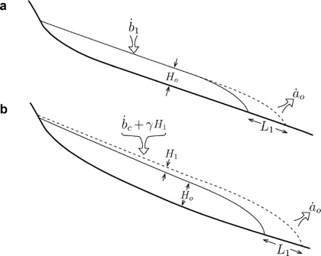
Figure 2: Schematic model for advance of a glacier following an increase in mass balance (a) if thickness changes are negligible and (b) allowing for thickness changes (from Cuffey and Paterson, 2010).

In the initial steady state, $\frac{dV}{dt}=0$. If the mass balance increases from $\dot{b_{0}(x)}$ to $\dot{b_{0}(x)}+\dot{b_{1}}$, then the length will vary from $L_{0}$ to $L_{0}+L_{1}(t)$. In this situation we can rewrite, $\frac{dV}{dt}$ from above as:
$$\frac{dV}{dt}=\overline{Y}L_{0}\dot{b_{1}}-Y_{t}\dot{a_{0}}L_{1}(t)$$
As the glacier advances, its volume increases by $Y_{t}H_{0}L_{1}(t)$. Taking the time derivative of this yields:
$$\frac{dV}{dt}={Y_{t}H}_{0}\frac{{dL}_{1}\left(t\right)}{dt}$$

Problem 1 (2 points) – Equate these two expression for volume change to derive a differential equation for the “one-stage” model of glacier. Show that the resulting differential equation should be:
$$\frac{{dL}_{1}\left(t\right)}{dt}+\frac{L_{1}\left(t\right)}{t_{r}}=\dot{b_{1}}\frac{\overline{Y}}{Y_{t}}\frac{L_{0}}{H_{0}}$$
Problem 2 (2 points) – What is $t_{r}$ in this expression? Describe this quantity using both a mathematical expression and a conceptual description.
Problem 3 (2 points) – The solution for this equation for a step change in mass balance is:
$$L_{1}\left(t\right)=L_{0}\frac{\dot{b_{1}}}{\dot{a_{0}}}\frac{\overline{Y}}{Y_{t}}\left[1-\exp\left(-t/t_{r}\right)\right]$$
After time $t_{r}$ passes following a step change in mass balance, how far has the glacier advanced? That is, what percentage of the glacier’s advance in response to the mass balance perturbation is finished at time $t_{r}$?
Problem 4 (2 points) – What are typical values of $t_{r}$ for a mountain glacier (100 m thickness, 10 m yr⁻¹ ablation rate at the terminus) and for an ice sheet (1500 m thickness, 1 m yr⁻¹ ablation rate at the terminus)?

