EARTH AND SPACE SCIENCE  431 PRINCIPLES OF GLACIOLOGY  505 THE CRYOSPHERE | Autumn 2018  4 Credits, SLN 14855  4 Credits, SLN 14871
Lab Week 4 – Glacier Flow

Find 1 or 2 partners, and work together to answer 1 of the following 2 questions. You and your partners will be asked to report your results to the class before the end of lab.

(1) Dynamic ice-flow estimation
A temperate glacier is 100 meters thick, with a slope of 6.3º (0.11 radian). The glacier is not sliding. Your coordinate system has x along the flow direction, and z is vertical, with values increasing up from the bed. The corresponding velocity components are u and w.
- Estimate the bed-parallel shear stress σ_{xz}(z) at the bed (z=0), at 20 m, 40 m, 60 m, 80 m above the bed, and at the surface (z=100 m). Plot your results on the provided axes.
- Using Glen’s flow law for ice at 0ºC, estimate the shear strain rate (∂u/∂z) at the same 6 depths. Plot your results on the provided axes.
- Estimate how fast the ice might be moving at each depth by populating the table on the following page. (Note that we are not asking you to use the analytic solution for ice velocity provided in class. You are approximating a solution to $\int_{0}^{H}{\frac{∂u}{∂z}∂z}$ by computing $\frac{∂u}{∂z}$ at a variety of depths, and summing the computed values). Plot your results.
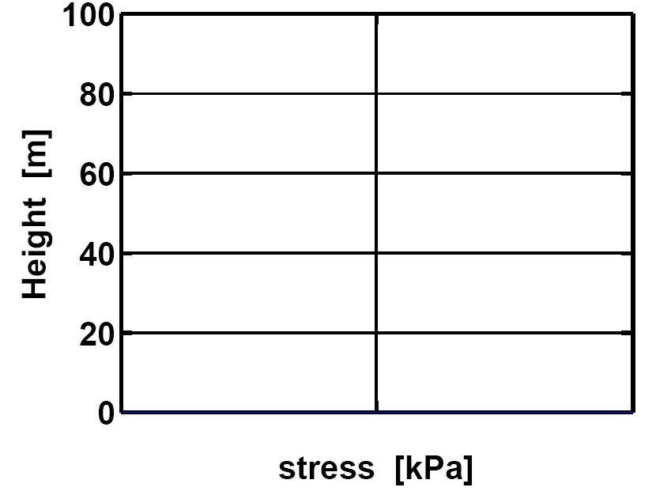 | 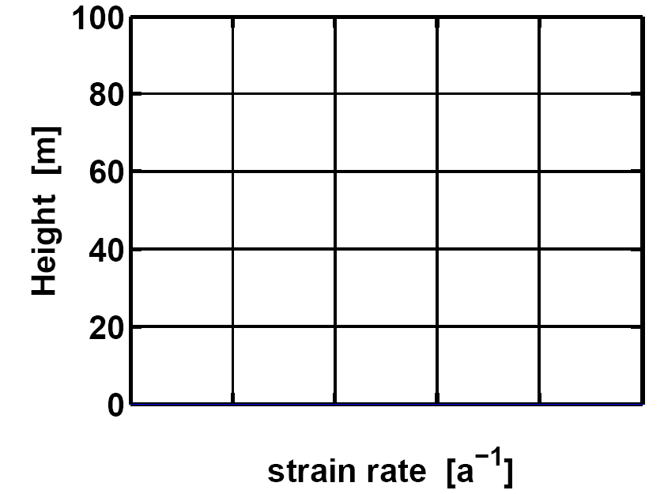
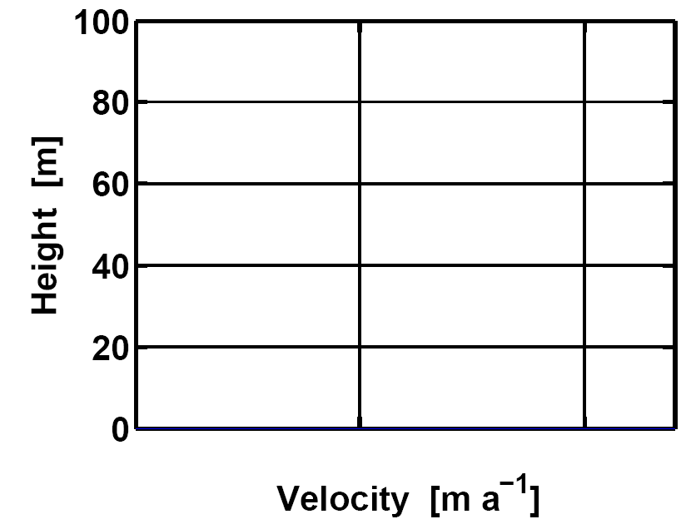

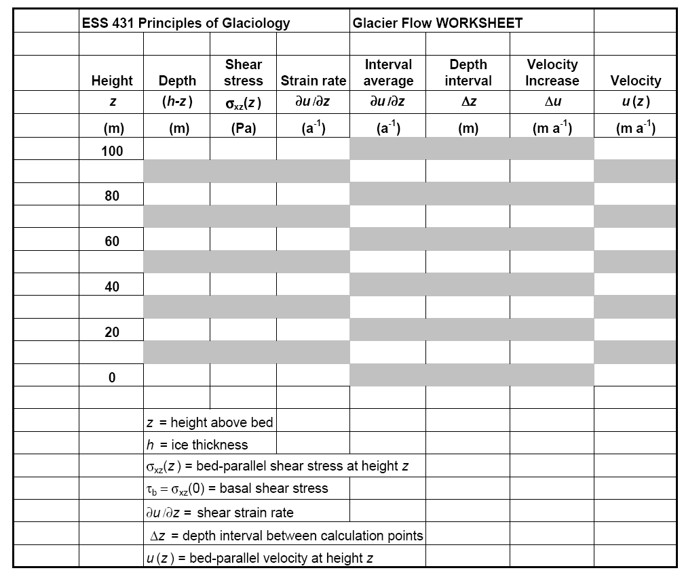

(2) Kinematic ice-flow estimation
A steady-state glacier has a net balance rate of 0.5 m a⁻¹ (ice-equivalent) in the accumulation area upstream from a target cross-section, 1 km from the headwall. At this cross-section, the glacier happens to be 200 m across, and 100 m deep.
- Find the total volumetric ice flux through this cross-section for a glacier in balance.
- Find the average ice flux per unit width for this cross-section.
- Find the depth- and width-averaged velocity of ice flowing through this cross-section.
- Knowing that there is drag from the sides and the bottom, use your averaged velocity to make a rough estimate of the actual speed of a marker on the surface at the center line. Explain your assumptions

OK, after hearing the other group reports, now all groups answer Question 3.

(3) Compare the dynamic and kinematic treatments
Both glaciers are 100 m thick and temperate. What factors might account for the differences in the estimates of the speeds of the markers at the surface on the center lines?

