Assessment of Operational Feasibilities for Implementing the OESF Conservation Strategy
University of Washington
Forest Engineering Class of 2001

Big Country Timber Sale

Prepared by:

University of Washington
Senior Forest Engineering
Class of 2001

Under the direction of:

Dr. Peter Schiess
Professor of Forest Engineering
And
Alec Arntzen
Research Assistant

Prepared for:

Tom Robinson
Region Manager
Olympic Region
Department of Natural Resources
Forks, Washington
Executive Summary

Project Expectations and Results
During spring quarter 2001, the University of Washington Forest Engineering program developed a harvest and access plan for the Big Country Timber Sale (sections 7, 8, 17 and 18 of T31N R12W and sections 12 and 13 of T31N R13W, surrounding the P-1800 road). This project is a collaborative effort between the DNR and UW designed to provide real-world experience to the forest engineering class, while also supporting DNR management goals.

The project develops a harvest and transportation plan that provides for the implementation of the OESF conservation strategy and also provides additional opportunities for DNR Research and Monitoring. After months of preparation and four weeks of fieldwork, a final report and presentation was submitted to interested officials of the Department of Natural Resources in June of 2001. Several expectations were included in the plan of operations for the Big Country project. Below is a list of expectations and the UW’s level of fulfillment of these expectations.

Expectation: P-1800 redesign, bridge design and costing analysis, ~2 miles of access reconstruction and field location of secondary roads.
Result: 11.8 miles of designed road, including 4.7 miles of reconstruction design, two bridge designs and field location of roads.

Expectation: Field assessment of road stability, field verification of areas of slope instability, unstable slope risk assessment.
Result: Field assessment and verification performed under the direction of Wendy Gerstel. Resulted in GIS coverage of unstable slopes and a report made by Wendy Gerstel (pending at time of publication). Slope transects were run on unstable zones. In depth analysis performed by Gerstel at Cougar Creek Bridge approach.

Expectation: Analyze potential for reducing roads required through long span yarding over riparian areas.
Result: An analysis comparing helicopter yarding to conventional systems was performed for the entire timber sale. Long span yarding options were explored in detail through cable analysis.
Expectation: Field bridge site survey work.
Result: Provided a detailed analysis for five access alternatives to the Big Country Timber Sale including field verification and detailed design. Site survey for West Clallam Bridge included in deliverables.

Expectation: Analysis of potential for Stream and Riparian restoration activities based on treatments provided by the HCP Research and Monitoring group.
Result: Harvest system designed for flexibility to meet desires for RMZ restoration and Research and Monitoring goals. Includes field verification of slope profiles. Harvest prescription decision matrix and suggested layout included for Research and Monitoring goals.

Expectation: Sediment delivery and recommendations for mitigation.
Result: Sedimentation analysis performed for all existing and newly designed roads in the Big Country Timber Sale.

Expectation: Transportation plan and maps
Result: A detailed transportation plan including access alternatives and bridge designs was created. Map deliverables include a map of final road locations and harvest prescriptions, a map of potentially unstable slopes, and a map of preliminary design work in addition to all working maps used throughout the project. In addition, an assessment of operational feasibilities for implementing the OESF conservation strategy was created.

Detailed Road Design
Approximately 11.8 miles of road were fully designed for new construction or reconstruction using ROADENG, a road design program. This includes the P-1800 road. These designs were included in the transportation plan and include notes for stationing, grade, side slopes, cut and fill volumes, horizontal and vertical offsets, and slope staking.
Two bridges and their approaches were designed. The approaches to the West Clallam Bridge and the East Cougar Bridge both required extensive redesign. In addition, alternative access routes were explored and designed.
Field location of all mainline roads and most spurs was completed.

Slope Stability Analysis
Under the direction of Wendy Gerstel, field assessment and verification of unstable slopes was performed across the Big Country Timber Sale. This included running some transects. Special attention was given to unstable slopes that interfere with the road system, especially at the West Clallam Bridge and East Cougar Bridge locations.

Deep seated landslides and shallow rapid landslides were identified from aerial photos and through field verification. This resulted in a GIS layer of identified potentially unstable slopes (Figure 1).

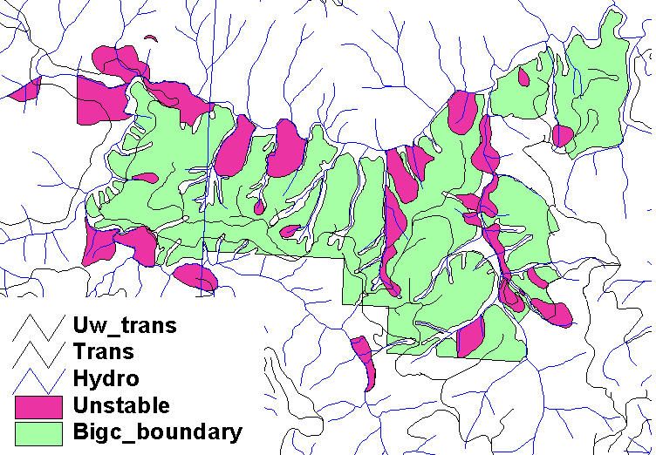
Figure 1. The magenta areas are the deep seated and shallow rapid landslide areas identified by Wendy Gerstel as seen in the GIS coverage UNSTABLE.

Wendy Gerstel is currently working on a report to accompany her findings.

Alternative Yarding System Analysis
Using LoggerPC, we performed an in depth analysis on approximately 200 profiles throughout the Big Country Timber Sale. Long span yarding was explored as an alternative, but was found to be non-marketable in the present state of this sale. An analysis comparing helicopter yarding to conventional systems was performed as well. It, too, proved to be non-marketable.

Access Alternatives
In order to allow the DNR to make a fully informed decision about which access route to use for the Big Country Timber Sale, five possible routes were analyzed. 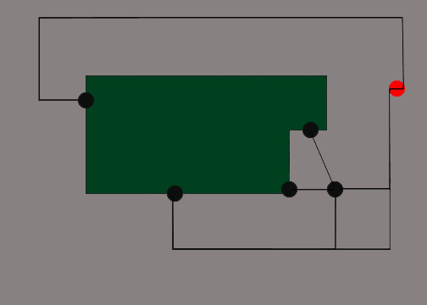

South
Bloedel
Southeast
West
West Bridge
Northeast
P1000
Main Gate at Hwy 112
Planning Boundary for Big Country Timber Sale
East

East
Cougar Bridge

P1800
Crown

XXXX
Gate
Figure 2. Conceptual representation of the planning area and access alternatives.

A conceptual representation of these five access routes and the planning area can be seen in Figure 2. The Northeast route was found to be infeasible in the field. The other four routes were analyzed fully, including a complete cost analysis and risk assessment for each alternative. In addition, the road design work was completed for three of these four options.

Research Applications
DNR Research and Monitoring’s main interest in this sale was the layout of harvest prescriptions to meet research needs for implementing the OESF conservation strategy. The result of our work was a fully flexible harvest design that allows any unit to be harvested with any prescription. The flexibility of the harvest design was verified in the field. In addition, we created a “marketability matrix” that helps in determining the most marketable prescription for each unit. A suggested prescription layout was also included that combines the most marketable layout with the realities of the operational difficulties found in the field (See Figure 3).
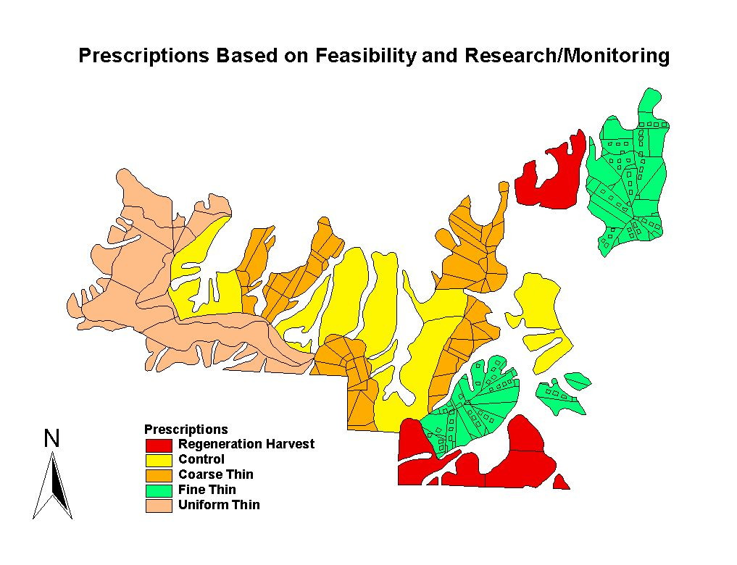
Figure 3. Proposed prescriptions based on operational feasibility and research/monitoring objectives.
Also of interest was the ability to implement RMZ restoration. Our harvest system is designed for flexibility to meet these needs throughout the timber sale.

Sedimentation Analysis
A sedimentation analysis was performed for all existing and newly designed roads in the Big Country Timber Sale. The analysis was performed using WEPP and X-DRAIN, computer programs used to calculate sedimentation. A GIS analysis was also performed to analyze sedimentation. By locating newly designed roads primarily on ridges, the risk associated with sedimentation was greatly reduced. Risk of sedimentation was reduced on existing roads through the design of cross drains.

Table of Contents
Executive Summary 2
Project Expectations and Results 2
Detailed Road Design 3
Slope Stability Analysis 3
Alternative Yarding System Analysis 4
Access Alternatives 5
Research Applications 5
Sedimentation Analysis 6
1 Design Team 16
1.1 Directors 16
1.1.1 Peter Schiess 16
1.1.2 Alec Arntzen 16
1.1.3 Weikko Jaross 16
1.1.4 Jeff Comnick 16
1.2 Forest Engineering Seniors 17
1.2.1 Bret Macaleer 17
1.2.2 Thomas Mohr 17
1.2.3 Santino Pascua 17
1.2.4 Matt Ringstad 17
1.2.5 Jarrod Todd 18
1.2.6 Jeremy Tryall 18
2 Introduction 19
2.1 Site Description 19
2.2 Goals 19
2.2.1 Olympic Region 20
2.2.2 College of Forest Resources 20
2.3 Objective 20
2.4 Design Challenges 21
2.4.1 Access 21
2.4.2 Yarding 21
2.4.3 Comparison of Alternative Harvest Prescriptions 21
2.4.4 Unstable Slopes 21
3 Data Collection 22
3.1 DNR Big Country 22
3.1.1 Introduction 22
3.1.2 Slope Stability 22
3.1.3 Road Design 22
3.1.4 Research and Monitoring 23
3.1.5 Aerial Photos 23
3.2 GIS Coverages 24
3.2.1 Initial Data Collection/Database 24
3.2.2 Creation of Layers 24
3.2.3 Modification of Layers 27
4 Slope Stability and Mass Wasting 28
4.1 Site Conditions 28
4.1.1 Soil Conditions 28
4.1.2 Stream Conditions 28
4.2 Unstable Area Analysis 29
4.3 Watershed Analysis Results for Road Design 31
4.4 Sedimentation Analysis 32
4.4.1 Road Proximity to Streams 32
4.4.2 Predicted Road Sediment 33
4.4.3 Cross Drain Spacing and Design 33
4.4.4 Culvert and Sediment Relationships 34
4.4.5 WEPP and X-DRAIN 34
4.5 References 36
5 Silviculture 37
5.1 Goals & Objectives 37
5.2 Thinning Criteria 37
5.3 Current Conditions 38
5.4 Turn Weights 39
5.5 Tail Trees 39
6 Roads 40
6.1 Design Inputs 40
6.1.1 Side Slope Considerations 41
6.1.2 Road Grade and Alignment 41
6.1.3 Stream Crossing 42
6.2 Field Reconnaissance 42
6.2.1 Processes 42
6.2.2 Equipment 42
6.3 Field Reconnaissance Prioritization 43
6.5 Overview of Final Road System 43
6.5.1 Road Statistics 44
6.5.3 Preliminary vs. Final Comparison 45
6.6 Road Design Challenges 45
6.6.1 Big Country Road Design Specifications 46
6.6.2 East Bridge (Cougar Creek) 47
6.6.2.1 East Bridge Area 47
6.6.2.2 Widening 48
6.6.3 West Bridge (Clallam River) 51
6.6.3.1 Stability 51
6.6.3.2 Culverts 52
6.6.3.3 Site Survey 53
6.6.4 South Access 55
6.6.5 Southeast Access 56
6.6.6 Alignment 56
6.6.6.1 East Access 57
6.6.6.2 West Access 58
6.6.6.3 South Access 58
6.7 Access Analysis 58
6.7.1 Introduction 58
6.7.2 Haul Cost and Reconditioning for each Alternative Access 59
6.7.2.1 Haul Cost 59
6.7.2.2 Reconditioning Costs for Each Access 60
6.7.3 Internal Road Scenarios for the P-1800 62
6.7.4 Internal Road Costs 63
6.7.5 Total Overall Costs per Alternative Access 64
6.7.6 Decision Matrix for Alternative Access 65
6.8 Surfacing Reduction 66
6.8.1 Introduction 66
6.8.2 Cost Comparison 66
6.8.3 Results 67
7 Harvest Systems 68
7.1 Systems Selected 68
7.1.1 Ground Systems 68
7.1.2 Cable Systems 68
7.1.3 Helicopter Systems 69
7.2 Setting Design and Analysis Process 69
7.2.1 Cable Analysis 69
7.2.2 Cable Analysis Assumptions 70
7.2.3 LoggerPC analysis 70
7.2.4 Choosing Payloads 71
7.2.5 Setting Layout 71
7.2.6 Analysis 72
7.3 Profile Verification 72
7.3.1 Marginal Profiles 72
7.3.2 Profile Comparison 73
7.4 Helicopter Settings 74
7.5 Alternative Equipment 74
7.6 Harvest System Owning and Operating Costs 75
7.6.1 Costing Models Used 75
7.6.2 Purpose 75
7.6.3 Method 76
7.7 Production Costing Summary 76
7.7.1 Felling 76
7.7.2 Yarding 77
7.7.2.1 Cable Yarding 77
7.7.2.2 Shovel Yarding 78
7.7.2.3 Grapple Skidding 79
7.7.2.4 Line Skidding 79
7.7.2.5 Helicopter Yarding 80
7.7.3 Processing 81
7.7.3.1 Manual Processing 81
7.7.3.2 Mechanical Processing 82
7.7.4 Loading 82
7.7.5 O & O Costs 82
7.7.6 Conclusion 83
7.8 Alternative System Analysis Comparison 84
7.8.1 Alternative Analysis Conclusions 85
8 Prescription Design Strategies 86
8.1 Operational Feasibility 86
8.2 Research and Monitoring Objectives 87
8.3 Field Location and Contract Administration 88
8.4 Marketability Matrix 89
8.4.1 Creating a Marketability Matrix 90
8.4.2 Results of the Marketability Matrix 93
8.5 Tradeoff Analysis 93
8.5.1 Differences in Layouts 94
8.6 Final Layout 96
8.6.1 Review of Prescription Design Strategies: 96
8.7 Conclusions 98
9 Conclusions 99
10 Appendices 100
10.1 Loggers Preferences 100
10.2 Harvest Volume Assumptions 102
10.3 Using LoggerPC 103

List of Figures
Figure 1. The magenta areas are the deep seated and shallow rapid landslide areas identified by Wendy Gerstel as seen in the GIS coverage UNSTABLE. 4
Figure 2. Conceptual representation of the planning area and access alternatives. 5
Figure 3. Proposed prescriptions based on operational feasibility and research/monitoring objectives. 6
Figure 4. The Big Country Timber Sale is located north of Sappho on the Olympic Peninsula. It consists of approximately 1100 acres with many incised stream channels. 18
Figure 5. All soils of the Big Country Timber Sale are potentially unstable except for Ozette. 27
Figure 6. The fish bearing streams surrounding the Big Country Timber Sale lack a significant amount of Large Woody Debris. 28
Figure 7. Total unstable areas combining the DNR GEO cover with Wendy Gerstel’s identified potentially unstable areas. UW planned roads in purple and existing P1800 shown in black. 29
Figure 8. Shotgun culvert eating away at roadside. 30
Figure 9. Lighter colors represent greater flow distance from streams. The streams are thus shown in black. UW designed roads are shown in purple. Notice that the designed roads primarily run along ridges (white areas). 31
Figure 10. Predicted sediment based on GIS analysis using road gradient, side slope, and flow accumulation. Darker colors indicate more sediment. 32
Figure 11. The preliminary road design crosses few streams by staying on ridges. After the best road locations are selected from the options shown here, the final road design will cross even fewer streams. 40
Figure 12. The final road system is broken into 5 groups. As noted previously, these roads cross very few streams. 43
Figure 13. On the east access, the P1800 is in good condition for about five stations after the junction with the P1810, due to the Cabin Fever Sale. After five stations, the surfacing is native and the quality of the road is poor. As it approaches the bridge on Cougar Creek, it goes through two unstable areas, as seen in the figure. The existing switchback has a radius of about 15 feet, so in the design it was important to raise it to 60 feet. 46
Figure 14. The approach to the Cougar Creek bridge is very steep and there are many springs in the area. Note the abundance of alder and salmonberry growing here. Full bench construction is needed going along the hillside, and a retaining method is recommended to keep the side slopes from failing. As the designed road crosses over the existing P1800, a large quantity of fill begins to accumulate. 47
Figure 15. A cross section of the P1800 in the s-curve on the Cougar Creek bridge approach shows a fill height of 18 feet. This section comes from the point of greatest fill height. Because of the fill, four feet of widening is required basically from the start of the curve through the bridge. 48
Figure 16. Plan view from RoadEng of the s-curve on the bridge approach. The black line shows the point and direction of the cross section seen in Figure 15. 48
Figure 17. The P1800 at the west bridge goes through an unstable area. The road itself is host to several fill and cut slope and prism failures. 50
Figure 18. P1800 as it cuts through a headscarp, marked by the arrow. The location of the headscarp is the flat bench by the clump of vine maple. Note the abundance of salmonberry, alder, and elder. 51
Figure 19. There are two major culverts that need to be replaced on the P1800 towards the P1000. The closer one to the bridge is 72 inches and could be changed to an open bottom culvert or arch pipe. The other is a 60-inch culvert. Both are located on large streams. 52
Figure 20. Site survey of west bridge. The survey was conducted in 1984 and the notes were entered into Foresight this year to put them into electronic form. Bridge design should be fairly straightforward here. 53
Figure 21. The south access comes off the P2100 road and is on private land. It needs a great deal of work to bring it to Forest Practice standards, most notably improving drainage and some realignment. 54
Figure 22. The Southeast Access provides a bypass for much of the South Access. This may reduce the amount of easement needed, and provides for a road in a better location than the South Access. 55
Figure 23. Depending upon which access route is chosen, the takeoffs for Skoal, Timber Wolf, and Kodiak Ice may have to be adjusted. 56
Figure 24. Conceptual representation of the planning area and access alternatives. 58
Figure 25. P-1800 Reconstruction/Abandonment Scenarios 61
Figure 26. Total access costs for each alternative. These costs sum all of the pieces discussed in previous sections. The results show that the East, South, and Southeast are comparable. 63
Figure 27. Red lines indicate profiles analyzed on LoggerPC. Yellow profiles indicate profiles taken in the field. 69
Figure 28. Comparison of field generated profiles vs. map generated profiles. Despite a discrepancy in the results, the map has proved to be an adequate source for analysis purposes. 72
Figure 29. Graph shows the relationship between flight distance and yarding cost for each of the four prescriptions. Cost includes felling-loading plus and average trucking cost. Depending on which access route is used this will change a few $/MBF. 80
Figure 30. Proposed prescriptions based on operational feasibility and research/monitoring objectives. 87
Figure 31. Prescriptions based on the Marketability Matrix 92
Figure 32. Final layout of prescriptions taking into consideration matrix, feasibility, research, and monitoring. 95

List of Tables
Table 1. Coverages created during the analysis process, either to do further analysis or as a product of analysis done. 24
Table 2. Table of coverages that have been modified. These coverages were modified to ease use in analysis and map making. 26
Table 3. The 100 year flow heights for all three bridges were calculated based on GIS watershed analysis, Manning’s Equation, and Q=UA. 30
Table 4. Comparison of predicted sediment on roads in the Big Country Timber Sale. 35
Table 5. A summary of stand data for the planning area. The values were found by taking the average of all the Research Inventory Units (RIU’s) and applying the various prescriptions to them. All Volumes are in Scribner bd ft to a 4” top. 37
Table 6. Grade and length statistics. Ideally the road grade would not exceed 15% however the best design for some roads required that the grade be increased up to 20%. 44
Table 7. Maximum widening of P1800 through s-curve before bridge. The total width through the curve should be about 23 feet in order to allow a log truck to pass safely. The curve widening differs depending on the method used. In this case, the drafting vehicle simulator provides the greatest amount of curve widening. 49
Table 8. Maximum widening of P1800 through the bridge. The total width of the bridge should be about 21 feet in order to allow a log truck to pass safely. The widening is based on the use of the drafting vehicle simulator. 49
Table 9. Results of curve widening without fill widening. Note that the total width based on DNR specs is four feet less than the other methods. However, in situations like this, there is usually a ditch available and adds to the drivable width (provided the ditch is repaired by the end of the sale). 49
Table 10. Speed zone classifications for haul time calculations. Classifications were based on road grade and alignment. 59
Table 11. Haul Costing for each access to the Mill 59
Table 12. Reconstruction costs for each access, including easements, maintenance, reconstruction, new construction, abandonment, and bridge costs. 61
Table 13. Decision Matrix for intangibles of each access. These are factors that can’t be described with an economic cost, but they are still important factors in the selection of an access route. 64
Table 14. Cost comparison of using Tensar BX1100 geogrid. There is a significant savings on the west access, but there is a significant loss on the east access. The south and southeast access show only a minor difference. 66
Table 15. Payloads of marginal profiles 71
Table 16. Comparison of safe working loads for PowerFlex vs. standard cable. The increased safe working load corresponds to increased payloads. 73
Table 17. Felling costs for each potential harvest prescription. SL_Pro was used to generate costs. Production estimates were taken from a FERIC report. 76
Table 18. Cable yarding costs were determined by compiling data from several sources. 77
Table 19. Grapple skidding costs were determined using Skid_PC and SL_Pro. 78
Table 20. Line skidding costs were generated with Skid_PC and SL_Pro. 79
Table 21. Costs for manual processing were determined by using equations from a FERIC report and the Region 6 costing program. 80
Table 22. Costs for mechanical processing were determined using SL_Pro and a production equation from FERIC. 81
Table 23. A list of equipment that was used to obtain an accurate assessment for cost analysis. 82
Table 24. Comparison between conventional cable yarding and helicopter yarding. Beyond the flight distance shown cable yarding becomes more cost effective. Note: Cable logging cost is stump to truck. Light and Heavy flight distances are not reversed 84
Table 25. Unit and Prescription table with corresponding SIMYARD values 89
Table 26. Normalized (relative) values for all prescriptions on each unit 90
Table 27. Normalized (relative) values for all units on each prescription 90
Table 28. Marketability Matrix 91
Table 29. Choosing prescriptions for harvest plan 91
Table 30. Loggers Preference Matrix. See assumptions and definitions at bottom of table. 100

1 Design Team

1.1 Directors

1.1.1 Peter Schiess
The University of Washington Big Country Timber Sale Project was under the direction of Professor Peter Schiess. Professor Schiess obtained his Ph.D. degree from the College of Forest Resources, University of Washington in 1975. After receiving his Ph.D. degree, Professor Schiess has played an important role in the development of the Forest Engineering curriculum at the University of Washington. He has research interests in mechanized harvest and cable thinning operations, and is currently researching timber harvest planning as a subset of landscape level analysis. Further information regarding Professor Schiess’s educational background, professional experience, and publications can be found at http://faculty.washington.edu/schiess/.

1.1.2 Alec Arntzen
Alec Arntzen is a graduate in forest engineering from the University of Washington. He graduated in December of 1999 with a Bachelor of Science degree in forest engineering with an emphasis on environmental analysis.

1.1.3 Weikko Jaross
Weikko Jaross received his Bachelor of Science degree from the College of Forest Resources, University of Washington in 1996. Weikko is currently a graduate student at the University of Washington studying to obtain a Masters Degree in Forest Engineering. Special interests are in DNR GIS and familiarizing University of Washington Forest Engineering students with aspects of harvest operations.

1.1.4 Jeff Comnick
Jeff Comnick is currently seeking a Master's Degree of Silviculture and Forest Protection at the University of Washington. He previously earned his BS in Forest Management from the University of Washington. Jeff has also served as a teaching assistant for UW Field Courses at Pack Forest, including Silviculture, Forest Measurements, Forest Survey, and Transportation. He conducts research in the UW Silviculture Lab, focusing on landscape level planning and managing for multiple objectives by providing all forest structures through silvicultural manipulations.

Forest Engineering Seniors

1.2.1 Bret Macaleer
Bret is a senior forest engineering student at the University of Washington expecting to graduate in March of 2002 with a Bachelor of Science Degree in Forest Engineering with emphasis on both environmental analysis/design and GIS/remote sensing. The first two years of his college education were spent at Florida Institute of Technology. He has interned with the Department of Natural Resources in the Northwest region. After graduation he would like to practice low volume road design in Central America and later on obtain a professional engineering license in the US.

1.2.2 Thomas Mohr
Thomas is a senior forest engineering student at the University of Washington expecting to graduate in the summer of 2001 with a Bachelor of Science Degree in Forest Engineering with emphasis on both environmental analysis/design and GIS/remote sensing. He has done internships and work study through the Department of Natural Resources with emphasis on culvert design and the creation of hydraulic curves for the South Western Cascades of Washington State. His future goals are to obtain a professional engineering license while applying the most up to date Forest Engineering knowledge.

1.2.3 Santino Pascua
Santino is a senior who will graduate in June of 2001 with a Bachelor of Science degree in Forest Engineering with an emphasis in environmental anlaysis. He worked last summer for the University of Washington in the Sciences and Tribes Educational Partership (STEP) relaying his knowledge of forest engineering to potential UW entrants in hopes of preparing them for entrance into the College of Forest Resources. Santino has accepted a position with the Washington State Department of Natural Resources where he will serve the South Puget Sound Region in Enumclaw on an internship. Santino’s future goals after graduation are to obtain a Professional Engineering License and return to school for a degree in graduate education.

1.2.4 Matt Ringstad
Matt will graduate from the University of Washington in June 2001 with a Bachelor of Science degree in Forest Engineering with an emphasis on GIS. Matt is interested in transportation design. His work experience includes varied transportation based internships.

1.2.5 Jarrod Todd
Jarrod is a senior in Forest Engineering at the University of Washington and will be graduating in June of 2001. He has held several jobs in the timber industry, which has provided valuable practical knowledge to supplement his education. His interest is in construction engineering. Following graduation, Jarrod plans to work for Schermer Construction, Inc. in Hoquiam, WA.

1.2.6 Jeremy Tryall
Jeremy is a Senior Forest Engineering student at the University of Washington. He will graduate Winter 2002 with a Bachelor of Science degree in Forest Engineering with an emphasis in GIS. His engineering experience includes summer work with the Department of Natural Resources’ Central Region in 1999 and South East Region in 2000. He will be returning to the South East Region this summer for six months. http://students.washington.edu/jtryall

2 Introduction

2.1 Site Description
The Big Country Timber Sale is located on the Olympic Peninsula, north of Sappho on Highway 112(See Figure 4). It is in T31N R12W sections 7, 8, 17 and 18, and T31N R13W sections 12 and 13. The sale consists of approximately 1100 acres. It contains many incised stream channels and is bounded by fish bearing streams on the east, west, and north. On the south, it is bounded by private land.
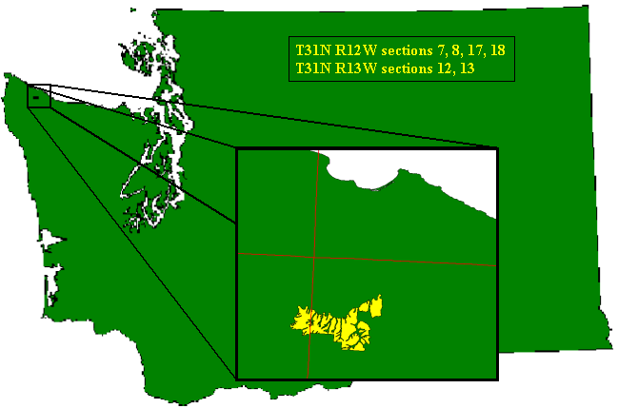

Figure 4. The Big Country Timber Sale is located north of Sappho on the Olympic Peninsula. It consists of approximately 1100 acres with many incised stream channels.

2.2 Goals
The two major parties involved in this project are the Department of Natural Resources Olympic Region, and the University of Washington College of Forest Resources. The main project goals for each group are listed below:

2.2.1 Olympic Region
- Access strategy for proposed Big Country Timber Sale
- Exploration of alternatives that mitigate risk of cost, slope stability, and sedimentation
- Implementation of OESF research and monitoring program by testing alternatives to reach desired habitat structures
- Provide Region Foresters opportunities for continuing education and skill enhancement

2.2.2 College of Forest Resources
- Provide DNR with a high quality product and qualified engineering applicants
- Expose students to new and emerging forest engineering technologies
- Provide a transition from academic learning to professional experience

2.3 Objective
The objective of this project is to provide an analysis of operational alternatives for the Big Country Timber Sale. This analysis includes the following specific objectives:
- Field verification of access and harvest alternatives
- Detailed road and harvest unit designs
- Risk assessment of cost, slope stability, and sedimentation
- Tradeoff analysis for access options and harvest prescriptions
- Decision framework for implementing the research and monitoring program

The goals and objectives for this project are similar to those of the Burnt Mountain Project from 2000. It can be found on the web in the past projects section of the FE 450 Web Site (http://courses.washington.edu/fe450).

2.4 Design Challenges
There were several interesting design challenges on this project:

2.4.1 Access
Access routes from the south cross private land, requiring the acquisition of easements. Access routes from the north, east or west cross fish bearing streams. All possible bridge locations have approaches that cross unstable areas.

2.4.2 Yarding
Long, uniform slopes with small wood make marketability difficult for some units at this time.

2.4.3 Comparison of Alternative Harvest Prescriptions
Allocating specific harvest prescriptions to meet the needs for research and monitoring, marketability, and operational feasibility requires detailed engineering analysis.

2.4.4 Unstable Slopes
Current mitigation of risk on unstable slopes may decrease available harvest volume.

3 Data Collection

3.1 DNR Big Country

Introduction
In order for the project to get under way and be successful, vast amounts of information had to change hands. While much of the information was stored electronically (i.e., in a GIS) some was only available within the minds of the DNR staff. Discussion of the electronic data is left to section 3.2. The latter is discussed here.

One of the primary and easiest methods of information exchange is verbal communication. To facilitate the exchange of ideas, UW forest engineers were able to work directly with DNR staff on several occasions. This facilitated an open exchange of ideas and served as a frequent reality check, keeping the project headed in the most productive direction. The UW engineers benefited greatly from this direct support from DNR staff, which in turn provides for a better product for DNR.

Information was exchanged on a variety of topics, including those discussed in the following sections.

Slope Stability
DNR Geologist Wendy Gerstel worked with the UW design team on multiple occasions both in the office and in the field. Topics discussed included lessons on the factors that cause landslides, how to identify unstable areas from aerial photos, and how to identify unstable areas in the field. She also worked with UW students in the field, running transects of some unstable slopes. The results of this work include an unstable slopes GIS coverage (see section 3.2.2), and a report on the geologic conditions in the Big Country Timber Sale (yet to be released at time of publication).

Road Design
Several DNR personnel were contacted regarding a variety of road design topics. These people include Unit Forester Brian Turner, and engineers Bill Traub, Eric Carlsen, and Aaron Roark.

Brian Turner met with the UW design team weekly while in the office at Pack Forest, and also worked closely with them while in the field. With his understanding of the existing conditions of the Big Country Timber Sale, he was able to answer questions about prioritizing road abandonment, existing road conditions, and feasibility of potential road locations including slope stability issues.

Bill Traub’s broader landscape management plan was utilized as a launching pad for the detailed road design performed by the UW design team. He also provided information about road costing.

Eric Carlsen provided a lot of information on bridge design and costing. This included a tour of bridges and pipe arches in various stages of construction.

Aaron Roark helped the design team to determine potential costs of easements for the South and Southeast access routes to the Big Country Timber Sale.

Research and Monitoring
DNR Research Scientist Richard Bigley provided information on the theory behind the current prescriptions for habitat creation as well as experimental prescriptions hoping to combine habitat creation and operational feasibility.

Brian Turner provided field knowledge necessary for the most marketable implementation of the research and monitoring prescriptions.

Aerial Photos
Aerial photos for the Big Country Timber Sale were available. In addition, orthographic photos for year 1994 were available for the Clallam River Planning Area. These photos provide additional information that cannot be seen from maps and GIS coverages. Some of the information that we collected from looking at the photos was useful in many areas of our harvest planning analysis. Unstable areas were identified by Wendy Gerstel and the UW design team and were then digitized into a GIS coverage. This data was used extensively in road location and design, as well as in selection of harvest prescriptions.

Contour Map
Due to the poor resolution of the DEM, a paper contour map was required. A 1”:400’ contour map was provided.

3.2 GIS Coverages

Initial Data Collection/Database
The DNR creates and maintains its own GIS database. The Olympia office is the main source of data and a relevant set of coverages was obtained in March.

The coverages we acquired from the DNR included, but are not limited to:

- DEM--a digital elevation model and contour coverage.

- HYDRO--a hydro coverage with arc features.

- TRANS--existing transportation system arc coverage.

- POCAL--a coverage with public land survey boundary information.

- RIU--forest stand or resource inventory unit coverage.

- GEO—a coverage of potentially unstable areas created by Susan Shaw.

- ORTHOPHOTOS--Orthophotos of the planning and surrounding areas.

- CLAMPLAN—Results from Bill Traub’s Clallam Landscape Plan including road locations and settings.

Other coverages were provided, but not utilized in our analysis as extensively as those above.

Creation of Layers
During this project, several coverages were created or modified to aid in our analysis. Modified coverages are discussed in section 3.2.3. This section discusses the coverages created, either to do analysis or as a product of it. The following table lists and briefly describes all of the coverages that we created. A more in depth discussion follows the table.

Table 1. Coverages created during the analysis process, either to do further analysis or as a product of analysis done.
Coverage | Note
Bigc_boundary | Boundary line of Big Country Timber Sale (excludes potentially unstable areas)
Bigc_stability | Combination of Geo cover (DNR cover created by Susan Shaw) and Unstable cover (digitized Wendy Gerstel’s work).
Clip_poly | Polygon used to clip covers to a standard size
DNR_Contour | 20 foot contour coverage created from DNR_DEM
Prescrip_riu | Harvest prescriptions for research and monitoring including riu data and payload information
Prescriptions | Harvest prescriptions for research and monitoring
Profiles | Digitized LoggerPC profiles
Sheet_box | Used to set map extent in map making
Slope | Grid of slope derived from DNR_DEM
Slpcls | Grid of slope classes (0-30%, 30-55%, >55%)
Slpcls_poly | Polygon coverage of slope classes
South_bound | Digitized new south boundary line based on survey completed during project
Ticcov | Tic Cover created by UW
Units | Basic unit boundaries including payloads, timber volumes, riu data, and mass wasting data
Unstable | Identification of unstable slopes by Wendy Gerstel (DNR) including deep seated landslides and shallow rapid landslides.
UW_trans | UW proposed road network
Weikko_riu | Units digitized by Weikko Jaross with riu data
Weikko_units | Units digitized by Weikko Jaross

BIGC_BOUNDARY is a preliminary boundary for the proposed Big Country Timber Sale.

BIGC_STABILITY is a combination of the GEO coverage and the UNSTABLE coverage. The GEO coverage was created from Susan Shaw’s work and shows areas with potential to be unstable. The UNSTABLE coverage was created from Wendy Gerstal’s work and shows areas that are visibly potentially unstable.

CLIP_POLY is a polygon that was used to clip large coverages into a manageable area.

DNR_CONTOUR is a 20 foot contour coverage created from DNR_DEM. 100 foot contours are flagged to assist in map making.

PRESCRIP_RIU is a combination of the PRESCRIPTIONS coverage and the UW_RIU coverage. It includes suggested harvest prescriptions based on Research and Monitoring requirements as well as data from the UW_RIU cover such as payloads and tailtree diameters.

PRESCRIPTIONS is a coverage of the suggested harvest prescriptions to meet Research and Monitoring needs. See Chapter 8 of this report for more information.

PROFILES is a coverage of the cable profiles analyzed in LoggerPC as a part of the cable analysis done in this project. All analyzed profiles are included in this layer.

SHEET_BOX was used in map making to define the extent of the map to be plotted.

SLOPE was created as a preliminary step to the SLPCLS_POLY layer. It is a grid of slope values based on DNR_DEM.

SLPCLS is a grid of slope classes. There are three classes. Slope class 1 has slope < 30%. Slope class 2 has slope between 30% and 55%. Slope class 3 has slope > 55%.

SLPCLS_POLY is a polygon coverage grouping all of the slope classes in SLPCLS. The same class breakdown applies.

SOUTH_BOUND was created after a survey crew discovered a mistake in the location of the south boundary of the Big Country Timber Sale. We digitized this new boundary and used it in our analyses. It is not incorporated in the BIGC_BOUNDARY cover and thus is not located on any of the hard copy maps.

TICCOV is a tic cover created by the UW for use in registering maps.

UNITS is a preliminary coverage in the creation of the PRESCRIPTIONS coverage. It includes all unstable areas, as well as payloads, harvest volumes, riu data, and preliminary unit boundaries.

UNSTABLE was created by digitizing the slide areas identified by Wendy Gerstel’s aerial photo and field analysis of the Big Country Timber Sale. Polygons are identified as deep seated or shallow rapid landslides.

UW_TRANS is the network of roads proposed by the UW design team. This layer does not include existing roads that need reconstruction (such as the P1800).

WEIKKO_RIU is a preliminary units layer created by Weikko Jaross. It includes RIU data.

WEIKKO_UNITS is a preliminary units layer created by Weikko Jaross.

Modification of Layers
It was necessary to modify some of the existing coverages so they could be easily utilized in analysis and map making. The following table lists coverages that have been modified, including what was done and a brief description. Then each item is discussed briefly with regard to its origin and its associated values.

Table 2. Table of coverages that have been modified. These coverages were modified to ease use in analysis and map making.
Coverage | Modification
Poca | UW_SECT#--Is an item in the POCA coverage that was created to help put text onto maps. Values ranged from one to thirty six and were the product of subtracting 100 from the SECTION.ID item. These values are the section numbers for each township and range within the coverage.
Uw_hydro | Poca section lines were removed from the hydro coverage to allow for more accurate watershed analysis calculations.
Uw_riu | Added tailtree Quadratic mean diameter data and payload calculations for each research and monitoring prescription to the original riu data.

UW_SECT#--Is an item in the POCA coverage that was created to help put text onto maps. Values ranged from one to thirty six and were the product of subtracting 100 from the SECTION.ID item. These values are the section numbers for each township and range within the coverage.

UW_HYDRO was created from the HYDRO cover for use in watershed analysis calculations. The POCA section lines were removed to avoid confusion in flow calculations.

UW_RIU contains information such as tailtree quadratic mean diameters and payload calculations that were done for use in cable analysis.

4 Slope Stability and Mass Wasting

4.1 Site Conditions

4.1.1 Soil Conditions
Soil types played an important role in our design process. All are potentially unstable except for Ozette. The soils of the Big Country Timber Sale are Andeptic Udorthents, Ozette, Palix, and Snahopish, shown in Figure 5.

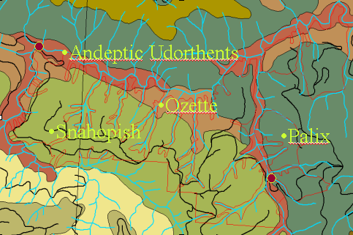
Figure 5. All soils of the Big Country Timber Sale are potentially unstable except for Ozette.

These soils are mostly silty and gravelly loam 40” to 60” deep. All soils are well drained with moderate permeability. There is at least a medium probability for windthrow for all soils with the exception of Palix and Ozette which have a high potential. Once soils are disturbed all soils become unstable to very unstable. With 90” of rain each year there is a good chance for soil detachment and energy build up on the many steep slopes. There are also many draws within the interior of the sale which can facilitate rapid delivery to the fish bearing streams surrounding the sale.

4.1.2 Stream Conditions
As seen in Figure 6, the streams surrounding the Big Country Timber Sale are lacking any significant amount of large woody debris. Most of the existing debris is of little size and of hardwood quality. The lack of longer lasting large woody debris such as fir may present a danger in future stream velocity suppression. That is, there is not a lot of impedence to slow down water speed and provide pools for spawning fish.

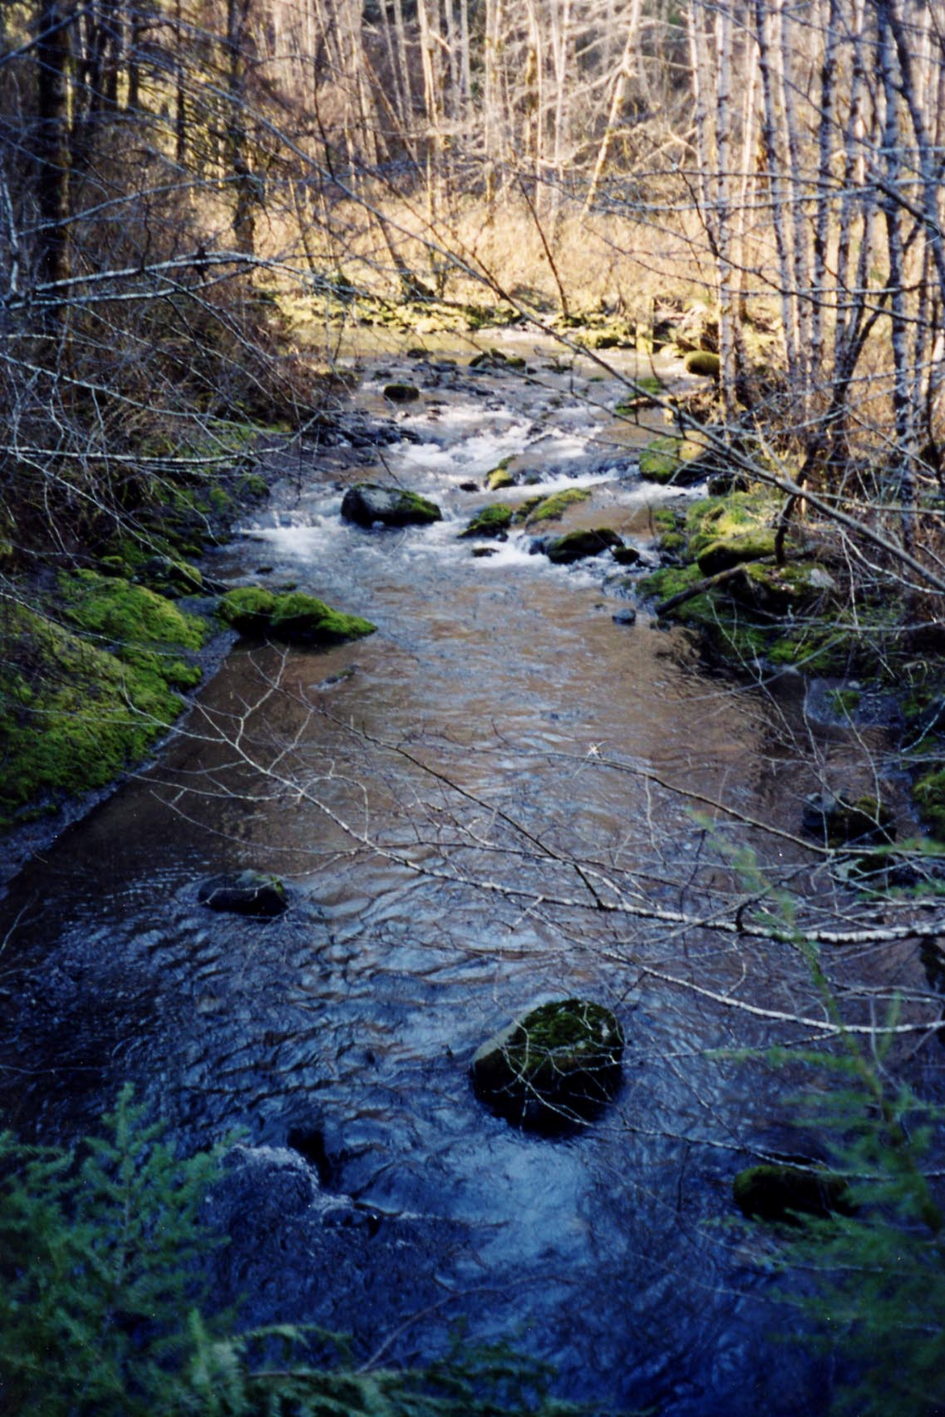
Figure 6. The fish bearing streams surrounding the Big Country Timber Sale lack a significant amount of Large Woody Debris.

4.2 Unstable Area Analysis

A large portion of the Big Country Timber Sale is affected by deep-seated landslides and shallow-rapid debris flows. The total potentially unstable areas are shown below in red (Figure 7). They were compiled by combining field work of Wendy Gerstel and the GEO cover, provided by DNR. Wendy Gerstel’s identified potentially unstable areas were digitized and combined with the DNR GEO cover to create the resulting BIGCSTABILITY cover, shown in Figure 7.

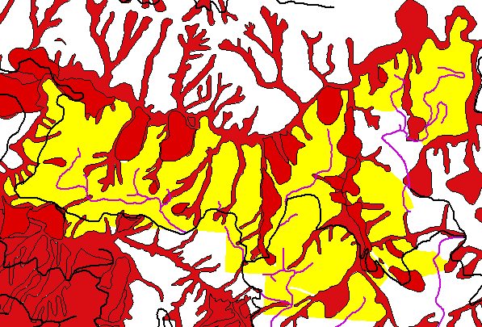
Figure 7. Total unstable areas combining the DNR GEO cover with Wendy Gerstel’s identified potentially unstable areas. UW planned roads in purple and existing P1800 shown in black.

Our road networks were designed to avoid potentially unstable areas. Care was taken to get above head scarps in field work and to stay clear of cutting into the toes of unstable slopes. The vast majority of new roads shown in purple cross little to no unstable areas. The P1800 crosses unstable areas at the “thumb” and at all bridge locations. All bridge locations occur at areas corresponding to deep-seated landsliding. The slopes surrounding the bridge areas have a high alder concentration, springs, and running draws.

Our logging designs facilitate riparian restoration and thinning opportunities allowing flexibility for mitigating risks. Many of the proposed control areas are concentrated on unstable slopes. Our logging designs allow flexibility in order to avoid unstable areas. Under the guidance of Wendy Gerstel, we took transects of unstable areas. Transects were taken from the furthest extent of failure down to the stream. Her final geotechnical report is still pending.

4.3 Watershed Analysis Results for Road Design
Three possible bridge sites were explored. The East Cougar Bridge crosses Cougar Creek at the southeast corner of the Sale. The West Clallam Bridge crosses the Clallam River at the northwest corner of the Sale. The Northeast Bridge crosses Cougar Creek near the confluence with the Clallam River. The 100 year flow heights for all three bridges were calculated based on GIS watershed analysis, Manning’s Equation, and Q=UA. Results are listed below in Table 3.

Table 3. The 100 year flow heights for all three bridges were calculated based on GIS watershed analysis, Manning’s Equation, and Q=UA.
100 year flow information for rivers surrounding Big Country Timber Sale
Bridge | CFS max | Velocity (f/s) | Max Height @ bridge
West Clallam Bridge | 58 | 2.9 | 2.5'
East Cougar Bridge | 67 | 4.6 | 4'
North East Bridge | 91 | 1.3 | 4.5'

To compound problems there are at present existing shotgun culverts and cross drains left in bad repair which are deeply incising selected areas that lie in proposed road locations. This will require a significant amount of fill and armoring to repair, as seen in Figure 8.

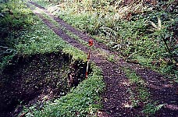
Figure 8. Shotgun culvert eating away at roadside.

4.4 Sedimentation Analysis

4.4.1 Road Proximity to Streams

Road proximity to streams suggests the risk of sedimentation. Proximity and flow direction are estimated with slope and distance from a stream. Roads are located atop ridges and away from streams where possible to improve drainage and mitigate for the risks of sedimentation. Below is a figure showing the existing P1800 and all new roads’ proximity to streams. Lighter colors represent greater flow distance from streams. The streams are thus shown in black. UW designed roads are shown in purple.

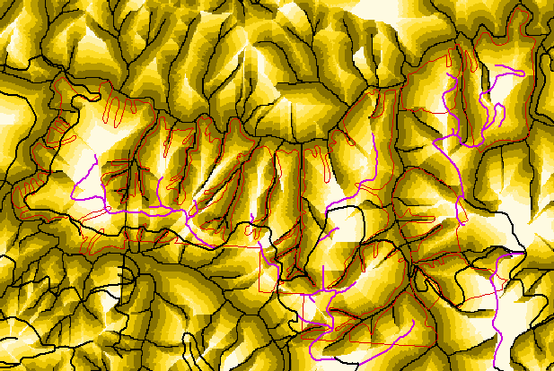
Figure 9. Lighter colors represent greater flow distance from streams. The streams are thus shown in black. UW designed roads are shown in purple. Notice that the designed roads primarily run along ridges (white areas).

Ridges don’t accumulate a lot of water due to lack of contributing area. Almost all roads are located on ridges or in regions far from streams. The P1800 parallels the river at a distance of 200 – 400’ often resulting in many smaller stream crossings. It is important to note the difference between absolute distance and flow distance. Flow distance is the distance traveled downhill to the nearest stream. Thus, flow distance may be much greater than the absolute distance to a stream, since the nearest stream may be on the opposite side of a ridge.

4.4.2 Predicted Road Sediment
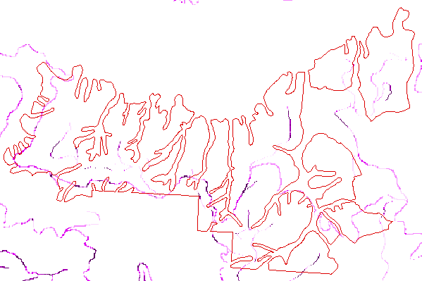
Figure 10. Predicted sediment based on GIS analysis using road gradient, side slope, and flow accumulation. Darker colors indicate more sediment.
Sediment levels on roads are determined using parameters of flow direction, road gradient, and side slope. Each cell represents a 30’ section of topography. Ranges are between 204 and 1418 pounds of sediment per cell per year. Light colors represent light sediment and dark colors heavy sediment. The P1800 is heavy in sediment due to slope, proximity to stream, and unstable areas. New roads are light representing low sediment. Sediment estimates are cross-checked with values of other sediment models such as WEPP and X-Drain. Sediment values are comparable between all models used.

4.4.3 Cross Drain Spacing and Design

Cross Drain Spacing is performed to the Forest Practices Board Manual specifications and Washington Administrative Code (WAC) 222. A spreadsheet supplied by the DNR took into account road slope, side slope, distance to stream, road surface precipitation, and soil as prescribed in the board manual. Maximum spacings were modified based on these variables to provide a final spacing. Size was established from WAC 222-24-040. Culvert Designs likewise came from the WAC as WAC 220-110-070 and WAC 222-24. In addition, the United States Geological Survey Method of culvert sizing was used to determine sizing.

The watershed areas that supplied culvert locations were determined so that areas of contributing area could relate culvert size. Possible sites were found through field note locations, contour maps, and GIS layers. In this way we could double check our field prescribed sizes to make sure the proper sizing was implemented. Areas surrounding culvert sites were given through watershed functions in ArcView. Areas that fit into the ranges of 10 to 18 acres might use an 18” corrugated metal culvert pipe (c.m. pipe). An area of 60 or more acres uses a 36” c.m. pipe. Our field suggested sizes fell in line with the prescribed size.

4.4.4 Culvert and Sediment Relationships
Culvert and cross drain spacing on the existing P1800 is averaged to 250’. This is due to the location where steep surrounding slopes, instability, close proximity to stream, and the existing road aid in possible sediment transfer. New roads are spaced at an average of 460’ because of larger culvert use, ridgeline runs, no sliver fills, proper mass hauling, long buffering distance from streams and avoidance of unstable areas. The use of geotextiles may prove to save roads from producing sediment as well due to the extended strength of the road and improved performance of ballast. Soil protected from water and mechanical destruction by a solid rock layer can further filter sediment and remain in place.

Wherever possible, new culverts were placed at breaks in topography to reduce the most energy developed in flow. Flumes and riprap are prescribed to prevent the soil around culverts from being penetrated and washed away. The angle of exit corresponds to the existing flow direction and grade. Exit diameters correspond to largest evidence of bank flow width (not existing stream trickle from field observations). This size also takes into account the amount of LWD upstream that can clog the culvert. Culverts are covered with a minimum 1’ of fill. Almost all existing culverts on the P1800 are undersized and will need to be replaced or flumed.

4.4.5 WEPP and X-DRAIN

WEPP and X-DRAIN are two sediment calculation programs. The importance of these programs is in identifying segments of heavy sediment. This knowledge allows us to redesign high sediment road segments by reducing cuts and fills, taking a gentler grade, or perhaps using shorter culvert spacing. It may also indicate key locations to close when the road is no longer needed.
The main difference between them is that X-DRAIN calculates the amount of sediment that will reach the stream, while WEPP simply calculates how much sediment is created by each road segment. It does not take into account the filtering process that occurs as sediment travels down a hillside.

WEPP uses variables of climate, ditch type, soil, side slope, and road parameters to determine sediment on a segment basis. Similar variables are grouped to analyze similar portions of road. WEPP can give a background estimate of existing roads. WEPP also details how roads will generate sediment and which segments are heavy producers. However, some roads may produce a lot of sediment but may deliver very little to the stream because of location. This must be taken into account when using WEPP data.

X-DRAIN uses soil, climate, buffer slope, and buffer distance to determine sediment. Based on culvert installation, X-Drain can tell how much sediment gets past the buffer to the stream.

Another thing to keep in mind when using these programs is that it is important to analyze roads on a network basis rather than a segment basis. Sometimes a high sediment portion of a road is unavoidable due to topography, alignment, or stability constraints but may remain a vital segment of a road network that is not a heavy sediment producer. For example, Kodiak is a vital link to southern timber but is the largest new road sediment producer on a segment by segment basis. However, when the entire Kodiak system is looked at, none of the other roads create any new sediment to the stream. As a network, the Kodiak System is not a major producer.

You can see how roads compare to each other in Table 4 below. The first column shows background sediment in Tons/STA/Year. The second column indicates the predicted amount of sediment delivered to streams with traffic. The third column is the change from background (i.e. 2X is twice as much sediment, 6X is six times as much).

Table 4. Comparison of predicted sediment on roads in the Big Country Timber Sale.
Tons/ STA/Year | NO | TRAFFIC
 | TRAFFIC | TO STREAM | BACKGROUND
 | SEDIMENT | Predicted | CHANGE
COPE BLACK | 0.37 | 0.7 | 2X
COPE STRAIGHT | 0.33 | 1.47 | 4X
KODIAK | 0.33 | 2 | 6X
KODIAK 14 | 0.33 | NONE | 0X
KODIAK 21 | 0.33 | NONE | 0X
KODIAK 31 | 0.33 | NONE | 0X
KODIAK ICE | NONE | NONE | 0X
PRIVATE | 0.33 | 1.38 | 4X
P1800 | 0.86 | 1.73 | 2X
SKOAL | 0.33 | 1 | 3X
SOUTH RECON | NONE | NONE | 0X
TIMBERWOLF | 0.33 | 0.4 | 1X
WEST ROOSTER | 0.33 | 0.9 | 3X

4.5 References

Forest Practices Board Manual March 2000
Physical Hydrology by Lawrence Dingman p 259
Roads Handbook October 2000
HCP Sept. 97
Washington Administrative Code 222 to 224
United States Geological Survey
Forest Practices

5 Silviculture

5.1 Goals & Objectives
The Big Country Timber Sale was designed as a pilot project to test the feasibility of integrating production and conservation across the landscape. This is stated in the HCP as a primary objective of the OESF (DNR HCP, IV.81). Because the DNR is currently in the Restoration Phase of the HCP, silvicultural treatments were designed to promote late-successional forest structure. Four silvicultural treatments were tested: 1) Uniform Thin from below to RD 45-50 or no greater than 40% change from original RD, 2) Variable Density Thin at a fine scale, 3) Variable Density Thin at a coarse scale, and 4) Control (No action). The first two treatments were based on DNR Procedures. The third treatment was proposed by Richard Bigley as a more operationally feasible alternative to variable density thinning at a fine scale.

5.2 Thinning Criteria
A preliminary analysis of proposed silvicultural prescriptions was done for each stand (based on FIU polygons and associated Forest Resource Inventory Summary (FRIS) data) in the Big Country Timber Sale and surrounding Clallam Block region. The Forest Vegetation Simulator (FVS) growth model was used to project data to the current year and project the original and treated stands to a future point in time. Calibration of FVS through the use of keyfiles was required to more closely simulate growth to local site conditions.
After projecting each stand from the inventory base year (1992) to present, each silvicultural prescription was modeled in the Landscape Management System (LMS). The proposed treatments were specified in DNR Procedure 14-006-080. The treatments were: No action; Uniform thin to a relative density (RD) of 40 or no greater than 40% change from original RD; Heavy and light variable density thinnings where, for every 10 acres, 1 acre is treated to 0 trees per acre (gap), 1 acre of no touch (skip), 3 acres thinned to 23 to 33 RD, and 5 acres thinned to 33 to 45 RD; Heavy and light variable density thinnings with corresponding ratios of 1:1:4:4; and a regeneration cut. All thinnings were from below, removing the smallest trees. Because FVS is a spatially independent growth model that cannot support spatially explicit variable density thinnings, output values were estimated for these treatments by modeling each stand to a single density, then calculating a weighted average (based on the 10 acre target) of the skip, gap, and two thins.
Outputs obtained from LMS for each stand for each prescription were harvest volumes in board feet per acre, average tree size of the harvested trees, average log size for both 16 and 32 foot log lengths from the harvested trees, and the quadratic mean diameter (QMD) of tail trees. All volumes reported were scribner board foot volumes to a 4-inch top. Assumptions used for the log calculations included a 4 inch small end diameter, 1 foot stump height, and 6 inches of trim. QMD’s (based on trees per acre) was then used to determine the QMD for the stand. Summary statistics (average, standard deviation, maximum, minimum, median) were also calculated on each output to determine outputs for the entire sale area.

The resultant data was used as inputs for various engineering and marketing analyses. Summarized results are shown in the table below.
Table 5. A summary of stand data for the planning area. The values were found by taking the average of all the Research Inventory Units (RIU’s) and applying the various prescriptions to them. All Volumes are in Scribner bd ft to a 4” top.
 | Ave Harvest Vol/Acre (MBF) | Ave Tree Size (bd ft) | Ave Log Size (bd ft) | Tail Tree Sizes (QMD Average)
Uniform Thin | 10.6 | 77 | 69 | 20.4
Light Thin | 17.4 | 95 | 76 | 20.4
Heavy Thin | 23.6 | 114 | 88 | 20.4
Regeneration Cut | 38.0 | 163 | 117 | 20.4

Further modeling could be done to analyize the effect of each silvicultural treatment on desired objectives through time. By defining any objective based on inventory-level measurable criteria, original, treated, and projected inventory can be analyzed to determine how many acres on the landscape meet each objective. Understanding the limitations of the models used is important. FVS is a spatially independent growth model, and cannot model many of the characteristics of a spatially explicit operation like variable density thinning.

5.3 Current Conditions
All stands in the planning area have a primary age of approximately 70 years old. The primary species in the area is western hemlock. Other species present include Douglas fir, red alder, western red cedar, and sitka spruce.

5.4 Turn Weights
Turn weights were calculated using the average log size (32 ft log) and tree length, an average density of 10.9 lbs/bf, and 3.5 logs per turn for cable yarding.

5.5 Tail Trees
Tail trees sizes were based on the largest trees at a 30 by 30 foot spacing (50 trees per acre) including douglas-fir (DF), western hemlock, red cedar, and sitka spruce. The QMD of DF was determined separately from all other species. The QMD for other species was reduced by 2” to account for reduced strength properties compared to DF. The weighted average of DF and other species for all FIU’s in the planning area was found to be 20.4”.

6 Roads

6.1 Design Inputs
In order to begin the design process, we needed to collect data. This is discussed in detail in Chapter 3. However, a few items are extremely relevant to the road design. Those items are listed below:

- Bill Traub’s road and setting design
- 10-meter DEM
- 1”: 400’ contour map
We were provided with an initial design performed by Bill Traub. This design included a complete road system, setting design, and PLANS analysis. Traub’s design covered a much larger area and was less detailed than ours.

We were provided with a 10-meter DEM. This did not provide us with enough resolution to perform the detailed analysis that we desired to perform. In order to have an adequate model of the terrain, we used a 1”: 400’ paper contour map. We printed our other coverages on transparent Mylar paper and overlaid them on top of the paper contour map.

From these maps, potential landings were identified on flat areas on the ridges (See Section 7.0). The next step in the design process was to design roads, on paper, to connect these landings to existing roads and to each other in a logical fashion. This process is called "pegging in" the roads. A divider was used to determine the desired grade and peg the road in between the control points, landings and existing roads. The guidelines used for this process are outlined below.

One important aspect of our design is the redundancy of some of the designed roads. Looking at the preliminary design in Figure 11, it is clear that there are more roads than necessary. This allows the flexibility to choose the best route from a range of options while in the field.

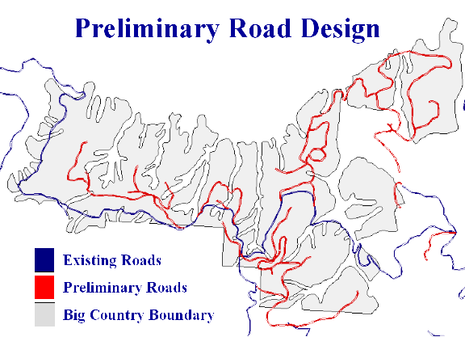
Figure 11. The preliminary road design crosses few streams by staying on ridges. After the best road locations are selected from the options shown here, the final road design will cross even fewer streams.

6.1.1 Side Slope Considerations
We developed a map coverage of side slopes and used this in the preliminary road design process. Whenever possible we tried to avoid pegging a road across a potentially unstable slope. The HCP states that all roads constructed on side slopes in excess of 40% must be designed with a full bench road prism. On roads with side slopes between 40%-55% a full bench road prism is required, but the excess material can be sidecast and compacted. Any road that is constructed on side slopes over 55% must have a full bench road prism and any excess material endhauled to a suitable disposal site.

On all roads constructed on side slopes of less than 40% a balanced cut/fill road prism may be used.

6.1.2 Road Grade and Alignment
Favorable road grades are defined as the downhill travel of a loaded log truck. Truck performance, safety, and DNR road standards limit the favorable grade to 18%.

Adverse road grades are defined as the uphill travel of a loaded log truck. Truck performance and DNR road standards limit the adverse road grade to 18%. There were some grades run at 18% to catch ridges or to stay on ridges. By doing this most wet areas and streams were avoided. We felt it would be better to sacrifice grade for location. The minimum curve radius used in the preliminary design of horizontal curves was 60 feet.

6.1.3 Stream Crossing
Recall from Figure 11 that we avoided stream crossings whenever possible by keeping the roads on the ridges. Most of the streams are located in incised channels that run north-south through the planning area. As you can see, most of our preliminary design avoids these areas. Our final design will cross even fewer streams.

6.2 Field Reconnaissance
Our fieldwork consisted of 4 weeks on the Olympic peninsula. During this time we set grade line, set P-line, traversed all of our designed roads, and ran corridor profiles. The data we gathered was then taken to the office and used to create the final design.

6.2.1 Processes
While performing field reconnaissance, when possible, the design team would follow the paper plans. The first step in locating the planned roads is to establish a grade line using orange flagging. Usually the grade line followed the paper plan very closely, however, there were areas where the paper plans needed to be modified in the field. These modifications were due to the need to avoid a problem area, due to changes in the desired ending point or due to the elimination of landing locations. For these areas, the design team would go ahead to the desired ending point, and then worked backward to miss the problem area until the flag lines met. The second step is to set a P-line with stakes. The last step is to perform an accurate road traverse of the P-line including distance, slope and side slopes.

6.2.2 Equipment
We used 3 different methods of traversing. The most basic was with a staff compass and chain. This was more tedious than other methods but provided consistent and accurate results. The method most familiar to this class was to use a Criterion impulse laser. This allows for multiple types of readings to be taken at one time and for them to be digitally recorded. The newest method to this class was using a LaserTech impulse laser, MapStar digital compass, and a Hewlet Packard data recorder. This method is fully automated and records all data that is needed for a traverse. Since this was a new instrument to the class several hours were spent learning how to operate the machine. Refer to the FE Handbook (http://courses.washington.edu/fe450) for detailed instruction on the operation of these instruments.

6.3 Field Reconnaissance Prioritization
Due to only a four week period in the field, time spent on road systems had to be allocated in such a way that areas of top priority were looked at first. We spent the majority of our time focusing on roads. Richard Bigley, in charge of DNR research and monitoring, identified this area for his research project. We prioritized the roads into 2 categories, primary roads and secondary roads.
During the three weeks of preliminary office work, primary roads were designed to access large areas within the timber sale. These roads were given top priority during the field reconnaissance since the road network was highly dependent upon the construction of these roads.
Some spur roads were pegged in on the maps in the office but were omitted from the gradelining and traversing done while in the field. These roads were given a low priority due to time constraints.

6.5 Overview of Final Road System

Our final road design reflects changes that were made after verifying our design in the field. This was created after visually analyzing road locations in the field and going through a RoadEng computer analysis in the office. Notice in Figure 12 that the final design is broken into five systems.

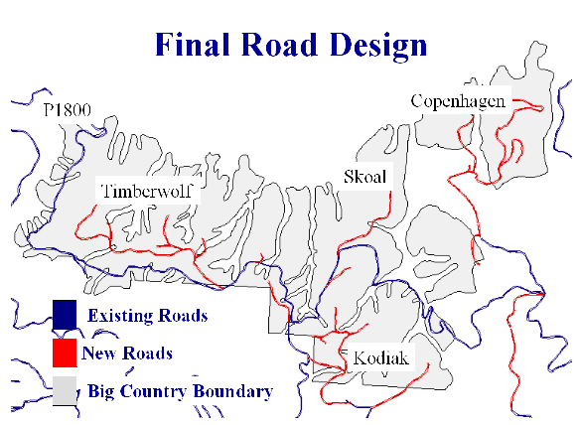
Figure 12. The final road system is broken into 5 groups. As noted previously, these roads cross very few streams.

6.5.1 Road Statistics

Listed below are some summary statistics for the road design. The majority of roads that we designed were close to $2000 per station. However, there is one road that costs closer to $3000 per station. This is due to an extremely large amount of cut that has to be dealt with on a mainline road.

- Total designed road length: 11.8 mi
- New road length: 7.1 mi
- Reconstruction length: 4.7
- Cost per station: $1700 - $3000
- Access area: 1108 acres

We divided our road system into 5 groups. The group outlined in blue in Table 6 is existing road and our analysis accounts for its reconstruction. The rest of the roads are new roads.

Table 6. Grade and length statistics. Ideally the road grade would not exceed 15% however the best design for some roads required that the grade be increased up to 20%.
Group | Road | Grade Range % | Length (sta) | Cost ($)
P1800 | P1800 | 0 – 15 | 329+50 | 639,502
P1800 | South Road | 0 – 5 | 8+68 | 20,885
Kodiak | Private | 0 -20 | 37+90 | 148,933
Kodiak | Kodiak | 0 - 16 | 41+50 | 86,478
Kodiak | Kodiak Ice | 1 - 17 | 9+45 | 17,623
Skoal | Skoal | 0 -17 | 36+60 | 79,552
Timberwolf | Timberwolf | 0 -16 | 69+10 | 208,880
Timberwolf | West Rooster | 1 - 16 | 4+65 | 9,045
Copenhagen | Copenhagen Black | 4 - 18 | 25+26 | 50,547
Copenhagen | Copenhagen | 0 -15 | 71+99 | 164,217
 |  | Total | 63468 | 1,426,662

Ideally the maximum grade on any road would not exceed 15%. However we found that the best design sometimes required a grade up to 20%. Table 1 shows a breakdown of the road lengths and grade ranges.

6.5.3 Preliminary vs. Final Comparison
As you can see by comparing Figure 11 with Figure 12, there were some significant changes between the preliminary and final road designs. Most of these can be accounted for by the selection of better locations from multiple options while in the field. In the field we noticed things that had not been noticed on the map. Our extensive preliminary design allowed enough flexibility to easily work around almost all of these trouble spots. One noted exception is Rooster Road, located almost directly in the center of the map in Figure 11 (the ‘M’ shaped road). In the field, this road was found to be infeasible with no alternative routes.

6.6 Road Design Challenges

There are four main challenges for road design in the Big Country Timber Sale. The first is the east bridge over Cougar Creek. Second is the west bridge over the Clallam River. Next is the south access. The final challenges are alignment issues. The road alignment changes on three roads, depending on which access route is chosen.

6.6.1 Big Country Road Design Specifications

Road design proceeded according to the following design criteria:

Design Vehicle: Log Truck
Critical Vehicle: Yarder

Design Speeds:
Main = 25 mph
Spur = 10 mph

Traffic Service Levels
Main = C
Spur = D

Traveled Width
Main = 12’
Spur = 10’
Slopes:
Fill Slope: 1 ½:1
Cut Slope: 1:1 => on steeper side slopes you may want to decrease to ¾:1
Ballast & Surfacing: 1 ½:1

Ballast Depth: 12”
Surfacing Depth: 12”

Curve Widening (added to inside of curve)
DNR specs:
2 feet extra --- 80 to 100 foot radius
4 feet extra --- 60 to 80 foot radius

USFS specs: go to
http://courses.washington.edu/fe346/projects/bridge_99/curvewidening/PS2.xls
and use the excel sheet to calculate the widening based on the USFS equation

Fill Widening
Based on fill height at shoulder
<6’ => 2’
>6’ => 4’

The widening for fills <6’ is flexible. As the height of fill decreases, the widening can decrease, i.e., 1’ of widening for a 3’ fill.

Turnouts: put one in about every 1000 feet. You can also put them in tight curves as part of curve widening.
50’ length
12’ width
50’ taper each side

Much of the road design for the sale is straightforward. The major roads follow ridges, with spurs as necessary. The following sections detail the major challenges faced in designing the roads for the Big Country Timber Sale.

6.6.2 East Bridge (Cougar Creek)
The main challenges at the east bridge are the area itself, fill and curve widening, and the bridge design.

East Bridge Area
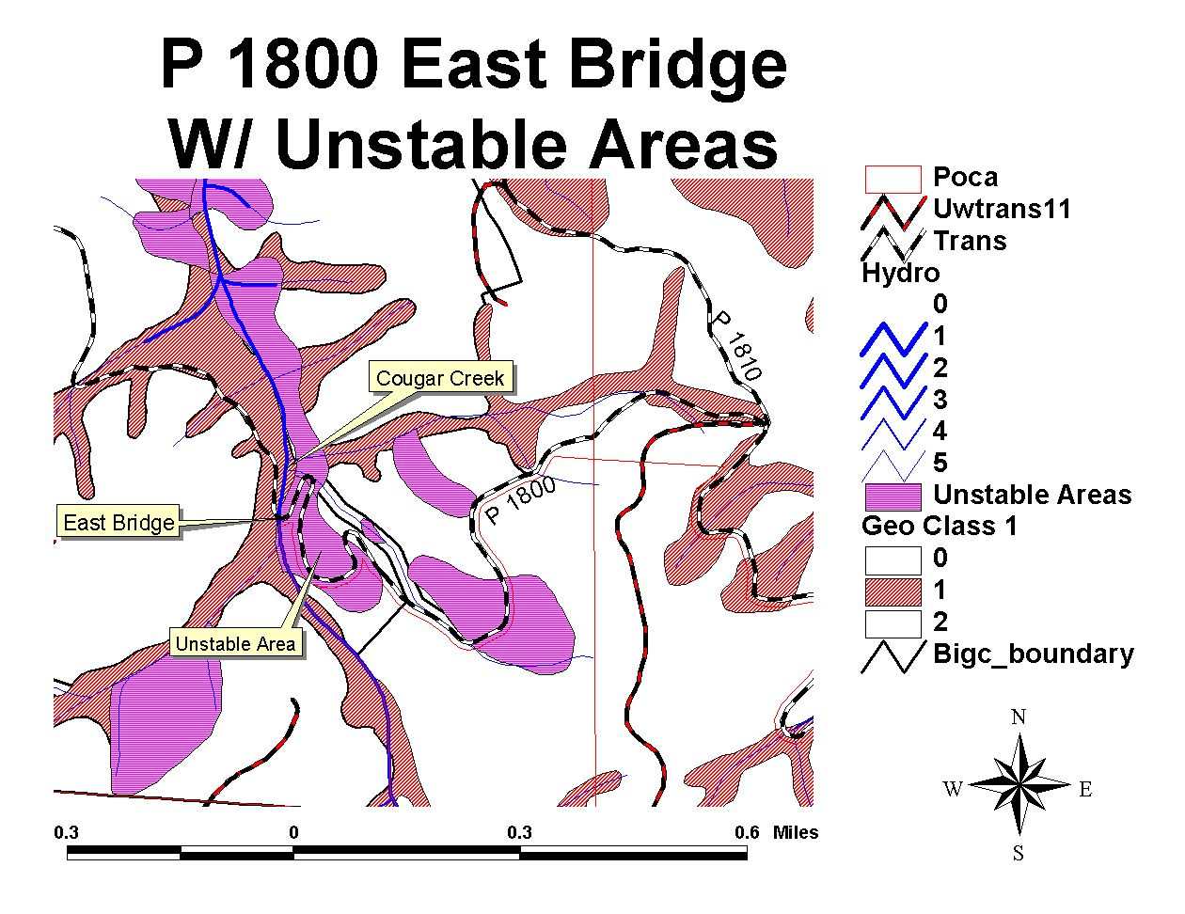
Figure 13. On the east access, the P1800 is in good condition for about five stations after the junction with the P1810, due to the Cabin Fever Sale. After five stations, the surfacing is native and the quality of the road is poor. As it approaches the bridge on Cougar Creek, it goes through two unstable areas, as seen in the figure. The existing switchback has a radius of about 15 feet, so in the design it was important to raise it to 60 feet.

The east bridge area is characterized by geologic instability, wet areas, primary vegetation of alder and salmonberry, and steep side slopes.

Areas of geologic instability are identified in Susan Shaw’s “Geo” Arc/Info coverage and those identified by Wendy Gerstel on aerial photos and through field work. The east bridge has a deep-seated landslide associated with it as one of these unstable areas.

We recommend reading Wendy Gerstel’s pending final report on slope stability analysis for her conclusions on the stability of the area and recommendations on ways to mitigate the risk of road failure.

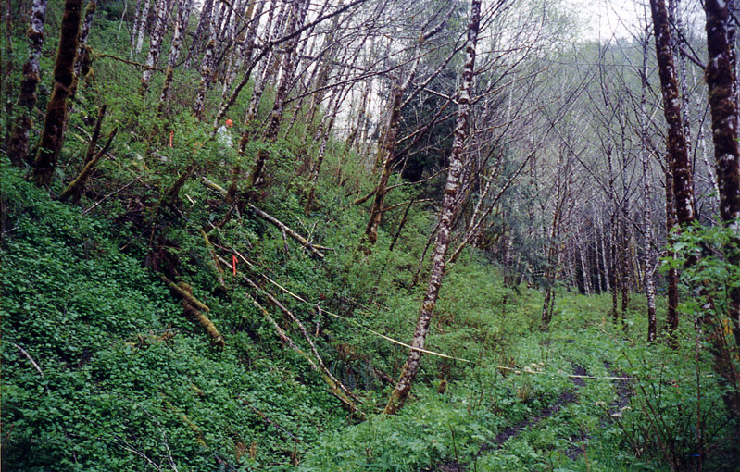
Figure 14. The approach to the Cougar Creek bridge is very steep and there are many springs in the area. Note the abundance of alder and salmonberry growing here. Full bench construction is needed going along the hillside, and a retaining method is recommended to keep the side slopes from failing. As the designed road crosses over the existing P1800, a large quantity of fill begins to accumulate.

The steep side slopes make for difficult horizontal and vertical alignment. The road has to run at 18 percent for a ways just to maintain a ten percent grade through the s-curve towards the bridge. Even so, the road ends up having a through cut in a wet spot with a small stream.

6.6.2.2 Widening
Further, due to the alignment, a large quantity of fill is required in the s-curve (about 18 feet maximum). This through-fill is problematic because it makes curve widening a much larger issue than on a typical self-balanced prism. On a typical self-balanced prism, a ditch can be used as part of the curve widening, which adds about 3 feet to the road width. Thus, the DNR specification of four feet of curve widening for curves having a radius between 60 and 80 feet makes sense. However, with the through fill there is no ditch of which to take advantage. This, combined with the generally unstable soils in the area, necessitates that curve and fill widening be examined closely.

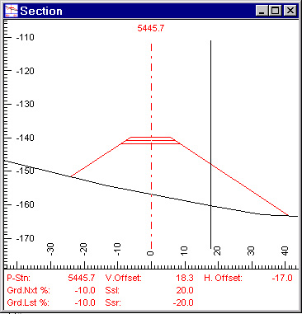
Figure 15. A cross section of the P1800 in the s-curve on the Cougar Creek bridge approach shows a fill height of 18 feet. This section comes from the point of greatest fill height. Because of the fill, four feet of widening is required basically from the start of the curve through the bridge.
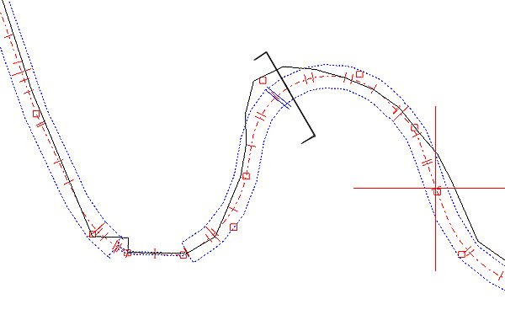
Figure 16. Plan view from RoadEng of the s-curve on the bridge approach. The black line shows the point and direction of the cross section seen in Figure 15.

Also, one of the critical parts of this area is the bridge approach. The curves have to have enough widening at the bridge and also have a straight enough approach such that a log truck can pass it. Further, the widening at the approaches directly influences the width of the bridge over Cougar Creek. With that in mind, three approaches towards widening were examined. These were the DNR specifications, the curve widening equation, and the use of the drafting vehicle simulator. The following tables illustrate the results.

Table 7. Maximum widening of P1800 through s-curve before bridge. The total width through the curve should be about 23 feet in order to allow a log truck to pass safely. The curve widening differs depending on the method used. In this case, the drafting vehicle simulator provides the greatest amount of curve widening.

Method | FW (ft) | Lane Width (ft) | CW (ft) | Total Width (ft)
DNR | 4 | 12 | 4 | 20
Curve Widening Equation | 4 | 12 | 6 | 22
Drafting Vehicle Simulator | 4 | 12 | 7 | 23

Table 8. Maximum widening of P1800 through the bridge. The total width of the bridge should be about 21 feet in order to allow a log truck to pass safely. The widening is based on the use of the drafting vehicle simulator.
Method | FW (ft) | Lane Width (ft) | CW (ft) | Total Width (ft)
DNR | 4 | 12 | 4 | 20
Curve Widening Equation | 4 | 12 | 6 | 22
Drafting Vehicle Simulator | 4 | 12 | 5 | 21

If there were no fill and hence, no fill widening, then the curve widening values would be four feet greater. For example, if there were no fill at the widest point on the s-curve, then the following results would occur:

Table 9. Results of curve widening without fill widening. Note that the total width based on DNR specs is four feet less than the other methods. However, in situations like this, there is usually a ditch available and adds to the drivable width (provided the ditch is repaired by the end of the sale).
Method | Lane Width (ft) | CW (ft) | Total Width (ft)
DNR | 12 | 4 | 16
Curve Widening Equation | 12 | 10 | 22
Drafting Vehicle Simulator | 12 | 11 | 23

6.6.3 West Bridge (Clallam River)

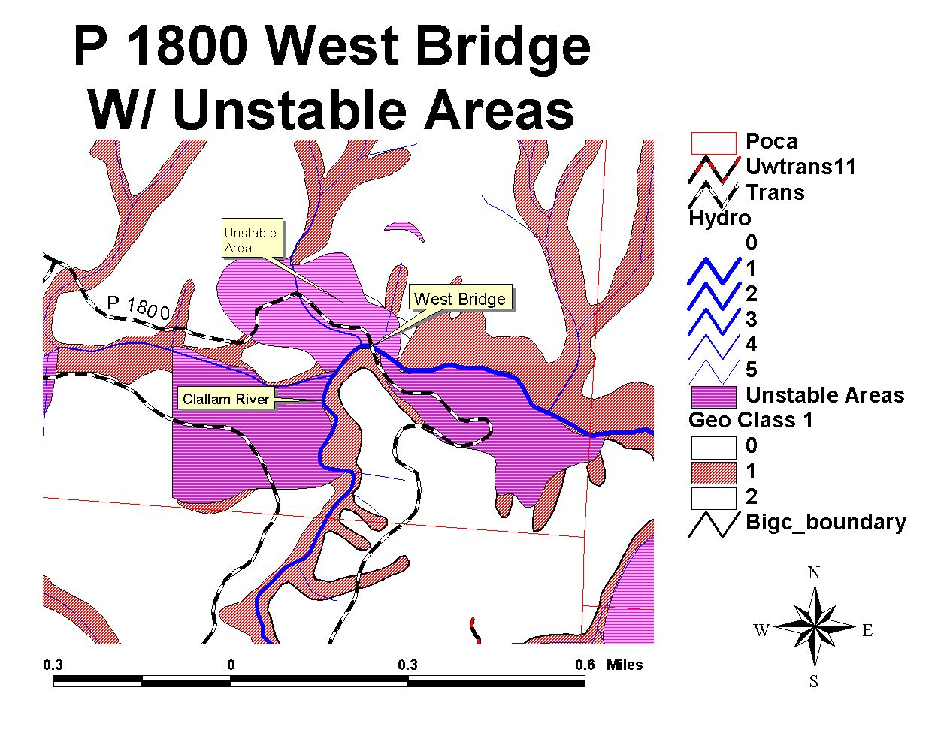
Figure 17. The P1800 at the west bridge goes through an unstable area. The road itself is host to several fill and cut slope and prism failures.

The major issues at the west bridge of the P1800 are road stability and the need to replace two major culverts. The bridge replacement itself should be fairly straightforward as a site survey was conducted in 1984. This survey was included in the project’s deliverables to DNR.

6.6.3.1 Stability
In the west bridge area, the P1800 cuts through a head scarp for about 300 feet. Other than this section of road, however, much of the road in the area is built on unstable ground. As Figure 17 shows, geologic instability in the form of shallow-rapid and deep-seated landslides dominate the area, including the bridge site. Cut and fill slope failures, slumps, steep side slopes, and several springs all characterize the area.

Because of the instability of the area and steep side slopes along the road, it would be a good idea to use some reinforcement technique to prevent the cut bank from failing. See the RoadEng cross-section printouts for more details on the cross sections.

As well, we recommend reading Wendy Gerstel’s final report (pending) on geology and slope stability for her analysis results.

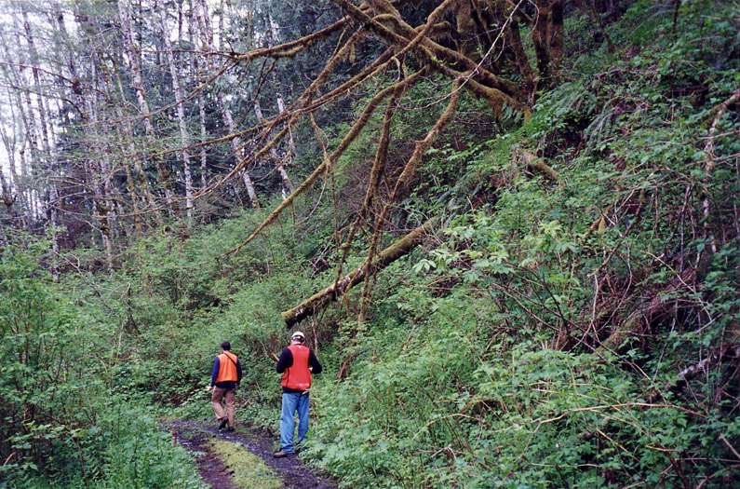
Figure 18. P1800 as it cuts through a headscarp, marked by the arrow. The location of the headscarp is the flat bench by the clump of vine maple. Note the abundance of salmonberry, alder, and elder.

6.6.3.2 Culverts
There are two major culverts west of the bridge that need to be replaced. Both are on large streams that empty into the Clallam River.

The one closest to the bridge is currently 72 inches in diameter and is a candidate for an open bottom or arch culvert. The other is 60 inches in diameter.
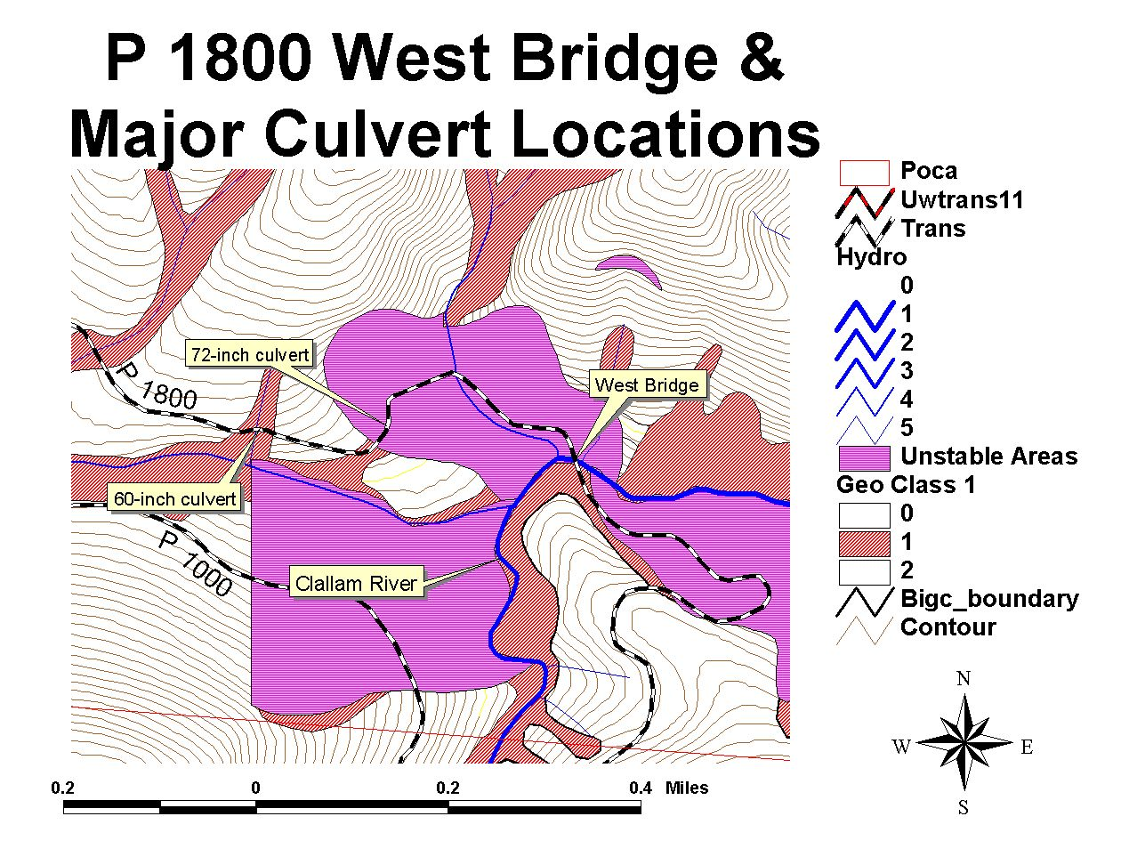
Figure 19. There are two major culverts that need to be replaced on the P1800 towards the P1000. The closer one to the bridge is 72 inches and could be changed to an open bottom culvert or arch pipe. The other is a 60-inch culvert. Both are located on large streams.

6.6.3.3 Site Survey

A bridge site survey was conducted at the west bridge in 1984. We entered the survey notes into a software package from TDS called Foresight to put them into electronic form. These files are included on the project CD in the transportation section.

In 1987, a geotechnical survey was conducted at the bridge site. The report provides extensive geologic notes for the bridge area, as well as recommendations on excavation and footings.

During the fieldwork phase of the project, we also reestablished some of the benchmarks at the bridge.

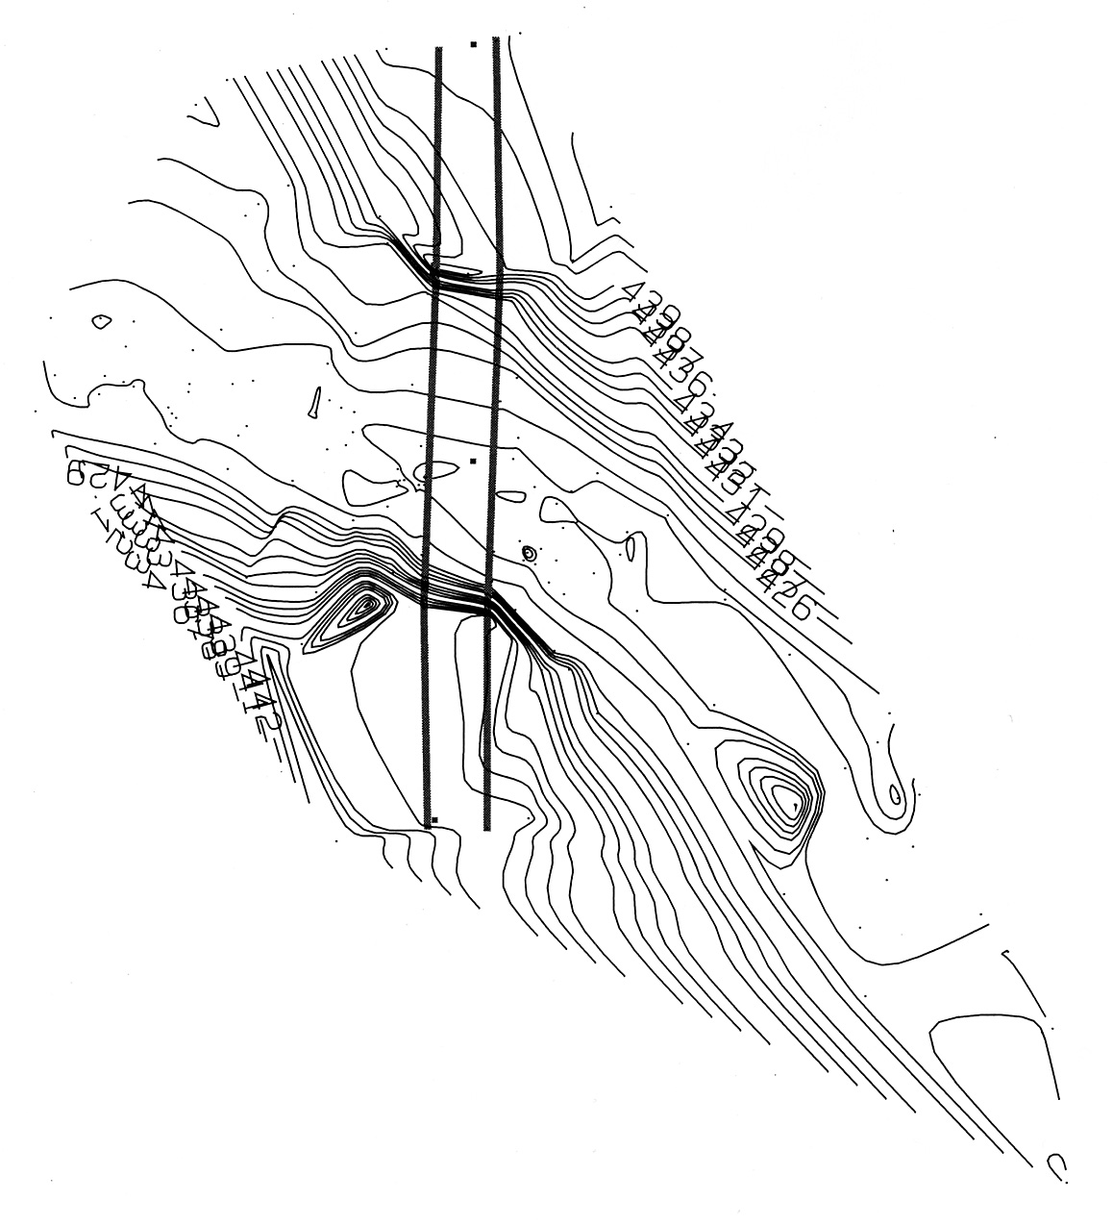
Figure 20. Site survey of west bridge. The survey was conducted in 1984 and the notes were entered into Foresight this year to put them into electronic form. Bridge design should be fairly straightforward here.

6.6.4 South Access

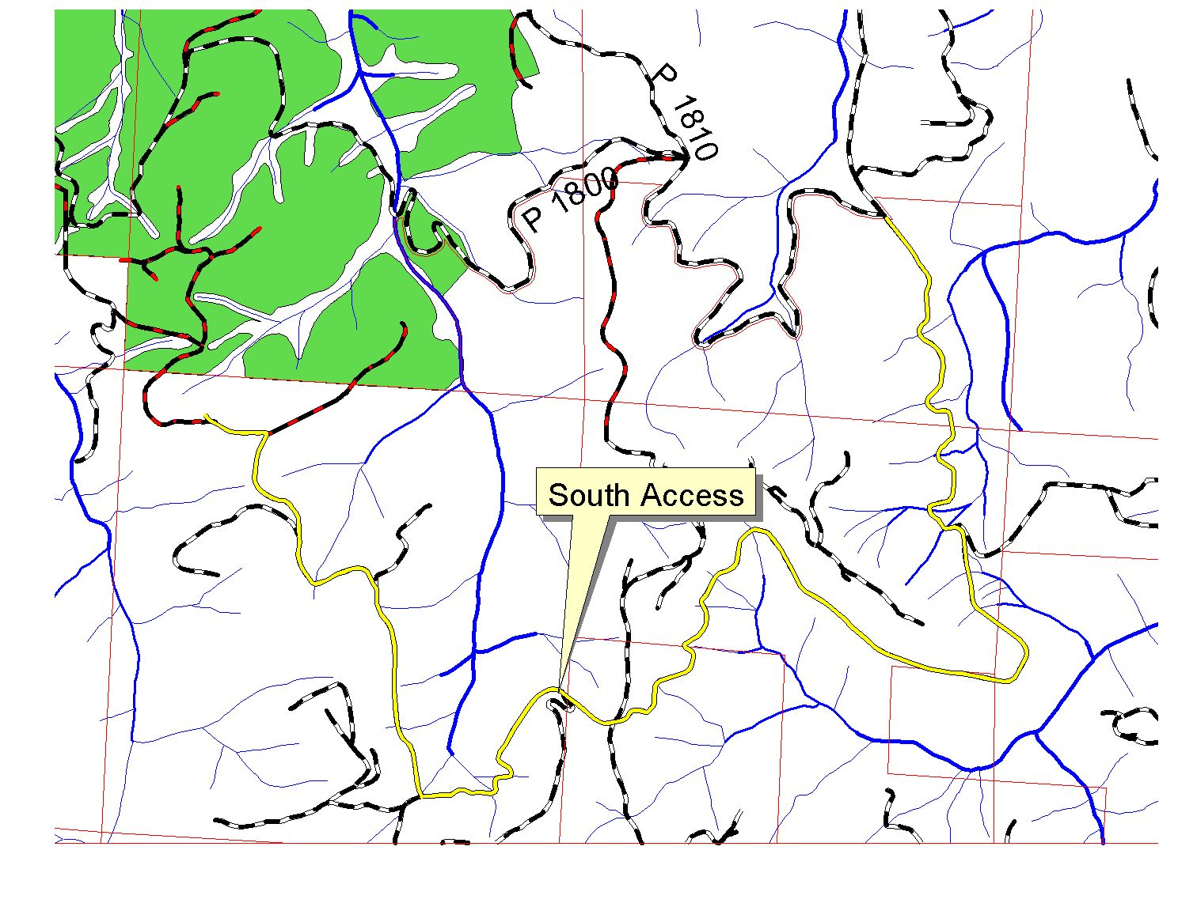
Figure 21. The south access comes off the P2100 road and is on private land. It needs a great deal of work to bring it to Forest Practice standards, most notably improving drainage and some realignment.

The south access eliminates the need for bridgework for this timber sale and also allows us to avoid building through unstable areas. However, it will need a substantial amount of work in order to meet Forest Practice standards. It needs realignment in at least one location in order to deal with sloughing of the cut and fill slopes. This will result in a large amount of excavation to deal with the steep cut slopes. It also needs about 19 new culverts, and 17 of the existing culverts need to be upgraded to larger diameters.

Given the road’s current location and condition, it represents a need for continuous maintenance, as well as a required easement. However, there may be a better option.

6.6.5 Southeast Access
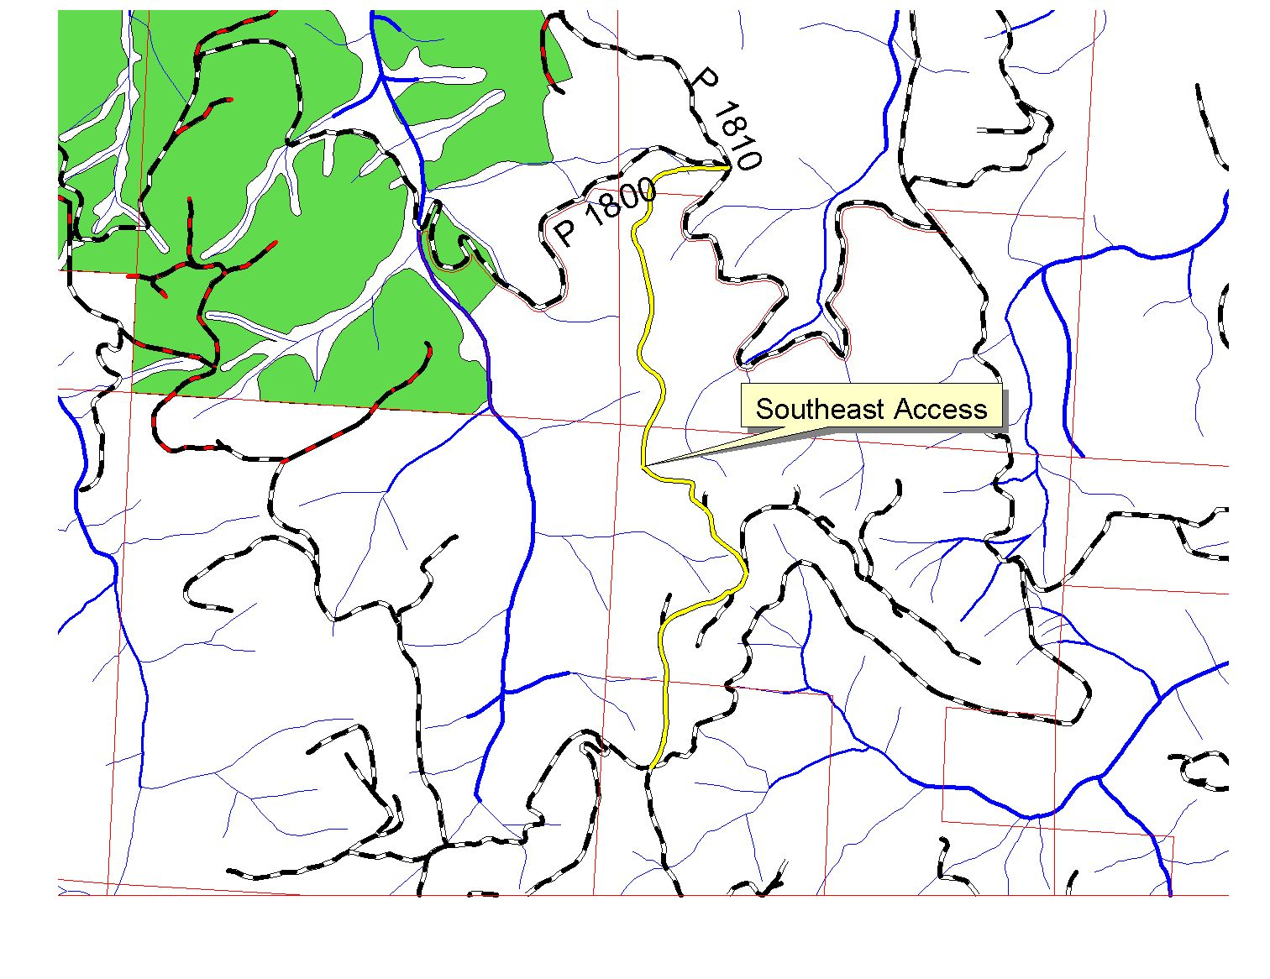
Figure 22. The Southeast Access provides a bypass for much of the South Access. This may reduce the amount of easement needed, and provides for a road in a better location than the South Access.

In the Clallam Landscape Plan, Bill Traub designed several roads through the Big Country Timber Sale. Most of our roads closely follow his designs, and one of these is a road that will bypass much of the South Access. We flagged in this bypass road, but it still needs to be traversed. The advantage of this road is that it is located on a ridge for its length, reduces the amount of work the south access alone represents, and has the potential to decrease the amount of easement required over the Crown land.

6.6.6 Alignment

Some adjustment of road alignment will have to be done depending on what access route is chosen. The east access affects the alignment of Skoal and Kodiak Ice. The west access affects only Timber Wolf.

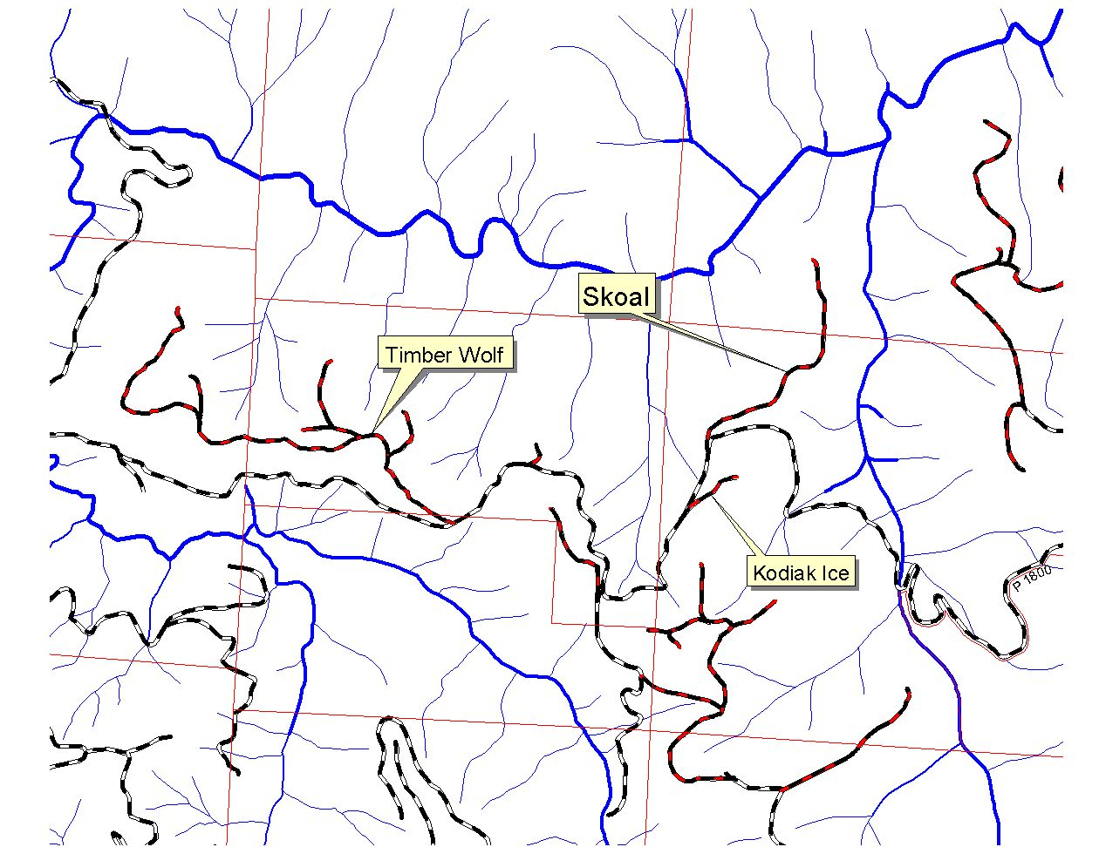
Figure 23. Depending upon which access route is chosen, the takeoffs for Skoal, Timber Wolf, and Kodiak Ice may have to be adjusted.

6.6.6.1 East Access
Skoal takes off east from the P1800 as currently designed. Coming from the east, however, necessitates that Skoal’s takeoff be changed to head NNW. There is a gradeline flagged in along this direction and is ready to be traversed. However, this area is problematic because the slopes coming off the P1800 here are very steep (60-70%). Thus, it is difficult to get the needed grade separation to get away from the mainline quickly or at a grade less than 15%.

The access to the landing at the end of Kodiak Ice will have to be changed as well. Its current design comes off the P1800, but the only other way to the landing is off one of the Kodiak spurs. There is a gradeline that was flagged in from Kodiak as far as the saddle before the landing, but was taken out of consideration early in the fieldwork. The current design was deemed more practical.

6.6.6.2 West Access
If the west access is chosen, only Timber Wolf has to have its alignment changed. In its current design, the road is set up for an east access. To come from the west requires that a switchback be added to the beginning of Timber Wolf. Adding in a switchback brings the road back to what Bill Traub had originally planned for it.

6.6.6.3 South Access
All of the roads were designed for a south access, so no alignment changes are necessary.

6.7 Access Analysis

6.7.1 Introduction
The purpose of the access analysis was to evaluate 5 possible access routes by comparing the roads as they lead from the centroid of the planning area to a common point. The common point to compare all the routes was the Main gate to the P1800 just off Highway 112. This makes it possible to compare the 5 access routes objectively because all the routes start at the same point and end at the same point. From this, the distances were extracted and broken into speed zones in order to calculate the haul time out of the project area. In addition to haul time and subsequently haul cost, major direct costs of rebuilding the access routes were considered. The result is the total cost attributed to hauling 18200 MBF to the end point of the comparison while factoring in the costs to adequately reconstruct each access road up to the planning area boundary. By evaluating the costs from two fixed points the best route can be determined as the access with the lowest overall cost. This method should also be used in conjunction with other known design intangibles to make a precise access choice. Figure 24 is a conceptual representation of the planning area and access routes.

South
Bloedel
Southeast
West
West Bridge

East
Cougar Bridge
Northeast
P1000

P1800
Main Gate at Hwy 112
Crown

XXXX
Gate
Planning Boundary for Big Country Timber Sale
East

Figure 24. Conceptual representation of the planning area and access alternatives.

6.7.2 Haul Cost and Reconditioning for each Alternative Access

6.7.2.1 Haul Cost
To calculate the haul cost between the two common points, the haul time for the duration of the project had to be determined. The first step was to isolate and extract the total distances of each route from the transportation GIS layer with ArcView 3.2 software. These access distances were then crosschecked on the maps we had of the area. The next step was to identify the speed a logging truck would be traveling at different locations along the access until the truck reached Highway 112. The first pass was conducted in the office by utilizing aerial photos, GIS orthophotos, GIS transportation layers, the GIS DEM of the area as well as existing maps. The aerial photos and orthophotos were used to look at the surrounding condition and alignment of each access. The DEM was then utilized to extract basic grades. Segments were then classified into speed zones using the basic grades, alignment and condition of the roads. These speed zones are described in Table 10.

Table 10. Speed zone classifications for haul time calculations. Classifications were based on road grade and alignment.
Speed Zones |  | Description
12 mph (poor) | Draws and Switchbacks, More difficult grades
18 mph (moderate) | Better Alignment, still difficult grades
25 mph (mainline) | Mainline roads better grades and alignment
40 mph | Paved mainline
50 mph | Paved Highway

Once the speed zone distances are found and allocated the haul time can be calculated. Using distance equals rate multiplied by time, each speed zone time was determined then summed for the total time out to the main gate. A total haul cost could be projected by taking into account round trips, amount of volume being extracted, a logging truck payload of 4 MBF, and a truck rate of $60/hr. See Table 11 for results of haul costing to the mill.
Table 11. Haul Costing for each access to the Mill
HAUL Variables | UNITS | East | West | NE* | South* | SE
12 | mph Zone (miles) | 5.54 | 5.47 | 4.06 | 4.82 | 4.43
18 | mph Zone (miles) | 0.4 | 0.7 | 0.95 | 2.35 | 2.34
25 | mph Zone (miles) | 0 | 4.48 | 0 | 0 | 0
40 | mph Zone (miles) | 0 | 3.25 | 0 | 0 | 0
50 | mph Zone (miles) | 17.7 | 17.7 | 17.7 | 17.7 | 17.7
Total Distance | miles | 23.64 | 31.6 | 22.71 | 24.87 | 24.47
Total Time to get out | minutes | 50 | 67 | 45 | 53 | 51
ROUND TRIP | minutes | 101 | 133 | 89 | 106 | 102
Total Haul Time For Project | minutes | 457487 | 605608 | 406831 | 483877 | 465829
Total Haul Cost | $ | $457,487 | $605,608 | $406,831 | $483,877 | $465,829

6.7.2.2 Reconditioning Costs for Each Access
The reconditioning costs for the access roads considered extraneous costs particular to each access such as reconstruction, new construction, abandonment, maintenance, easements and bridges. Cost per station estimates were obtained through Bill Traub who provided the Western Washington Costing Estimates for Comparing Construction, Maintenance, and Abandonment, which classifies the estimates $/station as high, medium or low. The classifications were defined by gradient combined with sideslope classes. This includes abandonment and bridges inside of the planning area where applicable. All maintenance 1-year totals were multiplied by 5 to represent a 5-year road life. All abandonment cost scenarios are derived from portions of the P1800 that do not have to be reconstructed, but do incur the cost to close (See P1800 Scenarios for locations). Bridge costs were obtained through Eric Carlsen.

- EAST – The east access has a 55 foot bridge span estimated at the highest range possible at $3000 per foot yielding $165,000 due to design issues for the Cougar Creek bridge approach. The East bridge area consists of 85 stations, all of which were allocated the largest maintenance rate at $37 per station. The rest of the east access received a medium classification of $18 per station. The reconstruction for the East access is minimal because the P1800 has the costs for reconstructing the Cougar Creek bridge.
- WEST – The west access has a 100 foot bridge span estimated at the average range of $2500 per foot yielding $250,000 bridge total. An extra $20,000 was allocated to the bridge cell because of the need for a 6-foot diameter culvert to cross another stream. All maintenance for the west approach was given a medium classification leading to the planning boundary. No major reconstruction is needed for the access (West Bridge costs are reflected in the P1800 scenarios).
- SOUTH – The south access does not necessitate a bridge but the south access is owned by two private owners and does require an easement purchase. The easement is based on approximately 950 attributing acres. An estimated $125,000 for an easement was determined through consulting Aaron Roark, an Olympic Region engineer. Through field reconnaissance, we also evaluated the level of reconstruction necessary on the south access. The south access was deemed a high classification of reconstruction at $900 per station, which totaled $240,000. Connecting the South access with the P1800 would take some new construction, but this is evaluated in the P1800 scenario.
- SOUTHEAST – The southeast access is very similar to the south access. It differs by an addition of about 85 stations of new road on easy ground. At $1850 per station the new segment of road would cost about $128,000, in addition to necessary reconstruction totaling $126,000. The southeast access also proceeds onto private land for a shorter length than the south access. The easement would total about $96,000.
- NORTHEAST – The northeast access has been ruled out upon field verification due to slope stability, terrain and proximity to multiple fish bearing streams.
The total haul and reconditioning of the access alternatives is listed below.

Table 12. Reconstruction costs for each access, including easements, maintenance, reconstruction, new construction, abandonment, and bridge costs.
RECON. COSTS | UNITS | EAST | WEST | NE | SOUTH | SE
Easement Cost | $ | $0 | $0 | $0 | $125,636 | $95,899
Maintenance Distance | miles | 4.44 | 8.65 | 5.12 | 7.17 | 6.77
Maintenance Cost x 5yrs | $ | $35,751 | $38,821 | $22,979 | $32,179 | $30,384
Reconstruction Distance | feet | 6200 | 0 | 0 | 26769.6 | 14040
Reconstruction Cost | $ | $34,100 | $0 | $0 | $240,926 | $126,360
New Construction Distance | feet | 0 | 0 | 3650 | 0 | 8400
New Construction Cost | $ | $0 | $0 | $73,000 | $0 | $128,100
Road Abandonment Distance | Moderate STA | 35 | 47 | 82 | 82 | 82
Road Abandonment Distance | Difficult STA | 24 | 26 | 26 | 26 | 26
Road Abandonment Cost | $ | $7,470 | $8,910 | $12,060 | $12,060 | $12,060
Bridge Cost (est. $2100-3000/ft) | $ | $165,000 | $270,000 | $200,000 | $0 | $0
Total Cost For ACCESS | $ | $692,338 | $914,429 | $702,809 | $882,618 | $846,572
Total $$/MBF | $ | $38.0 | $50.2 | $38.6 | $48.5 | $46.5

6.7.3 Internal Road Scenarios for the P-1800
The P-1800 is the existing mainline road inside of the Big Country Timber Sale Boundary. This road has 3 basic scenarios depending on which alternative access is chosen. The three scenarios reduce the 323 station total length of the P-1800 based on road that does not need to be reconstructed and can subsequently be abandoned because the timber sale will not justify its need. The locations and lengths are as follows.

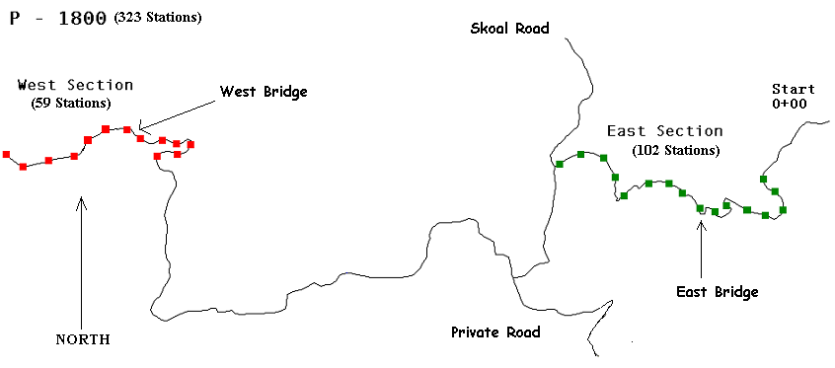
Figure 25. P-1800 Reconstruction/Abandonment Scenarios

IF WEST:
P-1800 will not necessitate the East Section reducing the P-1800 from 323 stations to 221 stations. The road would be located coming from the east to the west from stations 112+00 to 327+00. Cost for adjusted P-1800 = $499,437.

IF EAST:
P-1800 will not necessitate the West Section reducing the P-1800 from 323 stations to 264 stations. The road would be located coming from the east to the west from stations 0+00 to 264+50. Cost for adjusted P-1800 = $500,605.

IF SOUTH or SOUTHEAST:
P-1800 will not necessitate the West or East sections reducing the P-1800 from 323 stations to 162 stations. The road would be located coming from the east to the west from stations 112+00 to 264+50. Cost for adjusted P-1800 = $315,564.

6.7.4 Internal Road Costs
The final components of the total access costs are the individual costs of each proposed road stemming from but not including the P-1800. Costing out each road was achieved by gathering quantities of total surfacing, total ballast, total end haul, culverts, and clearing and grubbing square footage (achieved through RoadENG data sheets). From these quantities we priced everything out the East Access. The Ballast and Surfacing component of the cost sheet required haul through a particular direction, thus east was chosen. The total road cost is comprised of six components. The six components are Clearing and Grubbing, Excavation, Ballast and Surfacing, Culverts, Geotextiles and Overhead (Costing Spreadsheets are located on the CD in the transportation section). All the accesses have the same internal costs except the South and Southeast, which have an addition of one major realignment particular to those chosen accesses.

IF WEST:
Cost = $766,217

IF EAST:
Cost = $766,217

IF SOUTH & SOUTHEAST:
Cost = $638,227

6.7.5 Total Overall Costs per Alternative Access

The final overall road costs for each alternative access consists of hauling the timber to the mill, rebuild cost, P-1800 cost and the internal road network.
Figure 26. Total access costs for each alternative. These costs sum all of the pieces discussed in previous sections. The results show that the East, South, and Southeast are comparable.
These totals are estimates for each access. The internal road cost is the component that yields the most bias. Through time restraints it was not possible to cost each internal road particular to each access. All internal roads were cost evaluated to the east, which makes a difference in terms of surfacing haul costs. In addition, all roads were given geotextile in order to reduce the need to haul surfacing. This proves beneficial or breakeven to each access except to the east. Since the internal road network was evaluated to the east there is a $41 per station differential that should be accounted for in favor of hauling the surfacing.

IF EAST:
Cost = $1,959,218*
*There is $41 per station difference that needs to be accounted for because of the addition of geotextiles to the internal road network. Therefore, the east access needs to subtract $23,812 from the overall total to account for this discrepancy (Approx 11 miles of road). Adjusted total = $1,935,406

IF WEST:
Cost = $2,180,141

IF SOUTH:
Cost = $1,985,701

IF SOUTHEAST:
Cost = $1,949,655

6.7.6 Decision Matrix for Alternative Access

The following is a decision matrix that describes the intangibles of each access. The three main intangibles that could not be quantified in terms money are slope stability, design difficulty and Marketability. Slope Stability risk should be considered when making an access choice because of the large amounts of unstable soil and potential landslides in the area. Wendy Gerstel, DNR geologist, is finalizing the geological report of the area. Design difficulty should be considered because of alignment issues that would have to be observed for each access. Marketability is in reference to the purchaser and the sale ability for each access. The table below should serve to supplement the overall costs of each access in order to make an access decision.

Table 13. Decision Matrix for intangibles of each access. These are factors that can’t be described with an economic cost, but they are still important factors in the selection of an access route.
ACCESS | SLOPE STABILITY RISK | DESIGN DIFFICULTY | MARKETABILITY
EAST | High | High | Low
WEST | Medium | Low | Medium
SOUTH | Low | Medium | Medium - High
SOUTHEAST | Low | Medium | High

6.8 Surfacing Reduction

6.8.1 Introduction
Ballast and Surfacing is the most significant percentage of total cost to each road because of the long distance to the rock source. In an attempt to reduce the required 12 inches of surfacing to less than 12 inches we looked at introducing a geotextile that would make up the loss of structural integrity brought upon by reducing the surface material. After speaking with Brenden Reall, a representative of Contech Inc., a construction products distributor located in Port Orchard, the recommendation was to use a Tensar Earth Technologies Geogrid*. The TX1100 is a geosynthetic made from polyethylene that serves to distribute the load caused by wheel-to-road contact. Brenden Reall supplied us with SpectraPave Software version 1.2 to evaluate the subgrade for improvement. The program takes into account volume use, native base soil classification (CBR values), ballast material, surfacing material, and asphalt if necessary. The program results in a strength value. We first obtained a strength value with 12-inch shale ballast –12 inch 11/2 minus crushed surface, and a native soil CBR value of 4. With this given strength value we could now introduce the TX1100 and reduce the surfacing until we matched that strength value. Through the program, we reduced the necessary surfacing to 8 inches.
*Fabric was not considered because it does not add strength necessary to reduce surfacing to the road, it simply prolongs the road life.

6.8.2 Cost Comparison
In order to make a cost comparison we broke down the cost per station of 12 inches of surfacing and the cost per station of the TX1100 geogrid with 8 inches of surface. For a mainline there is 52 cubic yards needed per station with 12 inches of surfacing and 34 cubic yards with 8 inches. The TX1100 was quoted at 1.95 per square yard fully installed and required an additional foot on each side of the 12 foot running surface width. The results in Table 14 are tailored to each access because of varying haul distances.
Table 14. Cost comparison of using Tensar BX1100 geogrid. There is a significant savings on the west access, but there is a significant loss on the east access. The south and southeast access show only a minor difference.

6.8.3 Results
The east access is short enough that hauling the 12 inch surfacing is less costly than introducing the geogrid. The west is a good canidate for the geogrid and the south could offer some relief if other costs and intangibles are being considered as well. In the other scenarios and possibly other timber sales where haul is even longer, the Tensar TX1100 geogrid remains a viable option to reduce surfacing volumes.

7 Harvest Systems

7.1 Systems Selected
Terrain is the leading factor in deciding which systems can be used throughout the Big Country planning area. The terrain in the planning area is mostly steep and has very little area that ground based equipment can be used on. We will not be discussing ground based systems in great detail.

The choice of what system to use is dictated by site conditions. On level ground with slopes 0-30 percent, ground based systems can be used when the soil conditions are suitable. If the soil is too sensitive or the slope is greater than 30 percent, cable systems are employed. When the terrain is severely broken or there is no way to get a road to the site to facilitate yarding, helicopters are used. Ground operations are generally least expensive followed by cable systems, with helicopter logging being the most expensive.

7.1.1 Ground Systems

The terrain in the planning area limits the use of ground equipment. All the ground units in the planning area were analyzed with two high-tracked Caterpillar D5’s and a loader. The places on the sale where ground systems could be employed could also be harvested with a fellerbuncher and forwarder or any number of felling and yarding systems but for our analysis manual felling and two crawler tractors were chosen.

7.1.2 Cable Systems
Cable systems are limited less by the steep topography and more by shape of the ground. Cable systems are best suited for areas where the slopes are between 30% and 100+%. The major limiting factor is shape. A ground profile can be classified as concave, planar, or convex. The ideal ground profile is highly concave. This allows the cable system the greatest deflection, and therefore the highest payloads. The most difficult profile is highly convex. This ground shape affords little or no deflection and therefore payloads tend to be uneconomical. In the planar case, deflection can usually be found, but most times this requires rigging a tailhold tree 30-50 feet high and/or through the use of intermediate supports.

For the Big Country project, both a Madill 071 and T-Bird 6150 yarder were used for analysis. Both are medium sized yarders that are appropriate for the timber size on the sale. Additionally, Madill yarders are commonly used on the Olympic Peninsula. Since the two yarders are similar in size and capabilities, we used the 6150 to calculate production rates and stump to truck costs due to the fact that large amounts of data on this yarder had previously been entered into the USFS Region 6 log cost program by Rick Toupin, USFS logging systems specialist.

7.1.3 Helicopter Systems
The major benefit of a helicopter system is that it doesn’t need road access into the unit. This can be a huge benefit in steep, remote areas where road building is too costly or physically infeasible. It is also favorable in highly sensitive areas, such as near wetlands, because the site disturbance minimal. The major detriment to helicopter logging is that it is expensive and highly sensitive to turnweights and flight distance. As a rule of thumb, if turn time is over three minutes or if turns/hour drops below twenty it is likely that helicopter yarding will not be cost effective. For this reason the maximum external flight distance is approximately one mile. When selecting a helicopter for yarding, possible turnweights should first be estimated from stand data. Then the helicopter that has a maximum payload nearest to the turnweight should be selected. The goal is to maximize the payload for each turn. Another limiting factor for helicopter logging is the availability of adequate landings. A good helicopter landing must be at least four acres in size. This is to accommodate both the landing/decking of logs as well as the refueling of the helicopter and loading of trucks. An alternative analysis for the use of helicopter logging on the Big Country Timber Sale can be found in section 7.8.

7.2 Setting Design and Analysis Process

7.2.1 Cable Analysis
The DNR provided us with a 10-meter Digital Elevation Model (DEM). However, this DEM did not provide adequate resolution for the detail required in our design. We chose instead to use a 1”: 400’ paper contour map as a basis for our design. Using this contour map, we identified settings and created yarding corridor profiles to be analyzed on PLANS and LoggerPC.

PLANS is a computer program that analyzes multiple profiles for each setting. We used this program as a quick method of analyzing many settings. Because we did not have a detailed DEM, we were not able to use PLANS for large scale analyses of settings. Instead, we used LoggerPC, a computer program that analyzes independent profiles for yarding payloads and feasibility.

7.2.2 Cable Analysis Assumptions
The following assumptions were used in our cable analysis:
-Madill 071 Tower: 47’
-Eagle Eaglet Carriage: 1300 lbs
-Skyline: 1”
-Choker length: 15’
-Turn size: 3.5 logs
-Turn weight: 1100-6100 lbs
(Turn size and weights are defined by the RIU stand data of our silvicultural analysis. Rigging tree sizes and availability were determined by RIU stand data.)

7.2.3 LoggerPC analysis
We analyzed approximately 200 profiles for payload analysis and feasibility, as can be seen in figure 27. Of these 200 profiles we identified 8 that produced marginal results. We verified these 8 profiles in the field. Some areas do not have profiles. These areas are either suitable for ground based harvesting, or the corridors are not long enough to justify a detailed analysis. Figure 27 shows the profiles we analyzed in LoggerPC and in the field.
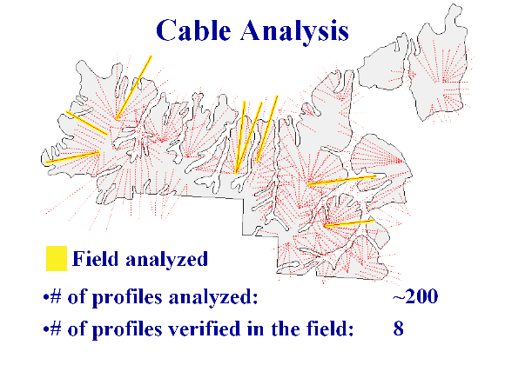
Figure 27. Red lines indicate profiles analyzed on LoggerPC. Yellow profiles indicate profiles taken in the field.

7.2.4 Choosing Payloads
Payloads were chosen based on stand data provided. Several assumptions need to be made when calculating payloads. First, how many logs will be yarded per turn? For our calculations we assumed 3.5 logs per turn for three chokers. Second, what size logs will be yarded? Will they be tree length, or a specified length? We calculated our payloads for 32’ logs. Third, what does the wood weigh? Based on scale weights from a stud mill on the peninsula the average board foot of wood weighs 10.9 pounds. Third, what is the average piece size for the logs being yarded? Our planning area was broken down into several different stands with varying average log sizes so payloads needed to be calculated for each RIU. Lastly, payloads will also differ depending on the level of cut. Regeneration harvests result in the highest payloads while light thins produce lower average log sizes and payloads. Based on all the information given above, payloads were calculated by the following formula:

3.5 logs/turn * 10.9 lbs/bdft * average # bdft/log = lbs/turn

7.2.5 Setting Layout
Now that payloads for the stands are calculated, a harvest plan needs to be designed so that these payloads can be feasibly and economically yarded. The first step is determining what logging equipment is available and appropriate for the job. If payloads are large, small equipment will not get the job done. If the payloads are small, large equipment would not be cost effective.

Once equipment is selected, specifications such as line sizes and lengths need to be determined. Tensions, and hence payload capabilities can be figured for varying line sizes. Skyline lengths and/or haulback lengths will determine the external yarding distance the yarder is capable of. A lateral step that should be taken before the setting layout progresses is determining the most efficient yarding distance. The two main costs to timber harvest are road building costs and yarding costs. As road density (and cost) increases, yarding distance (and cost) decreases. The ideal yarding distance is where the two curves intersect on a $/mbf vs. yarding distance graph. For this we used the Simyard computer program. Information about the equipment to be used and expected harvest volumes are entered and the graph is plotted. For our particular unit the most economical yarding distance was around 1,100-1,300 feet.

After the machine specifications are reviewed and yarding distances are figured, the settings are ready to be laid out. For this step, the topographic map with contour lines and the unit boundaries are needed. The ground needs to first be classified into classes of steepness. For our analysis we reclassified the ground into areas of slope 0-30%, 30-55%, and > 55%. There are two reasons for this: First, ground based harvest is possible up to roughly 30% slope and those areas should be taken advantage of since the cost is significantly less than cable yarding. Second, road building costs into areas of slope > 55% increase significantly. Once the areas that can be skidded are marked out the remaining area needs to be cable yarded. Short distances and uphill yarding are greatly preferred by loggers so emphasis should be made to design around those criteria where possible. The tower must be set up on a road or landing so when choosing landing locations road access must be considered. Landings are best located at the breaks of ridges or flat stretches of road. All areas within the unit must be able to be accessed from somewhere so spacing between profiles should not exceed the lateral yarding capability of the system being used.

7.2.6 Analysis
Once the landing locations were chosen on the map they were digitized into PLANS (Preliminary Logging Analysis) and the profiles roughly analyzed and adjusted for length. After the preliminary analysis, all the profiles were digitized into LoggerPC. The profiles were then checked against the anticipated payloads from the stand data. The procedure for analyzing the profiles in LoggerPC is detailed in Appendix 10.3.

7.3 Profile Verification
The DEM accuracy needed to be verified to ensure that the work being performed in the office was a viable alternative to walking every profile. Several of the profiles that showed marginal payloads were verified in the field. The field profiles were then compared to the DEM profiles. The DEM seemed to smooth out the more critical points of the profile, making them less noticeable.

7.3.1 Marginal Profiles
The 8 profiles highlighted in yellow in Figure 27 in section 7.2.3 are profiles that produced a marginally acceptable payload. We verified these profiles in the field by performing a profile traverse. These profiles are described below in Table 15.

Table 15. Payloads of marginal profiles
Profile | Payload (lbs) | Intermediate Supports
F1W-3 | 5000 | 0
F4E-3 | 2900 | 1
F2E-2 | 5858 | 2
F8W-3 | 5547 | 0
F2W4 | 5325 | 2
W3A | 5410 | 1

7.3.2 Profile Comparison
We performed a comparison of the map-generated profiles against the field-generated profiles. There is a discrepancy in their results. However, we feel that the map is an adequate source for our analysis because the 8 marginal profiles that we analyzed in the field all proved to be feasible. Most comparisons showed the map-generated profile to be the more conservative of the two, as seen in Figure 28.

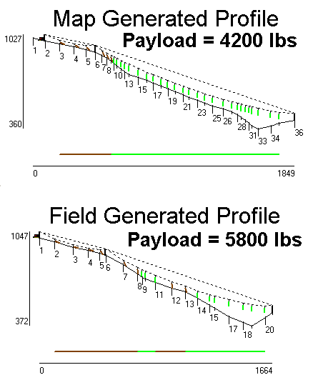
Figure 28. Comparison of field generated profiles vs. map generated profiles. Despite a discrepancy in the results, the map has proven to be an adequate source for analysis purposes.
Each profile had to meet specific requirements for this project. They had to have sufficient reach and adequate deflection with a set payload. The profiles for each setting design were checked to make sure there was adequate clearance over streams and that desired payloads were achieved. If these goals weren’t met, the profile was changed. Often, intermediate supports or rigged tailholds were required. For the longer profiles, rigging lengths were also monitored to maintain yarding distances within the capabilities of the machines used in the analysis.

The desired payload was set at 5,200 lbs to ensure that any plausible payload was achievable for the chosen system. The silvicultural data indicated that this was the maximum that could be expected for any type of harvest, thinning or regeneration, in the planning area.

7.4 Helicopter Settings
Two helicopter settings were created by dividing the planning area approximately in half, creating west and east settings. We found that helicopter logging was only cost effective if it did not require building new roads. That required that there be suitable landings on the existing roads. From the contour map and existing road coverage it was determined that the best locations for helicopter landings were on the P-1000 for the west setting and on a spur in the Cabin Fever Sale for the east setting. The program we used for analyzing helicopter logging, Helipace, calculated flight distance from the landing to the centroid of the harvest area. By estimating the centroids on the map and measuring the distance to the selected landing location, we found that both settings had flight distances around one mile. This distance is usually considered marginal at best.

7.5 Alternative Equipment
In our searching we found a new product that is an alternative to the standard yarding cable. PowerFlex cable is made by Macwhyte and can be used to increase safe working loads by 50%. The price per foot is $2.60 versus $2.37 for standard cable. We ran a profile to compare PowerFlex cable to a standard cable. A 1” EIPS cable offers a safe working load of 34,000 lbs. For the profile we ran, this produces a 2,700 lbs payload. A 1” PowerFlex cable offers a safe working load of 49,000 lbs. For the same profile we were able to get a payload of 5,300 lbs (See Table 16). PowerFlex cable is slightly more expensive, but the increased payloads may justify the cost. Please see Washington Administrative Code 296-54-553 concerning regulations for towers on cable size and capacity. It is up to the DNR and the contractor to determine if this is a safe and legal option for a yarding operation. More information about this product can be found at www.wrca.com.

Table 16. Comparison of safe working loads for PowerFlex vs. standard cable. The increased safe working load corresponds to increased payloads.
Line size | 9/16” | 7/8” | 1” | 1 1/8” | 1 3/8”
Standard Safe Working Load (lbs) | 33,600 | 79,600 | 103,400 | 130,000 | 192,000
PowerFlex Safe Working Load (lbs) | 48,000 | 115,000 | 151,000 | 186,000 | 263,000

7.6 Harvest System Owning and Operating Costs

7.6.1 Costing Models Used
Several costing models were used for the analysis of logging equipment cost and production. First, SL_Pro, designed by Weikko Jaross (DNR/UW liason), was used to find O & O costs (Owning and Operating Costs) for everything from felling to loading. When possible, several pieces of equipment of the same type and size but different manufacturer were calculated and averaged to assure a better cost estimate. Skid_PC, designed by John Sessions (OSU), was used to find both O & O costs as well as production estimates for ground based equipment. Likewise, Helipace, designed by Rick Toupin (USFS Region 6 loggings systems specialist), was used to calculate O & O and production numbers for helicopter yarding.

The next step was to calculate production rates for the various pieces of equipment. As was already stated, ground production rates came from Skid_PC, cable production came from Rick Toupin’s Region 6 log cost program, and helicopter production came from Helipace. Production for felling, bucking, processing, and loading were derived from equations found in the FERIC report “Harvesting Coastal Second-Growth Forests: Summary of Harvesting System Performance” in the March 1998 edition.

Lastly, the $/MBF calculations were found by dividing the O & O cost by the production rates (MBF/hr) to arrive at $/MBF values. Simyard, designed by Weikko Jaross, was also useful for estimating cable yarding costs as a function of yarding distance. The important inputs for the program were vol/acre, turn volume, and operators cost for the entire logging side.
The main assumptions that were made and used throughout calculations were fuel cost of $1.35/gallon and 220 work days/year.

7.6.2 Purpose
By combining the equipment costing information with the production information we can obtain the contractor’s cost per unit volume and/or cost per day. This is particularly important for determining the minimum bid price for timber sales and for the bidder to know if the sale would be profitable for them. By comparing logging cost $/MBF versus mill price $/MBF a contractor can make a reasonable bid on the sale. If the low bid is significantly lower than expected, it may be cause for further review.

7.6.3 Method
To better estimate costs, we included all equipment, owning and operating, and overhead cost associated with a sale. To do this we determined all the equipment that is required for a typical timber sale. The equipment was combined in several different systems in order to capture any given situation that presented itself. Each part of the logging process (felling – loading) was calculated independently for all possible types. For example, felling was broken down into manual and mechanized. Ground was broken down into cat, skidder, and shovel. Cat and skidder were then further broken down into line and grapple and for bunched and unbunched logs. The Vertol helicopter that was used for analysis was recommended by Rick Toupin based on site conditions and stand data we provided to him.

Actual $/MBF costs are the result of the total O & O for each piece of equipment per day divided by the volume of timber processed in one day. The $/MBF cost to run the loader or processor for example is highly variable and dependent on the wood available to it. In conclusion, probably the best way to estimate $/MBF for equipment is to estimate the number of loads that can be produced in one day (assume 4 MBF/load) and divide the O & O cost by the board foot volume. Based on the stand data for the Big Country area, type of yarding system, and the type of harvest (uniform, light, or heavy thin, or regeneration harvest), the number of loads/day ranged from 4 to 20. A production costing summary is provided in Section 7.7

7.7 Production Costing Summary

7.7.1 Felling
Felling can be done manually or mechanically where topography allows. Manual felling and feller buncher costs/hr were generated from SL_Pro (computer program). Production estimations were generated from equations found in the FERIC report “Harvesting Coastal Second-Growth Forests: Summary of Harvesting System Performance” in the March 1998 edition. From the $/hr and the mbf/hr calculated a $/mbf value was obtained. Manual fell & buck as well as just felling costs were generated for each prescription.

Assumptions –

- The average volume/tree across all the RIU’s in the planning area was used in the volume equations (for each prescription)
- Cost/hr for equipment used was the average of several comparable pieces of equipment found in SL_Pro
- A medium sized feller buncher was used at 75% Utilization

The results are found below in Table 17.

Table 17. Felling costs for each potential harvest prescription. SL_Pro was used to generate costs. Production estimates were taken from a FERIC report.
Manual Felling | Prescription | $/hr to operate | MBF/Hr | MBF/Hr | $/MBF | $/MBF
Manual Felling | Prescription | $/hr to operate | Fell & Buck | Fell | Fell & Buck | Fell
 | Uniform | 41.26 | 1.56 | 3.13 | 26.38 | 13.16
 | Light | 41.26 | 1.83 | 3.68 | 22.53 | 11.20
 | Heavy | 41.26 | 2.11 | 4.27 | 19.53 | 9.67
 | Clearcut | 41.26 | 2.69 | 5.48 | 15.33 | 7.53
Feller Buncher | Prescription | $/hr to operate | Fell & Bunch |  | $/MBF
 | Uniform | 105 | 58.76 |  | 25.02
 | Light | 105 | 62.85 |  | 23.39
 | Heavy | 105 | 67.57 |  | 21.76
 | Clearcut | 105 | 78.99 |  | 18.61

7.7.2 Yarding

7.7.2.1 Cable Yarding
Cable Yarding has the most factors influencing cost, so data was taken from several sources to verify accuracy of results. $/hr costs were compiled using SL_Pro and USFS Region 6 log cost program. Several similar sized yarders were compared and factors such as turn size, cable size, ayd, etc. were kept constant. Production estimates were arrived at by using the Simyard program and working backward given $/hr and $/mbf. The Region 6 cost program was also used as a reality check for production. The FERIC report contained several equations for computing production but were all based on clearcut conditions and larger log sizes (190 bdft/log). As a result production estimates tended to be high and therefore $/mbf values were low. These data were not used in our calculations.

Assumptions:

- An AYD of 500’ and 3.5 logs/turn
- $/hr for tower includes the machine, operator, and crew of four.
- Turn weights/volumes were based on stand data provided and 10.9 lbs/bdft, which came from scaling information at a local mill.
- Hook/unhook time for chokers was calculated from the FERIC equations and assumed not to vary much with turn size but rather more with # of chokers.
- Line speeds were calculated from the equations in the publication by Charles Mann.
- Truck loads were assumed at 4 mbf/load
The results are found in Table 18.

Table 18. Cable yarding costs were determined by compiling data from several sources.
Prescription | $/Hr to Operate | MBF/Hr | Loads/Day | $/MBF
Uniform | 225 | 2.16 | 4.59 | 104.17
Light | 225 | 2.43 | 5.16 | 92.59
Heavy | 225 | 2.88 | 6.12 | 78.13
Clearcut | 225 | 3.74 | 7.95 | 60.16

* Note: Region 6 log cost program produced a value of $ 436/hr, which includes cable yarding, mechanized processing, a landing cat, and a shovel/loader and a total crew of 8 personnel. Total move in/move out cost equals $6,900.

7.7.2.2 Shovel Yarding
Not much data was available on shovel forwarding. FERIC did not provide any equations but rather a range of potential productions based on external distance and piece size. These were not very applicable to our situation since the graphic extended only to an external distance of ~ 150’ and piece size was much larger than our stand data supported. Phone calls were made to independent contractors and a consistent answer of 20 loads/day for average sized timber on 10% ground and clearcut harvest was arrived at. Since shovel logging is difficult in thinnings due to the inability to swing through residual trees we will provide only a cost for clearcut conditions and an external yarding distance no more than 400’. $/hr cost was the average of several mid-sized (200 series) shovels from SL_Pro.

Assumptions:

- 4 mbf/truckload
- 8.5 hrs/day
Results:

Based on the limited information we were able to obtain a ballpark estimate of $11.70/mbf.

7.7.2.3 Grapple Skidding
Grapple skidding costs were calculated using Skid_PC (computer program). The machine used for cost analysis was a Clark 667. Values were calculated for 3 log turns and 4 log turns because increased turn volumes would result from mechanically felled and pre-bunched wood. Cost per hour to run the machine was generated using SL_Pro.

Assumptions:

- 32’ logs were used for the thinning volumes and tree length logs were used in clearcut situations
- 10% slope and 400’ external distance were assumed in calculations
- Cone index was set at 75 to reflect wet soil conditions most of the year
The results are shown in Table 19, below:

Table 19. Grapple skidding costs were determined using Skid_PC and SL_Pro.
Prescription | $/MBF (3 log turns) | $/MBF (4 log turns)
Uniform Thin | 19.38 | 14.63
Light Thin | 17.58 | 13.34
Heavy Thin | 15.23 | 11.52
Clearcut | 8.46 | 6.48

7.7.2.4 Line Skidding
A Cat D6 was used for this Skid_PC analysis. This machine is too large for a small wood thinning but adequate for clearcut harvest. The cost was very similar for a Cat D5H, which would be better suited for thinning conditions and is capable of operating on slightly steeper slopes. So the analysis is appropriate for both. Cost per hour was generated from SL_Pro. The cost for line skidding is higher than grapple skidding out to a distance of approximately 550 feet, after which line skidding becomes cheaper due to the ability to yard larger payloads/turn. Mechanical felling and bunching allows for more pieces per turn and therefore greater turn volume. That is the reasoning for four log turns and 5 logs turns.

Assumptions:

- 32’ logs were used for the thinning volumes and tree length logs were used in clearcut situations
- 10% slope and 400’ external distance were assumed in calculations
- Cone index was set at 75 to reflect wet soil conditions most of the year
The results can be found below in Table 20:

Table 20. Line skidding costs were generated with Skid_PC and SL_Pro.
Prescription | $/MBF (4 log turns) | $/MBF (5 log turns)
Uniform Thin | 45.96 | 36.91
Light Thin | 41.88 | 33.65
Heavy Thin | 36.17 | 29.24
Clearcut | 20.15 | 16.45

7.7.2.5 Helicopter Yarding

Difficult yarding conditions can sometimes be done cost effectively with the use of helicopter yarding. Part of the Big Country timber sale contains difficult yarding ground and should be considered for helicopter yarding. Helicopter yarding is highly sensitive to variations in turn volume, flight distance, etc. We contacted Rick Toupin, USFS Region 6 logging systems specialist, to clarify a few things and provide us with accurate estimates for our analysis. We used Helipace (computer program), designed by Toupin, to come up with our cost for this logging system. The analysis is based on a Vertol helicopter out of central Oregon.

Assumptions:

- If effective minutes/turn exceeds 3, yarding will likely not be profitable
- If effective turns/hour fall below 20, yarding will likely not be profitable.
- The costs calculated are stump to mill costs and include everything from felling through trucking and include no road building costs.
Note: Trucking was estimated based on mileage to Portac Mill in Beaver.

Results:

The cost to operate the helicopter including loading, processing, and ground crew was figured to be $2,323/hr.

Figure 29. Graph shows the relationship between flight distance and yarding cost for each of the four prescriptions. Cost includes felling-loading plus an average trucking cost. Depending on which access route is used this will change a few $/MBF.

7.7.3 Processing

7.7.3.1 Manual Processing
Depending on the degree of processing done when the tree is felled some processing will need to be done on the landing. This can either be done manually or mechanically. Manual processing requires the aid of the loader to move logs around for the chaser (roughly 30% of the loader’s time). We used the equations in the FERIC report to calculate production rates and costs for one chaser and two. The cost/hour for labor came from the Region 6 program.

The results can be found below in Table 21:
Table 21. Costs for manual processing were determined by using equations from a FERIC report and the Region 6 costing program.
 | $/MBF (one bucker) | $/MBF (two buckers)
Uniform | 11.41 | 18.24
Light | 10.79 | 16.50
Heavy | 9.87 | 14.19
Clearcut | 8.18 | 10.59
Uniform (tree length) | 10.71 | 16.28
Light (tree length) | 9.40 | 13.11
Heavy (tree length) | 8.28 | 10.78
Clearcut (tree length) | 6.43 | 7.56

7.7.3.2 Mechanical Processing
There are several types of processors on the market today but for our purposes all types were grouped as one. Operating costs were averaged for stroke delimbers and excavators with processing heads such as a Keto or Waratah. $/hr was calculated using SL_Pro. The production equation we used came from FERIC and was modeled after a Denis stroke delimber. Processors are used primarily after tree length yarding but log length data was provided as well. FERIC’s data suggested that a processor working independently (without aid of loader to move processed logs) can work most cost effectively. However, if the loader is used to sort or otherwise move processed logs there is little difference in cost between manual and mechanical processing.

Assumptions:

- 80% utilization assumed
- Equation was modeled around larger wood, we are assuming the equation holds true for smaller stem sizes.

The results are shown in Table 22, below:
Table 22. Costs for mechanical processing were determined using SL_Pro and a production equation from FERIC.
 | MBF/Hr (log length) | MBF/Hr (tree length) | $/MBF (log length) | $/MBF (tree length)
Uniform | 3.43 | 4.96 | 27.73 | 19.17
Light | 4.78 | 7.90 | 19.90 | 12.04
Heavy | 6.83 | 10.56 | 13.93 | 9.00
Clearcut | 10.80 | 15.43 | 8.80 | 6.16

7.7.4 Loading
Loading cost is dependent on wood and trucks available. Also the loader’s time is divided between multiple tasks so only a fraction of every hour is spent loading. FERIC estimates that if shift level production was from 48-95 mbf/shift and performed no other task, the loading cost would range from $13.10 – $26.15. The cost/hour to run the machine was found using SL_Pro but was also supported by costs found in the FERIC report.

7.7.5 Owning & Operating Costs
Table 23, below, shows a list of equipment that was used to obtain an accurate assessment for cost analysis. The assumptions used in creating these values are listed below the table.

Table 23. A list of equipment that was used to obtain an accurate assessment for cost analysis.
Equipment | Type |  | $/hr |  | Risk&Profit | Total Cost/hr
Tbird 6150 | Swing Yarder |  | 191.15 |  | 28.67 | 219.82
Diamond 210 | Swing Yarder |  | 191.40 |  | 28.71 | 220.11
Westcoast | Swing Yarder |  | 209.48 |  | 31.42 | 240.90
Manual Felling | Chainsaw |  | 35.88 |  | 5.38 | 41.26
Timbco 425 | Feller Buncher |  | 79.57 |  | 11.94 | 91.51
LinkBelt 2800 | Feller Buncher |  | 65.98 |  | 9.90 | 75.88
Cat D5H | Cat |  | 44.18 |  | 6.63 | 50.81
JD 548G | Skidder |  | 50.81 |  | 7.62 | 58.43
Cat 527 | Skidder |  | 81.42 |  | 12.21 | 93.63
LinkBelt 3400 | Shovel |  | 81.26 |  | 12.19 | 93.45
Case 9030 | Shovel |  | 106.57 |  | 15.99 | 122.56
Kobelco 200 | Shovel |  | 92.15 |  | 13.82 | 105.97
Kobelco 150 | Processor |  | 68.98 |  | 10.35 | 79.33
Timberjack 1270 | Processor |  | 96.57 |  | 14.49 | 111.06
Assumptions/Notes:
All $/hr numbers came from SL_Pro
Fuel Cost assumed at $1.35/gal
220 operating days/year
8.5 hrs/day
6hrs/day for cutters
Risk/Profit = 15% of hourly cost
Manual Felling includes only one cutter

Labor included:
Tower = operator + 4
Shovel = operator + 1
Processor = operator
Cat/Skidder = operator
Feller Buncher = operator

7.7.6 Conclusion
The equipment chosen is reflective of the size of timber found on the Big Country planning area. By listing equipment costs independently, a system can be custom built around the equipment available in the area and the $/MBF cost for each piece can be easily calculated provided a production estimate is known.

7.8 Alternative System Analysis Comparison
The Big Country planning area provided many challenges both in road design and harvest systems design. At this point there is still no final word on how the area will be accessed. To provide an alternative to road building an analysis was performed comparing helicopter logging versus conventional cable yarding.

Cable yarding requires approximately 700 stations of road to be built or reconstructed at a cost of nearly $2 million. Based on existing roads and the roads we traversed in the field the average cable yarding distace was calculated to be roughly 500 feet. During the preliminary planning for this project all profiles were analyzed in Logger_PC and all were found to be feasible based on the stand data provided. Payloads varied based on the stand and the type of harvest employed but values ranged from 2,600 – 4,400 lbs for log length turns. Stump to truck costs for the cable system were calculated using a Thunderbird 6150 yarder, a 200 series log shovel, and a Kobelco processor. Logging costs ranged from $109/MBF for regeneration cut to $249/MBF for uniform thin. Helicopter costs were more difficult to quantify due to the uncertainty of flight distance.

Certain areas within the planning area incurred exorbitant logging costs when analyzed with a cable system. Generally, this was a result of long yarding distance and a light payload. One benefit of helicopter logging is the larger turn size. When talking to Rick Toupin about reasonable parameters for payloads he suggested five piece turns. We also had the benefit of watching a helicopter show in progress near the Synder work center. Typical turns were four or five pieces. Unlike cable yarding where deflection is an issue, helicopter yarding provides complete deflection. Therefore tree length logs can be yarded without damaging residual trees or creating hang-ups. The Vertol helicopter used in the analysis has a payload capacity of 8,000 lbs. This is more than adequate for the payload ranges we can expect. At the low end uniform thin payloads average 3,200 lbs and at the high end regeneration cuts average 6,900 lbs. The unknown variable for helicopter logging in this situation is flight distance. There are only a handful of possible landing locations on existing roads near the planning area. From these possible landings to the centroid of the sale area flight distance exceeds one mile in most cases and is only slightly under in the remaining cases.

Using Helipace, the breakeven flight distance for logging cost between helicopter and cable yarding was found. The $/MBF logging cost for cable yarding was entered into Helipace and held constant. This allowed us to find the flight distance where this breakeven point occurred. Beyond this flight distance cable yarding became the more cost effective alternative. A third alternative is to build the roads and still helicopter yard. This would decrease flight distance and therefore increase productivity. However, it would require adding the road building cost to the system. The breakeven point was found in the same way only with drastically different results. It was found that cable was the cheaper alternative for all prescriptions and flight distances except a light thin at less than 400 feet flight distance. This is still not feasible due to the vast road network that would be required. A summary of logging costs and breakeven flight distances can be found in the following table.

Table 24. Comparison between conventional cable yarding and helicopter yarding. Beyond the flight distance shown cable yarding becomes more cost effective. Note: Cable logging cost is stump to truck. Light and Heavy flight distances are not reversed
 | Cable Logging Cost ($/MBF) | Breakeven Helicopter Flight Distance (ft)
Uniform Thin | 249 | 1,200
Light Thin | 235 | 2,600
Heavy Thin | 162 | 2,200
Regeneration | 109 | 3,300

7.8.1 Alternative Analysis Conclusions

From the location of existing landings it is not a viable option to helicopter yard the Big Country timber sale in its entirety. No analysis was done on each individual setting. It may be cost effective to use helicopters on certain settings depending on the prescription applied and the flight distance. Additionally it remains to be seen which access alternative will be used. This may change the economic viability of helicopter yarding somewhat.

8 Prescription Design Strategies

The prescription strategies for the proposed Big Country Timber Sale present silvicultural and operational challenges. To assist the department, a decision matrix and mapping examples are presented with considerations of the marketability of operational and conservation objectives in mind. The results of a qualitative review of operational and research and monitoring objectives are presented first, followed by the results of the marketing simulation summarized with a Marketability Matrix. A third alternative is presented based on the review of these methods and the insight of Olympic Region staff.

A qualitative review of the suggested retention levels is presented. The considerations of operational feasibility are provided first, followed by the research and monitoring objectives. The results are illustrated in Figure 30.

8.1 Operational Feasibility
The proposed prescription locations include the consideration of the following variables:
- Yarding distance
- Number of intermediate supports
- Deflection considerations
- Tailtree availability
- Yarding type
- Uphill (majority)
- Downhill
- Side hill
- Available Timber
- FRIS stands boundaries
- Harvestable volume and sorts
- Tailtrees and intermediate support trees
- Access considerations
- Risk of blow-down
- Landing locations
- Fan setting
- Parallel setting

8.2 Research and Monitoring Objectives
The proposed prescription locations included the consideration of the following variables:

- Sub-basin Boundaries (ridge top to ridge top)
- FRIS stands
- Controls for comparison of treatments,
- Further division of Coarse and Fine Thins
Figure 30 illustrates a prescription layout based on the considerations of operational feasibility and research and monitoring objectives.

Figure 30. Proposed prescriptions based on operational feasibility and research/monitoring objectives.
Figure 30 illustrated possible locations for prescriptions based on operational feasibility and research/monitoring objectives. There were approximately equal proportions of regeneration harvests and thinnings that included coarse filter variable density (procedures pending), and fine filter variable density and uniform thinnings (current procedures). For the purposes of research and monitoring, controls were established in operationally challenging and contiguous units within sub-basins. Maps tell one story; locating these prescriptions in the field require another.

8.3 Field Location and Contract Administration
The fine resolution variable density thinnings, as defined in the current DNR procedures, require a sophisticated arrangement of heavy and light uniform thinnings as well as un-harvested and open areas better known as skips and gaps. To keep things simple, the general prescriptions are applied across stands and kept within sub-basin boundaries. In the case of the fine filter variable density thinning, the arrangement of the four variable retention treatments may be accomplished best by using the cable corridors as guides.

Considering the topography of Big Country, the cable corridors may preferably be spaced approximately two hundred feet to optimize productive time. This approximate spacing establishes a lateral control distance that bounds the four required retention levels, illustrated in Figure 30. The distance (or stationing) along the corridor is then an efficient means of communicating and administrating the expected starting and ending points of the four retention levels.

From a marketability perspective, skips or controls should be left in areas that are either unsafe or infeasible to reach with conventional techniques, or locations along corridors that provide a high level of control while yarding logs. While the suspension of a turn and the location of rub trees are important considerations for safely positioning logs into the corridor, these qualities are not necessary for crossing skips as long as the logs are within the bounds of the corridor and not damaging trees that are expected to remain as future commercial products.

Locations for gaps offer the most flexibility from a marketability perspective. Given that 100% of the trees may be removed in these areas, suspension and control requirements are unnecessary. However for the two thinning treatments, adequate suspension and control may be necessary as more trees are retained. These considerations apply to ground-based operations as well. Flexibility, ingenuity, and cooperation of the contractor, purchaser, and department are key qualities for making variable density thinning a viable option. The prescription allocations based on the Marketability Matrix are presented next.

8.4 Marketability Matrix
A marketability matrix is a quantitative summary and ranking of competing values based on a simulation of prescriptions and market considerations for each stand. SIMYARD, created by Weikko Jaross, is used as a marketing analysis tool. This software accounts for silvicultural parameters such as volume/acre and average log sizes, as well as operational considerations and setting complexities that include the following variables:

- Harvest Volume
- 10.6 MBF/acre for Uniform Thin
- 17.6 MBF/acre for Fine Thin
- 23.6 MBF/acre for Coarse Thin
- 38.0 MBF/acre for Regeneration Harvest
- Turn Volume (bdft)
- Turn volumes were estimated as function of harvest volume and average log sizes.
- Operator’s cost
- Stump to Truck = $3700/day
- Production delay
- 18% for every analysis
- Landing setup
- Fan setting
- Parallel setting
- Normalized values for prescriptions on each unit
- Normalized values for units in terms of each prescription
- Desired acreage for each prescription

8.4.1 Creating a Marketability Matrix
A step-by-step process of creating a Marketability Matrix is presented. The results of this study are presented in Figure 31 (section 8.4.2). The supporting calculations are available on the CD in the Research and Monitoring section.

Step 1.
A table is created from the chosen units (based on settings) and the prescriptions; it also contains marketable inputs from SIMYARD. Table 25 provides an example of how this step is accomplished.

Table 25. Unit and Prescription table with corresponding SIMYARD values
 | Uniform Thin | Fine Thin | Coarse Thin | R.H.
Unit | $/MBF | $/MBF | $/MBF | $/MBF
1 | 250 | 210 | 180 | 100
2 | 240 | # | # | #
3 | 180 | # | # | #
4 | 150 | # | # | #
5 | 180 | # | # | #
6 | 200 | # | # | #
7 | 195 | # | # | #
8 | 200 | # | # | #
9 | 260 | # | # | #
10 | 250 | # | # | #

Step 2.
Normalized (relative) values are created for all the prescriptions on each unit by dividing each row by the highest marketable value in that row. Table 26 provides an example of how this is accomplished.

Table 26. Normalized (relative) values for all prescriptions on each unit
 | Uniform Thin | Fine Thin | Coarse Thin | R.H.
Unit |  | Normalized | Values
1 | 250/250 = 1 | 210/250 = .84 | 180/250 = .72 | 100/250 = .4
2 | # | # | # | #
3 | # | # | # | #
4 | # | # | # | #
5 | # | # | # | #
6 | # | # | # | #
7 | # | # | # | #
8 | # | # | # | #
9 | # | # | # | #
10 | # | # | # | #

Step 3.
Normalized (relative) values for all the units on each prescription are created next. This is accomplished by dividing each column with the highest value in that column. Table 27 provides examples for normalizing by the suggested harvest units.

Table 27. Normalized (relative) values for all units on each prescription
 | Uniform Thin | Fine Thin | Coarse Thin | R.H.
Unit |  | Normalized | Values
1 | 250/260 = .96 | # | # | #
2 | 240/260 = .96 | # | # | #
3 | 180/260 = .69 | # | # | #
4 | .150/260 = .58 | # | # | #
5 | 180/260 = .69 | # | # | #
6 | 200/260 = .77 | # | # | #
7 | 195/260 = .75 | # | # | #
8 | 200/260 = .77 | # | # | #
9 | 260/260 = 1 | # | # | #
10 | 250/260 = .96 | # | # | #

Step 4.
Step 4 combines the two previous normalized value tables by multiplying the corresponding cells. Table 28 provides an example of how the cells are combined.

Table 28. Marketability Matrix
 | Uniform Thin | Fine Thin | Coarse Thin | R.H. | Uniform Thin | Fine Thin | Coarse Thin | R.H.
Unit | $/MBF | $/MBF | $/MBF | $/MBF |  | Normalized | Values
1 | 250 | 210 | 180 | 100 | 250/250 = 1 | 210/250 = .84 | 180/250 = .72 | 100/250 = .4
2 | 240 | # | # | # | # | # | # | #
3 | 180 | # | # | # | # | # | # | #
4 | 150 | # | # | # | # | # | # | #
5 | 180 | # | # | # | # | # | # | #
6 | 200 | # | # | # | # | # | # | #
7 | 195 | # | # | # | # | # | # | #
8 | 200 | # | # | # | # | # | # | #
9 | 260 | # | # | # | # | # | # | #
10 | 250 | # | # | # | # | # | # | #
 | Uniform Thin | Fine Thin | Coarse Thin | R.H. | Uniform Thin | Fine Thin | Coarse Thin | R.H.
Unit |  | Normalized | Values |  |  | Multiplication | Chart
1 | 250/260 = .96 | # | # | # | 0.96 | # | # | #
2 | 240/260 = .96 | # | # | # | # | # | # | #
3 | 180/260 = .69 | # | # | # | # | # | # | #
4 | .150/260 = .58 | # | # | # | # | # | # | #
5 | 180/260 = .69 | # | # | # | # | # | # | #
6 | 200/260 = .77 | # | # | # | # | # | # | #
7 | 195/260 = .75 | # | # | # | # | # | # | #
8 | 200/260 = .77 | # | # | # | # | # | # | #
9 | 260/260 = 1 | # | # | # | # | # | # | #
10 | 250/260 = .96 | # | # | # | # | # | # | #

Step 5.
Using the multiplication chart presented in Table 28, the most marketable prescription allocation is determined by first choosing the lowest numbers in the Regeneration Harvest column until the desired acreage is found. Then with the next most marketable prescription the same process is continued, leaving the control prescription for the end. Table 29 provides an example of how the prescriptions and units are sorted.
Table 29. Choosing prescriptions for harvest plan
Uniform Thin | Fine Thin | Coarse Thin | R.H. | Acres | Unit
 | Multiplication | Chart
0.96 | 0.71 | 0.66 | 0.49 | 10 | 1
0.91 | 0.77 | 0.70 | 0.52 | 15 | 2
1.00 | 0.91 | 0.75 | 0.55 | 20 | 3
0.86 | 0.71 | 0.63 | 0.46 | 16 | 4
0.82 | 0.71 | 0.66 | 0.49 | 30 | 5
0.86 | 0.71 | 0.63 | 0.46 | 15 | 6
0.50 | 0.39 | 0.29 | 0.18 | 7 | 7
0.93 | 0.76 | 0.69 | 0.48 | 22 | 8
1.00 | 0.80 | 0.71 | 0.49 | 45 | 9
0.87 | 0.70 | 0.62 | 0.47 | 9 | 10

8.4.2 Results of the Marketability Matrix
Figure 31 illustrates a proposed allocation of prescriptions based on the Marketability Matrix.
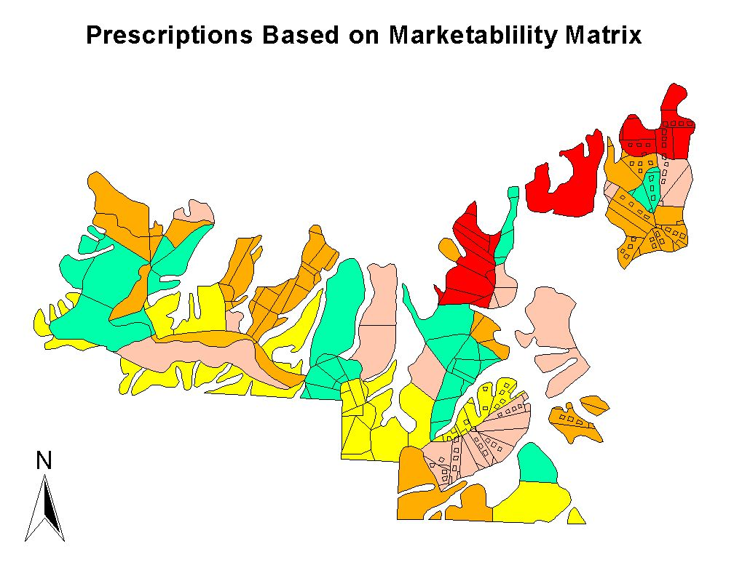
Figure 31. Prescriptions based on the Marketability Matrix

The results of the Marketability Matrix were illustrated in Figure 31. The map legend from Figure 30 applies. Notice that the allocation supported the objectives of research and monitoring by maintaining continuous prescriptions across stands and within sub-basins. Additionally, the prescriptions for each unit were determined independently using the Marketability Matrix. A tradeoff analysis that compares the qualities of Figures 30 and 31 is presented next.

8.5 Tradeoff Analysis
The operational feasibility and research/monitoring layout accounted for

- Silvicultural concerns
- Yarding concerns
- Practical knowledge of the area
- Outside concerns

The marketability matrix accounted for

- Silvicultural concerns
- Yarding concerns
- Operational Concerns
- Statistics
- Economics

With this knowledge, an arrangement of prescriptions, which combines the marketability matrix layout and the feasibility, research, and monitoring layout, will form the most desirable layout for all parties concerned.

8.5.1 Differences in Layouts
From a marketing perspective, the locations, amounts and qualities of timber are important considerations. Figures 30 and 31 resulted in different allocations and arrangements. The general and specific unit locations are provided. For a reference of the specific locations please refer to the working maps provided with this report. The details of the differences between Figures 30 and 31 are summarized by the following prescriptions.

Regeneration Harvest:
The regeneration harvest prescription is limited to 130 acres based on the Clallam River Landscape Planning strategies. Regeneration harvest areas were selected in the Southeast corner of the harvest area. This area has current evidence of blow-down. This is not consistent with the matrix layout, which was expected, so this sends a domino effect throughout the harvest area in terms of the comparison of the layouts.

The next most feasible place for a regeneration harvest is in the Northeast (unit 15d), where ground yarding is prevalent and high volumes of timber are available. The matrix layout also suggested this location, so there is no argument over the prescription here. These areas account for 130 acres of Regeneration Harvest.

Coarse Thin:
Both layouts suggest a course filter variable density thinning in units 7a, 7b, 7c, and 7d. Since the development of the matrix layout does not account for the risk of wind throw, these are logical locations of regeneration harvests. Therefore, the next best location for course filter variable density thinning is in the northeast areas in Unit 9a.

Fine Thin:
The fine filter variable density thinning is placed in the area northwest of the blow-down. While this area is susceptible to wind throw as well from the southwesterly winds, the feathering affects of this retention pattern may provide means to maintain the desired outcomes.

Uniform Thin:
Costs and operational concerns such as short yarding distances and no road building are good qualities for uniform thinning, so units 1 – 5 are suggested for uniform thinning. The P1800 and Timberwolf roads parallel each other; allowing for short yarding distances and reasonable suspension in areas of low to medium timber volume.

Suggested Layout:
Based on the review of Figures 1 and 2, it is recommended that the department also consider the following suggestions. Allocate the coarse filter variable density thinning in units 14d, 14e, 15a, 15b15c. Assign the fine filter variable density thinning to units 10a, 10b,16a, 16b, and 16c. These suggestions are based a review of the Marketability Matrix, the benefit of stratified prescriptions by specific sub-basins, and a lack of feasible reasons to have the prescriptions elsewhere. Figure 32 presents the results of this suggestion.

8.6 Final Layout
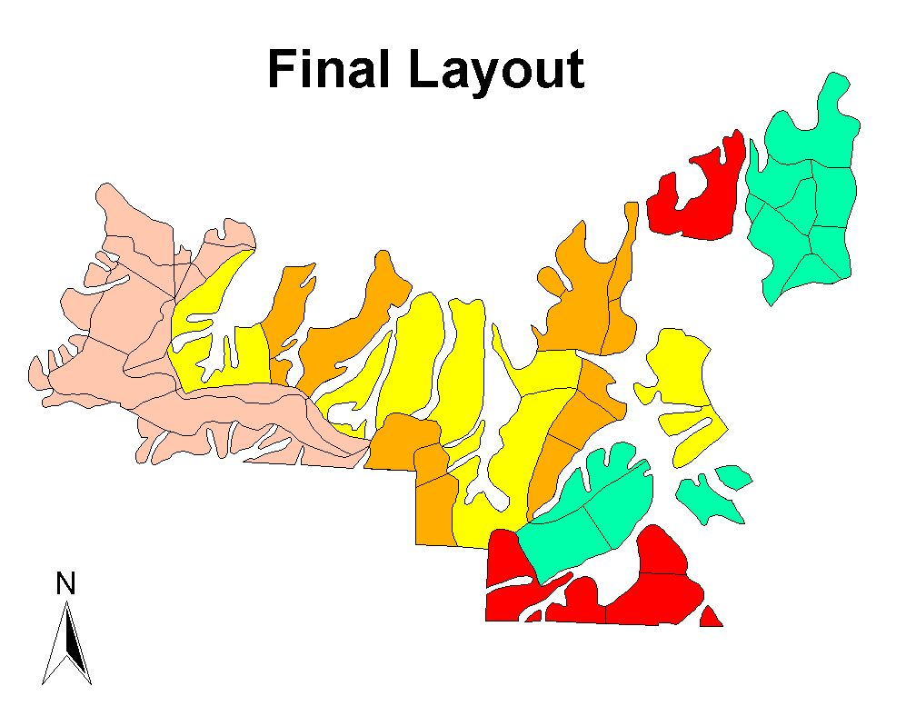
Figure 32. Final layout of prescriptions taking into consideration matrix, feasibility, research, and monitoring.

Figure 32 illustrated an arrangement of treatments that balances the benefits of the Marketability Matrix with the qualitative and important objectives of feasibility, and conservation objectives. The legend provided for Figure 30 applies. For review, the suggested strategies for successfully implementing these proposals are presented.

8.6.1 Review of Prescription Design Strategies:
- Regeneration Harvest
- Blowdown areas since other prescriptions may not be feasible
- Shovel ground with high timber volume
- Coarse Filter Variable Density Thinning
- Left over Regeneration Harvest areas from Marketability Matrix for economical reasons
- Sub-basin boundaries
- Larger continuous units that limit stand disturbance of other prescriptions.
- Further breakdown of harvest area into 10 acre plots of which each plot is
- 10% skip
- 10% gap – placed at landings or along corridor
- 40% Heavy Thin to RD 25 – 30
- 40% Light Thin to RD 35 - 45
- Fine Filter Variable Density Thin (based on current procedures)
- To protect areas susceptible to blowdown
- Sub-basin boundaries
- Larger continuous units to cut back on stand disturbance since there are more leave trees and we do not want to disturb them with any other prescriptions
- Shorter yarding distances then coarse
- Further breakdown of Harvest area into 10 acre plots of which each plot is
- 10% skip at 0.5 acre average
- 10% gap – placed at landings and along corridors at 0.25 acre average
- 30% Heavy Thin to RD 25 – 30
- 50% Light Thin to RD 35 - 45
- Uniform Thin
- To protect areas susceptible to blow down
- Shortest yarding distances
- Control
- Ecological values
- Difficult yarding conditions
- Access and stability concerns
- Products with low market demands.

8.7 Conclusions
The prescription strategies for the proposed Big Country Timber Sale present operational challenges. However, alternatives for prescription arrangements were considered that balanced many objectives.

Figures 30 and 31 illustrated the results of two independent methods for allocating treatments. Figure 30 used a qualitative and experience based approach, while Figure 31 presented the results of a marketability simulation using SIMYARD created by Weikko Jaross. Each of the two methods could not independently account for all the necessary considerations. Based on a thoughtful review of Figures 30 and 31 and the input of Olympic Region staff, Figure 32 was created.

To assist the department, a decision matrix, mapping examples, and suggestions for successful implementation were presented. These considerations included marketability with operational feasibility and conservation objectives in mind.

9 Conclusions

There are still many unknowns for the Big Country Timber Sale. Unfortunately, many of these unknowns will remain when important decisions are made. The contents of this report and the accompanying materials provide valuable information to help in making the best decisions possible, understanding that some information will always be unavailable. Some of the analyses that will help in making these decisions are outlined below.
The alternative access analysis is one tool that will help in making these decisions. Several alternatives are comparable, all with potential risks. The analysis provided in Chapter 6 gives unbiased data about the costs of each access, and the risks and challenges involved with each one. Ultimately, this becomes a question of which risks are higher. We leave that decision to the reader.
Our transportation and harvest plans were designed with flexibility. We have provided a plan capable of harvesting every area of the Big Country Timber Sale. This allows flexibility for implementing the OESF Conservation Strategy, and for potential research applications. It also provides for future RMZ restoration.
The slope stability analysis performed by Wendy Gerstel identifies areas that show movement in the present, or leave evidence of past movement. The GEO coverage, created from the work of Susan Shaw, identifies potentially unstable areas. By combining these data sources and avoiding the areas identified as potentially unstable with our road designs, we have reduced the potential loss due to slope failure.
The harvest prescription design, created to meet the goals of Research and Monitoring, comes with a framework within which we made our decisions. This framework can be used to make future decisions on the Big Country Timber Sale, or on other sales with similar research criteria. The flexibility of our harvest plan allows prescriptions to be interchanged easily, allowing freedom to change with new information. The suggested final layout combines the results of the marketability matrix with operational feasibility and current conditions of the sale to create the best possible layout given the current information.
This report does not answer every question about the Big Country Timber Sale. However, it does provide a valuable resource that will help in making difficult decisions in the face of uncertainty.

10 Appendices

10.1 Loggers Preferences
Loggers Preferences were based on yarding distance, topography (uphill or downhill), and ease of harvest. Clearcuts generally have the fewest hang-ups and the highest payloads. Light thinnings typically incur more hang-ups and lighter turn weights. Logging utility values used to produce the numbers in the table were extracted from “Setting Design Evaluation Incorporating Pacific Northwest Loggers’ Preference” by Dean Rae Berg, Independent Forest Contractor, and Peter Schiess, Professor of Forest Engineering, University of Washington. The utility values did not reflect loggers perceptions regarding full/partial suspension or varying thinning densities. Further surveys need to be completed to get a more accurate picture of true preferences on these issues. Variable density as well as uniform density should also be addressed.

Given these tables of preferences, each profile can be analyzed and the optimal prescription applied for the varying conditions. The minimum distance for any prescription should be 300 feet as a rule. Washington State Administrative Code Chapter 296-54 states that cutters must be at least two tree-heights apart. (The site trees for the area were found to be approximately 150 feet.) A minimum distance of 300 feet would allow one cutter to cut a specific prescription while another cutter may safely work on a different prescription.

Some of the assumptions that I made when compiling the tables:

- No harvest beyond leave areas 500+ feet from the landing
- Loggers prefer leave trees toward the tail ends of the unit
- Loggers prefer heavier thins to lighter ones (higher payloads)
- 32’ logs were assumed. Tree length would cause more problems in partial suspension areas
- Thinning densities were arbitrarily assigned to give a range of possible prescriptions and are subject to change to fit specific managerial objectives.
- The cut-off between side-hill and either uphill or downhill has not been defined and at this point is a judgment call of the engineer or manager

Table 30. Loggers Preference Matrix. See assumptions and definitions at bottom of table.
Uphill Cable Yarding - Loggers Preference
RMD |  | leave | 20-30 | 30-50 |  | 50-70 |  | 70-100
<500 | fly | 2 | 1 | 1 |  | 1 |  | 1
 | drag | 2 | 2 | 2 |  | 1 |  | 1
500-1000 | fly | 2 | 2 | 2 |  | 1 |  | 1
 | drag | 2 | 5 | 4 |  | 3 |  | 2
1000+ | fly | 1 | 4 | 3 |  | 3 |  | 2
 | drag | 1 | 5 | 4 |  | 3 |  | 3
Downhill Cable Yarding - Loggers Preference
RMD |  | leave | 20-30 |  | 30-50 | 50-70 |  | 70-100
<500 | fly | 3 | 2 |  | 2 | 2 |  | 2
 | drag | 3 | 4 |  | 3 | 3 |  | 2
500-1000 | fly | 3 | 3 |  | 3 | 2 |  | 2
 | drag | 2 | 4 |  | 4 | 3 |  | 3
1000+ | fly | 1 | 5 |  | 5 | 4 |  | 4
 | drag | 1 | 5 |  | 5 | 5 |  | 4
Uphill-Sidehill Cable Yarding - Loggers Preference
RMD |  | leave | 20-30 |  | 30-50 | 50-70 |  | 70-100
<500 | fly | 2 | 1 |  | 1 | 1 |  | 1
 | drag | 4 | 3 |  | 2 | 2 |  | 1
500-1000 | fly | 2 | 3 |  | 2 | 1 |  | 1
 | drag | 2 | 5 |  | 5 | 3 |  | 2
1000+ | fly | 1 | 4 |  | 3 | 3 |  | 3
 | drag | 1 | 5 |  | 5 | 4 |  | 3
 |  | leave | 20-30 |  | 30-50 | 50-70 |  | 70-100
<500 | fly | 3 | 2 |  | 2 | 2 |  | 2
 | drag | 3 | 4 |  | 4 | 3 |  | 2
500-1000 | fly | 3 | 3 |  | 3 | 2 |  | 2
 | drag | 1 | 4 |  | 4 | 3 |  | 3
1000+ | fly | 1 | 5 |  | 5 | 4 |  | 4
 | drag | 1 | 5 |  | 5 | 5 |  | 4
Assumptions
Values are based on loggers preferences for
distance, topography(Uphill, downhill), and
ease of harvest. Clearcut being the easiest with
the fewest hangups and lighter thins being the
most difficult
Loggers prefer to harvest higher volumes
the worst uphill is better than the best downhill
Assuming 32' logs
Note: Tree length will make
dragging less favorable
Assuming no harvest beyond leave areas out 500+ feet
Good Bad
1 ------> 5
Definitions
1= Paydirt!
2= Not my ideal but I'll do it for a beer
3= At least a 6 pack
4= Damn Engineers
5= I'd rather be watching Oprah!

10.2 Harvest Volume Assumptions
Objectives:
- Harvest volumes for each prescriptions:
  - No action
  - Uniform thin to RD 40 or 40% change from original RD
  - Light variable density thin (see DNR Procedures)
    - 10% skip, 10% gap, 30% to 33 RD, 50% to 45 RD
  - Heavy variable density thin (see DNR Procedures)
    - 10% skip, 10% gap, 30% to 23 RD, 50% to 33 RD
  - Experimental light variable density thin (see Big Country proposal- Richard Bigley)
    - 10% skip, 10% gap, 40% to 30 RD, 40% to 45 RD
  - Experimental heavy variable density thin (“”)
    - 10% skip, 10% gap, 40% to 25 RD, 40% to 35 RD
- Average Tree Size (in board feet) of cut trees for each prescription.
- Average Log Size (in board feet) of cut trees for each prescription.
- QMD of tail tree rigging for each prescription.

Assumptions:
- Harvest volumes:
  - SDI used to approximate RD. Regression of SDI to RD resulted in equation: SDI=-2.453+5.880RD
  - Most stands for uniform thin limited by 40% change from original RD.
  - Weighted average used to determine all values from light and heavy variable density thins after each stand treated to a single SDI. Weights based on DNR Procedures for skips, gaps, light, and heavy thinnings.
  - See Procedure 14-006-080
- Average tree size determined by dividing total volume by the number of trees removed that accounted for some portion of the total volume (8” DBH or greater, because LMS volumes were SV6).
- Average log size determined by weighted average:
  - (vol/log)(exp. factor)₁+…+(vol/log)(exp. factor)_{n}
Sum(expansion factors)
  - Volumes from LMS were SV6, so bucking parameters were 16 ft. logs, 6” small end diameter, 1’ stump height, 1” trim.
- Tail tree rigging QMD determined by largest 50 trees (based on 30 x 30 ft. spacing) per acre including DF, WH, RC, SS. QMD of DF and all other species determined separately. QMD for other species reduced by 2” to account for reduced strength compared to DF. Weighted average of DF and other species QMD’s (based on trees per acre) then used to determine QMD for stand.

10.3 Using LoggerPC
Now that the profiles are digitized into LoggerPC a payload analysis needs to be performed on them to ensure that suitable payloads can feasibly be achieved. The ideal yarding situation is full suspension with a standing skyline and tailhold at stump level. Therefore, this scenario is checked first. If payloads meet or exceed the anticipated maximum payloads for clearcut conditions the analysis is done. If not, changes need to be made until the design payload or the max possible payload is reached.

Once you have LoggerPC open, click the profile pull down menu and choose open to bring up the profiles that were saved when they were digitized. Select the one you want to analyze and click ok. Next, click the yarder pull down button and choose the yarder and carriage you want to use for your analysis. Lastly, click on Goto Analysis and the analysis window comes up. In this window set the tailhold where you want it and the desired height. The yarding limit may or may not be the full distance to the tailhold; the limits can be set by changing the terrain points to give the true yarding limits. Now choose the type of yarding system you want to use (start with standing). When you click on one of the types you will have the option to watch or run the analysis and also to change the payload and line length. Set the payload to the desired amount and try to run the analysis. If the payload is not possible an error message will come up and you will have to make some changes. If the payload is possible it will run, but LoggerPC does not check to see if the skyline tension is within the SWL, so you will need to know what the SWL is for the line size that you are using. Increasing the line length will reduce tension and decreasing line length will increase tension.

If you have tried standing skyline, full suspension and are not able to get the desired payloads, the first change to make in LoggerPC is to try raising the tailhold height to get the necessary deflection for full suspension. Try raising the tailhold height to 30 feet and check for clearance and payload. Next try 40 feet, and finally 50 feet. If the desired payload is still not met the next adjustment to make is to switch from full suspension to partial suspension and drop the tailhold height back down to two feet (stump height). Again, adjust the tailhold height up incrementally from two feet to 30, 40, and then 50 feet. If none of these adjustments work, the next option is to go to a multispan system.

A multispan system will ask for locations for intermediate supports and heights. By looking at the profile, try to locate the terrain point with the worst deflection and place the intermediate support there. The minimum and starting height should be 30 feet. Run the analysis on the multispan system and see what kind of payloads can be generated. If they are not what you need try moving the intermediate support around to different terrain points to see if you get better results at different locations. When you find the location that provides the highest payload and if it is still not adequate then increase the height of the intermediate support to 40 feet and run the analysis again. If not enough try 50 feet. For practical rigging purposes do not exceed 50 feet rigging height for intermediate supports or tailholds. If the desired payloads are still not met add an additional intermediate support where the deflection is poorest and repeat the process above until design payloads are met.
The last method to try is live skyline. It will produce the highest payloads of the three methods but is inadequate for most thinnings. Live skyline works well for clearcuts or heavy partial cuts. If live skyline must be used try to get full suspension. Use a series of lifts if necessary to gain the best deflection.

