Quick Guide to Image Analysis version 3.0

In this document, you will not be using all the Software’s functions. However, we have provided a general overview. The full FMBIO manual goes into more details on each of these analysis functions.

This quick guide will be divided into 2 parts :

- 1D Image Analysis : Basic functions
- 1D Image Analysis : Detailed protocols for multicolour gels,

Main Features of the Software
Single and Multiple Lane Setting
Automatic Band Calling
Manual Band Setting
Establishing Marker Sets
Setting Marker Lanes
Base Pair Sizing
Summary Data Table

FMBIO Image Analysis is a comprehensive software package that allows you to analyse a 1-D gel image by setting lanes, calling bands and sizing the bands against a known marker set. The scanned image can also be annotated for use in papers and presentations by using the figure drawing features and information labelling option.

Part A 1D Image Analysis : Basic functions

This guide will give you a brief walk through of how to get started with basic gel analysis. We will cover the following functions.

Setting lanes
Auto-calling bands
Setting the sizing marker
Calculating fragment sizes of an image using the FMBIO Software

Launching the application program

- Launch the FMBIO analysis application by double clicking on the Image analysis Icon.
- From file menu, choose New Project, then go to the Project Menu and select New 1D-Gel Experiment (select the Image you want to work with, in this example it will be 1D-Gel Image).
- A new set of buttons will appear on top.
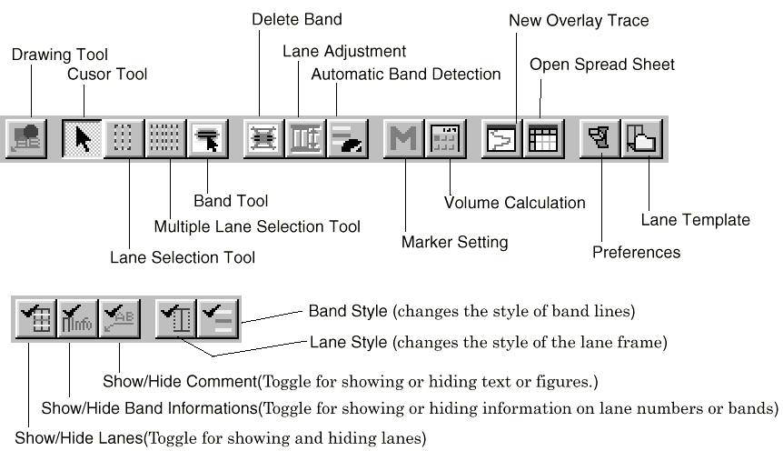

Setting the lanes :

Individual lanes. The user sets lane width for single lanes manually. For multiple lanes it can be either automatically calculated or a specific lane width can be set. Adjustment to lane position, width and shape can be made after the lanes are set.

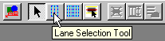

- Click on the Lane selection tool icon, and place the cursor on the upper left-hand corner of one lane.
- Drag to the bottom right-hand corner of the lane and release the mouse button to finish the selection.
- Click on the bottom center box to swing the angle of the lane. Only the bottom of the lane will move.
- Click on one of the outside boxes of the active lane (either top or bottom) to re-size the width of the lane from the end chosen. The lane will widen starting at the end chosen.
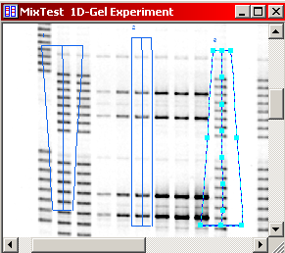

Multiples lanes

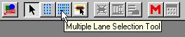

- Click on the multiple lane selection tool icon,
- Place the cursor on the upper left-hand corner of the first lane.
- Drag to the bottom right-hand corner of the last lane to finish the selection and release the mouse button.
- A dialog box will appear. You can choose Automatic Lane Detection or enter the number of lanes manually and then click OK.

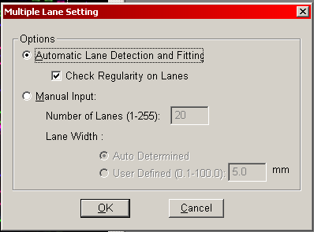

- The lane width will automatically be calculated for you (or customized your own by using the User Defined option).

Lane adjustment, to do so just push the following icon and the program will automatically select the entire lane for you.

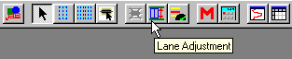

Defining Bands
Bands can be set either in the manual or automatic mode. The auto band mode has adjustable parameters to improve band identification. We will first automatically define bands and then edits bands manually.

Select the lane(s) of interest by clicking on it/them (by pressing the shift button concurrently). Click on the preferences icon as shown

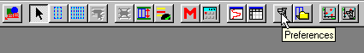

A new window appears with 4 different settings (Automatic band detection, Band information, Calculation and Multi-band colour separation). For our purpose we will adjust settings of the Automatic band detection and Band information.

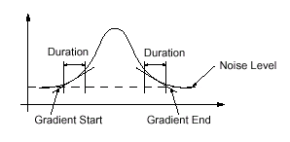
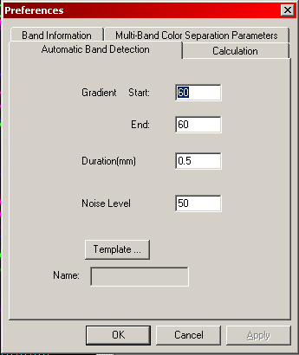
The automatic band detection allow you to set the parameters which affect the auto-banding as shown hereafter:

The Band information menu offer you the possibility to set the information you want to work with, in this simple example we will choose BP for base pair:

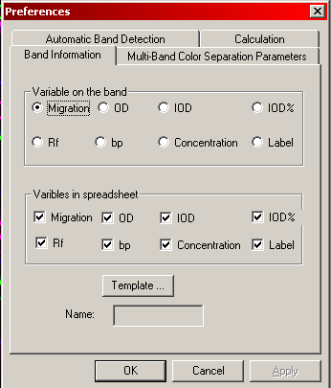

After modifying the settings, click ok and click on the Automatic Band detection icon.

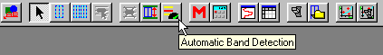

For each lane check if the recognition is correct, if not play with the auto-banding parameters (gradient start/end, duration, noise level).

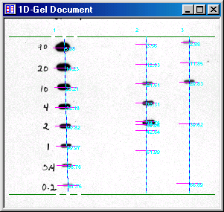

When bands in the lanes are detected automatically, the beginning of the band line, the ending of the band line and the peak line for the peak are shown as well as a number that represents the distance in mm between the electrophoresis migration line.

Work with bands:

When further bands does not closely match after an automatic band detection, it is possible to move the band’s beginning and ending line, to adjust the peak line and of course to add/remove bands.

Operating procedure:
Double click on the lane of interest, and click on the band Tool icon

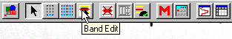

Use the cursor to drag the band over the image so that it corresponds with the beginning, the end and the peak of the band.

Before adjustment After adjustment
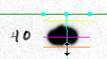
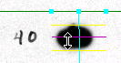

To add a band, double click on the lane you wish to edit, click on the band edit icon and align the cursor over the center of the band image you want to add, and then click. To adjust the beginning as well as the end and the peak line click of a band, move your cursor over this band and with the right button of the mouse, click and select edit band as shown:

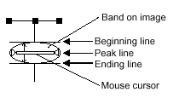

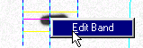

Then you can adjust lines for the band.

To remove a band, double click on the lane you wish to edit, click on the band edit icon, and align the cursor over the desire band you want to remove. Then, press the delete key and the band will disappear.

Note : You can automatically delete all the band of one/further lane by selecting the desire lane(s) and press the delete band icon as shown :

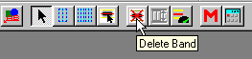

Finally the results should be :

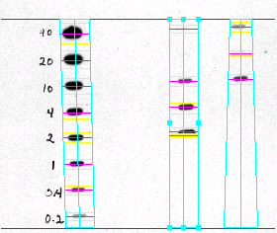

Determining the length of the fragments

Identify the lanes that carry the size markers during electrophoresis. Markers are used to calculate the length of the fragments of the test samples.

Set Markers

After the bands have been detected/edited, the length of the fragments in each band can be calculated by setting the marker lane. If a marker has not been recorded, you can create a new market by Clicking on the marker setting button/icon,

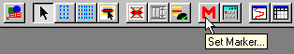

Select one of the following three types of marker modes from drop down menu near the upper right hand corner:

  - Separate : Markers are selected for each image,
  - Mix : the selected markers affects the calculation in all the images,
  - Layer : Only the markers from a single image are set.

For 1-D Gel associated with the PowerPlex 16 BIO kit from Promega®, use the Layer mode. Complete details on working with Markers, please refer to page 5-68 of the manual.

Calculating Fragments Lengths

Using the markers as reference points, the fragment lengths and the volume of the bands of the unknown test materials can be calculated. This will be referred to as the volume calculation.

Click the volume calculation button as shown

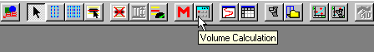

Click the Spreadsheet button to obtain the results
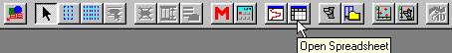

and the following results can be obtained:

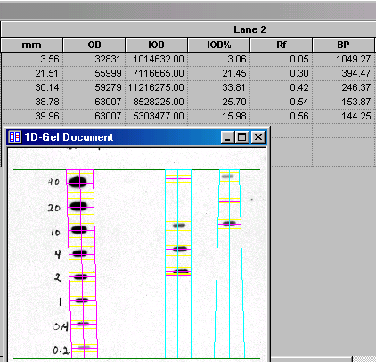

Part B: 1D Image Analysis – Detailed protocol for multicolour gels

New Project File

If you want to create a new project select New Project and then go under the Project menu and select New 1D-Gel Experiment).

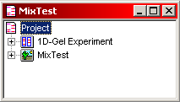

The Project file will appears as follow

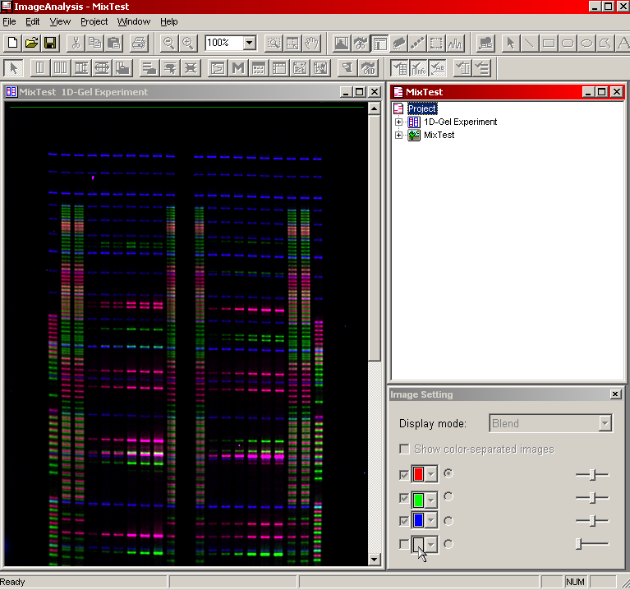

Grayscale Adjustment

The first step in analysis of the image is the adjustment of grayscale for each layer.
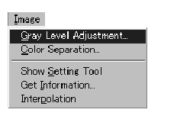

\

A new window called Gray Level Adjustment windows opens
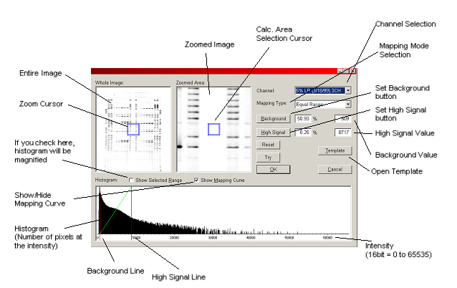

Operating Procedures

The gray level values for the Background and High Signals can be set using the following method.

- Move the magnification cursor to show a magnified image band. Surround a band with the selection cursor, and click the High Signal button. The High Signal level % and the gray level value will show. Next move the selection cursor to a white area away from the band, and click the Background button. This sets the Background signal level % and the gray level value. When the gray level values are changed, the appearance of the bands will change.

- Enter the Level % into the Background and High Signal text boxes.

- Enter the gray level value into the Background and High Signal text boxes.

- Use the cursor to move the minimum (Min) background line (red) or the maximum (Max) background line (green) that is shown in the histogram.

- Set the gray level value from a template if needed.

- The gray level correction can be changed on all of the channels together by using the channel selection list. Repeat the grayscale adjustments described in step 1 for each layer. Switch between layers in the gel using the Image Window Setting (Highlight a layer to display it when in Mono Mode).

- Click the OK button when finished.

But you can also have other alternative possibilities as described bellow :

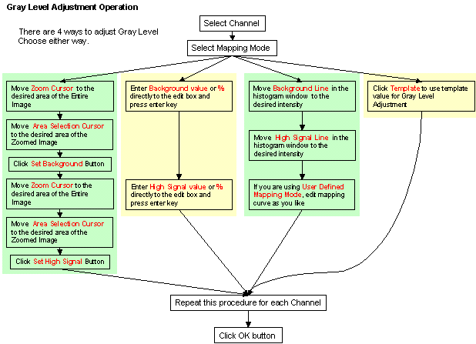

Guidelines for Setting the Gray Level Correction

When the image density is not clear, corrections can be made in the image, which will show details of the bands. This is called the gray level correction and includes setting a restricted band of values for the gray level and to have upper and lower cut-off levels. The range of values is from 0 to 65535. The gray level correction is performed on each channel individually.

The image file contains 16 bits per pixel or 65,536 gray scale levels. To show the image on an 8 bit display, data is converted to 256 shades of gray. The histogram is based on all of the pixels in the image. Pixels values are excluded from further analysis if they are lower or higher than the gray level values that have been set. The area that is used is divided into 256 parts.

Note

After the image is changed to 256 levels of gray, this information is only used for showing the image in the image window. During image calculations, the original 65536 levels in the image are utilized.

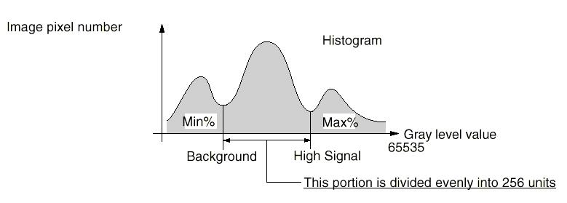

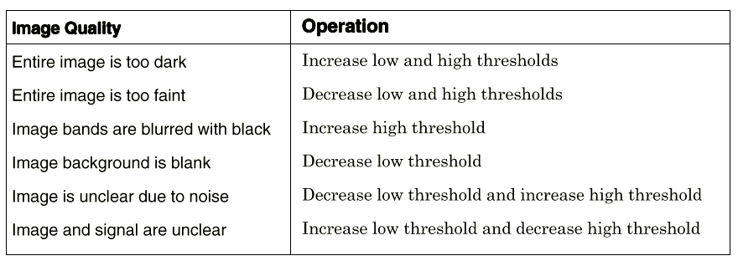
Set the gray level correction value % to encompass the area for the maximum and minimum number of pixels to be included. Set the values according to the qualities of the image according to the following.

Color Separation
This function removes the proportion of the signal that bleeds through from other channels.

Operating Procedure
- Make one lane for Multi-band Colour Separation (MBCS): Find a good lane for colour separation, it is recommended that all bands in the lane are separated clearly and that every channels has to have at least one band in the lane (more than 2 is recommended).

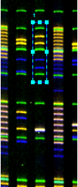

2. Perform automatic band detection, then click on the MBCS icon as follow :

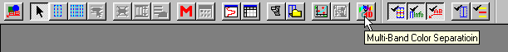

3. A new windows appears with lane image, lane trace, background, prediction results (colour number) are shown on the left side., Copy the prediction result by clicking the ‘Copy>>’ button or you can load order list from template.

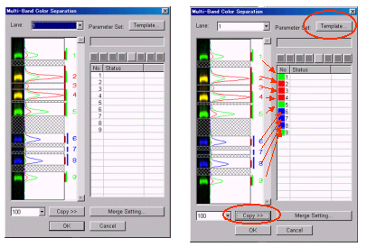

4. Edit band colour by using tool button if necessary. In this case, band 3 and 7 are not bands but overlapping signals, so choose none from tool bar. After editing, press ok button. Then the colour separation dialog window will appear.

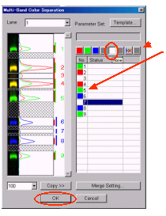

5. Preview Colour Separation result and hit OK.

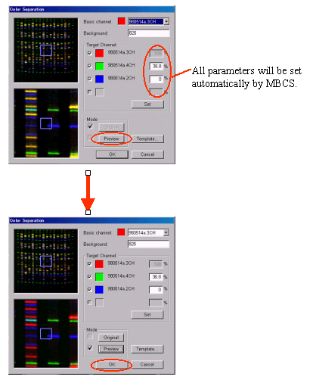

If all lanes have been set, bands detected, and markers set, you are ready to calculate the fragment lengths

Calculating Fragments Lengths

Using the markers as reference points, the fragment lengths and the volume of the bands of the unknown test materials can be calculated. The calculated results are shown in the spreadsheet.
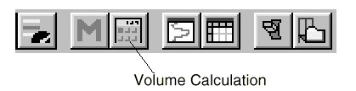
Click the volume calculation button

Showing the results of the Spreadsheet Calculations

Click the Spreadsheet button

Fragment length and band volume are shown for the bands in each channel.

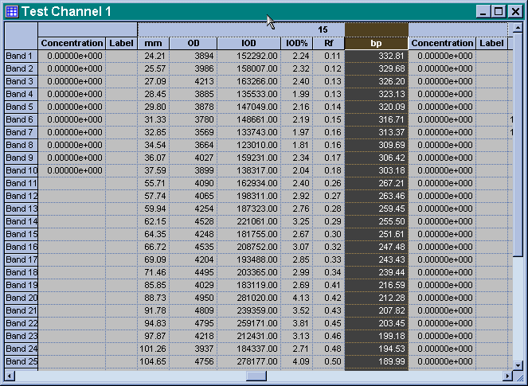

Spreadsheet can be exported by using the following option: Spreadsheet / export as a dat file (.dat) for use with STaRCall software.

