Lab 1
Pipetting & Buffers

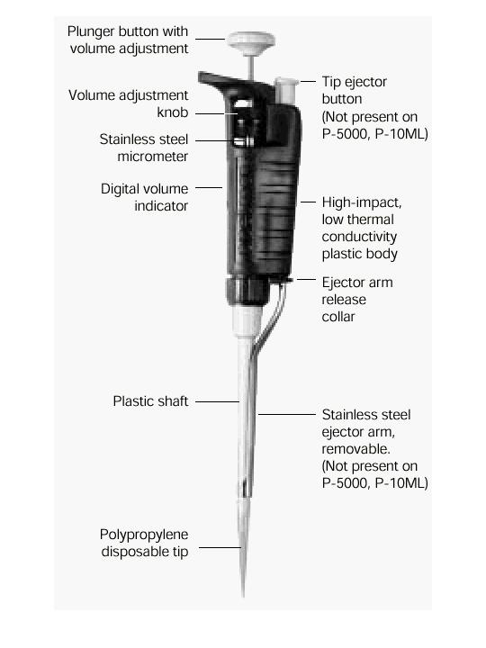
Part A: Pipetting

Proficient pipetting is probably the most crucial part of this class, for three reasons:

- Accurate pipetting is crucial to the success of molecular projects. Mistakes during pipetting may cause your experiments (e.g. PCR) to fail or to be irreproducible, and thus cause long delays and considerable expense
- Pipettes are delicate pieces of equipment with high accuracy, which can easily be knocked off their calibration. Furthermore, they are expensive – the five pipettes in front of you represent about $ 1,500.
- Pipettes are the main source of contamination in PCRs, and thus can cause a lot of problems.

You may have some experience with pipettes, but a refresher on pipetting is probably quite useful.

Rainin Pipetman
Pipette | Top | Volumes (µl) | Tips
P-1000 | Blue | 100 – 1000 | Blue
P-200 | Yellow | 20 – 200 | White, tall
P-100 | Yellow | 10 – 100 | White, tall
P-20 | Yellow | 2 – 20 | White, tall
P-10 | White | 0.1 – 10 | White, small

Volume Adjustment
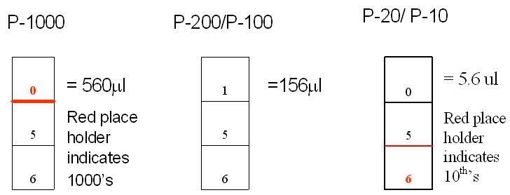

Red/black indicates the decimal point.
Never
- Never rotate volume adjustor beyond the upper limit
  - Changes calibration
- Never use without a tip.
  - Liquid will get into piston – damage and contamination.
- Never lay down or turn upside down a pipette with filled tip.
  - Liquid could run back into the piston, and damage/contaminate it.
  - Use pipette holders provided
- Never let plunger snap back after withdrawing or ejecting fluid
  - Damages piston
Use
  - Use the correct pipette. Never adjust the volume beyond the maximum setting, but also do not use pipettes that are too large. Accuracy and precision drop rapidly towards the lower limit of settings.
  - Adjust volume by turning the volume adjustment knob or the plunger. Be sure to locate the decimal point correctly when reading the volume setting (see above). Always dial DOWN to the desired volume to avoid mechanical backlash affecting accuracy.
  - Firmly seat the proper-sized tip on end of the pipette. If the fit is lose, you will draw up less volume than intended and the liquid will drip from the tip during use.
  - When withdrawing or expelling fluid, always hold the tube firmly between thumb and forefinger. Hold close to eye level to observe change in fluid level in tip. Do not pipet with the tube in rack or when someone else is holding the tube.
  - The pipettes have a two-stop position plunger. Depressing to the first stop measures the desired volume. Depressing to the second stop introduces an additional volume of air to blow out any remaining fluid from the tip.
  - To withdraw fluid from tube.
    - Hold the pipette almost vertically (< 20º from vertical)
    - Depress plunger to first stop and hold. Dip tip 2-4 mm into the fluid. Do not push down to the bottom of the vial, otherwise the tip is blocked and you draw less liquid than intended.
    - Gently release thumb. If you release quickly, you will create aerosols (small droplets) which will contaminate the pipette.
    - Wait for a second or so, to confirm that all the liquid has been taken up.
    - Slide pipette tip out along wall of tube to dislodge remaining droplets adhering to the outside of the tip.
    - Check that there is no air space at the very end of the tip.
    - Learn the approximate levels that particular volumes fill the tip – this will allow you to check your pipetting visually.
  - To expel sample into tube
    - Touch tip to wall of tube
    - Slowly depress plunger to first, and then to the second stop to expel fluid.
    - While keeping the plunger at the second stop, slide the tip out of the fluid, along the tube wall and out of the tube.
  - Eject the tip into trash, by pressing the tip ejector button.
Prevention of cross contamination

  - Use a fresh tip each time
  - Do not touch the tube with the pipette, only with the tip
  - If you suspect pipette contamination, wipe with ethanol on the outside. If the inside is contaminated, talk to Danielle or Lorenz.
  - Draw up liquid slowly to prevent the formation of aerosols
  - For specific applications, use pipette tips with filters

Pipetting exercise
Be careful to use the correct pipette. Use distilled water. You don’t have to change tips for these exercises.

Large volume:
- Add 179 µl to a tube
- Add 465 µl to the same tube
- Remove 602 µl from the tube
- Remove 42 µl from the tube

Small volume:
- Add 8.3 µl to a tube
- Add 13.5 µl to the same tube
- Remove 15.6 µl from the tube
- Remove 6.2 µl from the tube

Very small volume (as used for PCR):
- Add 2.3 µl
- Add 1.8 µl
- Remove 3.2 µl
- Remove 0.9

To make the last experiment more interesting, repeat using glycerol (has similar viscosity to TaqI polymerase).

How accurate were you?
- Is some liquid left in the tube? Measure it by drawing it up, and adjusting the pipette volume until all air below the liquid is expelled from the tip. Remember to hold the pipette vertically while doing so.
- Did you draw air up with the last removal of liquid? Measure the volume of step 4 by adjusting the volume downward. Remember to hold the pipette vertically while doing so.

The pipettes have an accuracy and precision of about 1% - any more than that is human pipetting error! If you got it very wrong, try again.

Part B: Buffers (see also Appendix I in Sambrook & Russell 2001)

Introduction

Buffers are used to stabilize the pH in biological reactions, which are usually strongly pH dependent, but also tend to generate or consume protons (H⁺ ions determining pH). Many buffers also contain other ingredients, for example, EDTA inhibiting enzymes.

The most commonly used buffer is Tris (Tris(hydroxymethyl)aminomethane, also known as Trizma), which came to fame in the 1940s, when it was introduced to stabilize the pH of seawater used for transporting life fish to the market. (This does not mean that Tris is harmless – it is an irritant and toxic to most mammalian cells.) Tris has its highest buffering capacity at pH 8, and is a fairly poor buffer at pHs below 7.5 and above 9.0.

A lot of the reactions we will carry out need very accurately prepared buffers. Many commercial enzymes and kits come with their own buffers, but some buffers still have to be prepared in the lab. We will prepare an extraction buffer, a salt solution, and buffer to store DNA. While this may appear an easy and somewhat tedious exercise, keep in mind that the quality of your buffers will affect your work for the next few weeks.

Molarity and prefixes

Buffers are defined by their concentration and the pH. Concentrations are normally given as mol per liter, usually with one of the prefixes below (mM – millimol). A 1 molar solution contains one mol of the substance (or its molecular weight in grams) in one liter of solution. You can find the molecular weight of almost all substances on the container. Occasionally you will find percentages, usually weight per volume (w/v) – this simply means grams per 100 ml solution.

Multiple | Prefix | Symbol |  | Multiple | Prefix | Symbol
10⁻³ | milli | m |  | 10³ | kilo | K
10⁻⁶ | micro | µ |  | 10⁶ | mega | M
10⁻⁹ | nano | n |  | 10⁹ | giga | G
10⁻¹² | pico | p |  | 10¹² | tera | T
Table 2: Commonly used prefixes for very small or very large units.

The best way of preparing buffers is to weigh out the substances, dissolve it in a volume of distilled water smaller than the final volume of the solution, check and adjust the pH, and finally make up to the required volume with distilled water. Use hydrochloric acid (HCl) or sodium hydroxide (NaOH) to adjust pH.

Dos and don’ts
- Work out the needed volumes and weights before you start.
- Don’t add the final volume of water to the substance – because the substance has some volume as well, the volume of the solution will be larger than needed.
- Completely dissolve the substance before checking the pH – this can best be done on the magnetic stirrer.
- Label all solutions with name, date and name of solution.

For example:
To make a 500 ml of a 100 mM NaCl solution:
Molecular weight of NaCl: 58.44 (i.e. 58.44 g in one liter is a 1M solution)
500 ml: 58.44 g / 2 = 29.22 g
100 mM = 0.1 M = 2.922 g

Solutions to make:

Ingredient | Final concentration
Extraction buffer (prepare 500 ml)  Tris  NaCl  EDTA  Adjust pH to 8.0  Lasts indefinitely (room temp) | 10 mM  100 mM  10 mM
NaCl solution (prepare 50 ml)  NaCl | 5 M
5 x TBE buffer (prepare 500 ml)  Tris  Boric Acid  EDTA  Check pH – should be pH 8.3  Lasts indefinitely (room temp) | Per 500 ml  27 g  13.75 g  2.325 g

Part C: Tour of MMBL

Part D: Set up DNA extractions

Each person gets two samples, one sockeye salmon and one other species (chinook, coho, steelhead). Both of these samples will be used for both extraction methods, that is, each student will get 2 samples of 2 individuals each. Work in pairs, that is, each pair gets 8 samples to work on.

Salt extraction: (full protocol on website – print out and read before Thursday)

- Dissolve 0.5% SDS in 10 ml extraction buffer. Careful – SDS is an irritant and toxic by inhalation, ingestion or skin absorption. Wear goggles, lab coat and mask.
- Remove a small tissue section (e.g. 0.5 cm² fin tissue), cut to pieces and place in labeled Eppendorf tube.
- Add 500 μL extraction buffer and 10 µl proteinase K to each tube. Mix by inverting.
- Incubate overnight at 55°C. All tissue should be digested

QIAGEN DNeasy extraction: (full protocol on website – print out pages 18-20 and read before Thursday)

- Cut up to 25 mg tissue (e.g. 0.5 cm² fin tissue – less is usually more) into small pieces, place in a 1.5 ml microcentrifuge tube, and add 180 µl Buffer ATL.
- Add 20 µl proteinase K, mix by vortexing, and incubate at 55°C until the tissue is completely lysed.

