Lab 3
Agarose electrophoresis and RFLP

Summary:

PART A: Agarose Electrophoresis

PART B: Restriction Fragment Length Polymorphism

Procedure:

Time | Electrophoresis | RFLP
13:30 | Pour Gel
14:00 | Discuss electrophoresis
14:30 | Load gel
15:00 |  | Discuss RFLP
15:30 |  | Set up RFLP
16:00 | Stain Gel
16:30 | Photograph gel and discuss stain

Agarose Gel Electrophoresis
The purpose of this lab is to introduce you to methods used to separate and visualize DNA fragments (extractions, PCR products, etc). We extracted DNA; how did we know it worked? We set up a PCR reaction; how do we know it worked? We used restriction enzymes to digest PCR product; how can we see what happened? How do we visualize genetic variation in a population?

Gel electrophoresis
Electrophoresis is movement of charged particles in an electric field. In molecular genetics, electrophoresis refers to the separation of proteins, DNA, or RNA in a gel with an electric field. DNA and RNA have a negative charge, so in an electric field they are attracted to (will move toward) the anode (the positively charged electrode). The gel acts as a sieve, separating molecules by their ability to move through the gel. Large molecules have a more difficult time moving through the gel than smaller molecules and thus move a shorter distance over a given time than do smaller molecules. Thus longer DNA fragments have a slower mobility than smaller fragments. It is thus possible to separate fragment of different size (e.g. microsatellites, RFLP), estimate the fragment length of a PCR product by comparison against a size standard, or assess the quality of the DNA extraction (absence of small degraded DNA fragments).

For DNA electrophoresis there are two types of gels that are commonly used: agarose and polyacrylamide gels. Agarose is a polysaccharide extract from seaweed; polyacrylamide is a synthetic polymer. Agarose gels are best at separating larger DNA fragments (100-20,000 base pairs), while polyacrylamide gels are best at separating smaller DNA fragments (5-500 bp). Agarose gels usually require less time than polyacrylamide gels. In contrast to acrylamide, which is a potent neurotoxin, agarose is also relatively safe to handle.
Table 1. Mobility range of DNA in different percentage agarose gels (taken from the Owl Easycast owner’s manual – link on webpage).
Agarose % w/v | DNA fragments (kb)
0.3 | 60 to 5
0.5 | 30 to 1
0.7 | 12 to 0.8
1.0 | 10 to 0.5
1.2 | 7 to 0.3
1.5 | 4 to 0.2
2.0 | 3 to 0.1
3.0 | <0.1

For each type of gel, the resolution can further be manipulated by changing the concentration of the gel: higher concentrations (%) = better resolution of smaller molecules (Table 1). Resolution is the ability to distinguish different sizes of molecules, and depends on separation between bands and the fuzziness of bands. Agarose gels effectively separate DNA fragments that differ by ~20 bp, depending on the concentration. In contrast, polyacrylamide gels effectively separate fragments that differ in length by just 1 bp. This fact makes polyacrylamide the gel choice for anyone who is directly sequencing DNA.

LAB PROTOCOLS

PART A.1: Pouring A Gel

- Each group has a gel tray and buffer chamber, and should make their own gel.
- Place the gel tray into the buffer chamber so the rubber seals provide a firm seal against the walls of the buffer chamber
- Weigh out 1 % agarose for 100 ml buffer (that is _____ g)
- Add 100 ml 0.5 x TBE (diluted from the stock you prepared it in the last lab) to the agarose
- Heat in microwave until boiling, but be sure that you don’t boil it over. Check every 30 sec and swirl (caution – hot). If you boil it over, clean the microwave and start again, if you lost a lot of agarose.
- Let cool by continuous swirling (or on magnetic stirrer). Cooling can be aided by swirling flask underneath cold water (don’t get any water into flask). The flask should be cool enough to be touched without a glove (i.e. below 60ºC). If you pour too hot, you will crack and warp the gel tray.
- Carefully pour into gel tray.
- Insert both combs, with the thicker (1.5 mm) teeth down.
- Leave to cool for > 30 min.

PART A.2: Loading samples (after electrophoresis discussion)

Each group will load their DNA extractions (8 samples) and mtDNA PCR products (7 samples + 1 negative control). Microsatellites are too small to be separated on this gel. Remember to write down which sample is going in which well, and which well has the ladder. It is a good idea to offset your ladder well (load it in an asymmetrically located well) to facilitate later sample identification. This will also make it easier to prevent mix-up of gels between groups.

- Get molecular ladder and samples organized.
- Turn gel tray 90 degrees, so the comb closest to the edge of the tray points towards the cathode (black).
- Fill buffer chamber with 0.5X TBE buffer as running buffer – it takes about 800 ml. It is always best to use the same batch of buffer as for the gel. The gel should be just about (5 mm) covered – watch for the fill line on the buffer chamber.
- Remove combs carefully, by slowly pulling them out of the gel. Don’t rip them out, otherwise half the gel will go with them.
- Cut a strip of parafilm. Aliquot a small dot of loading dye (approximately 1 μl) onto the parafilm, one dot for each sample you are going to load on the gel.
- Mix the 3 μl of DNA extract with one dot of loading buffer on the parafilm – make sure not to mix up dots, and not to transfer fluids between dots. Load the mixture into a single well on the top row of the gel (the one nearer the cathode - black). Remember to leave one lane free for the ladder, and avoid the outermost lanes.
- Mix the 5 μl of mtDNA PCR product with one dot of loading buffer on the parafilm. Load the mixture into a single well on the bottom row of the gel (the one nearer the anode – red). Remember to leave one lane free for the ladder, and avoid the outermost lanes.
- Load 3 μl of Hi-Lo ladder in one well on each row of your gel.
- Carefully put the lid on your gel rig and plug it into a power source. Remember: DNA ‘runs to the red’, that is it migrates toward the anode which is the red jack in the power source.
- Turn the power source on and turn the voltage to ~125 volts.
- Run these gels for approximately 1 hour. Write all of the running conditions in your lab notebooks including: gel concentration, sample locations, ladder used, running buffer used, voltage applied, current, start and end times of electrophoresis.

PART A.3 (after RFLP set up): Staining

- Switch off powerpack and disconnect plugs.
- Use double gloves – top one should be the expensive ones I showed you
- Open lid and remove gel
- Place gel into staining tray, and leave for 20 min in a dark box.
- Place gel on DarkReader transilluminator, cover with trash bag and photograph. You will have to use about 1 min exposure time. Take one photograph for each person in the group.
- Clean transilluminator and dispose of gel in toxic trash can.
- Discuss with us what you see, and make notes in your lab book

PART B:

Restriction Fragment Length Polymorphisms – RFLPs

RFLPs is a method of indirect sequence detection. By using enzymes cutting the DNA at specific sites, we can detect whether individual DNA sequences (usually PCR products) posses this restriction site or not. Fragments can be separated by electrophoresis on an agarose or a polyacrylamide gel. By quantifying fragment length, we can also estimate the relative position of restrictions sites to each other. RFLP is an easy and quick method of surveying genetic variation, though much of the sequence information is lost in the procedure.

RFLP can be applied to a range of problems from population genetics to species identification to phylogenetics. Because of the dropping costs of sequencing, it is these days mainly applied if a larger number of samples have to be surveyed. A good strategy is to collect sequences, identify variable regions and find restriction enzymes that cut in these positions.

What are restriction enzymes?
A restriction enzyme is an enzyme that cuts double-stranded DNA in a specific location based on a short sequence of DNA. This sequence of DNA is typically palindromic, i.e. the sequence reads the same from 5’ to 3’ on either strand of DNA, e.g. 5’ – GGCC – 3’, the sequence recognized by HaeIII. Restrictions enzymes are naturally found in bacteria and are used by bacteria as a defense against invading viral DNA. Restriction enzymes are named for the organism from which they are isolated – for example, Eco RI was isolated from Escherichia coli.

Over 400 restriction enzymes have been identified; many of them are commercially available. Some recognize and cut at the same sequence of DNA; these are called isoschizmers. For example, MboI recognizes the sequence 5’- ^GATC – 3’ (the ^ shows where the DNA is cut). Both DpnII and Sau3A also recognize the same site and cut in the same place. DpnII and Sau3A are isoschizmers of MboI.

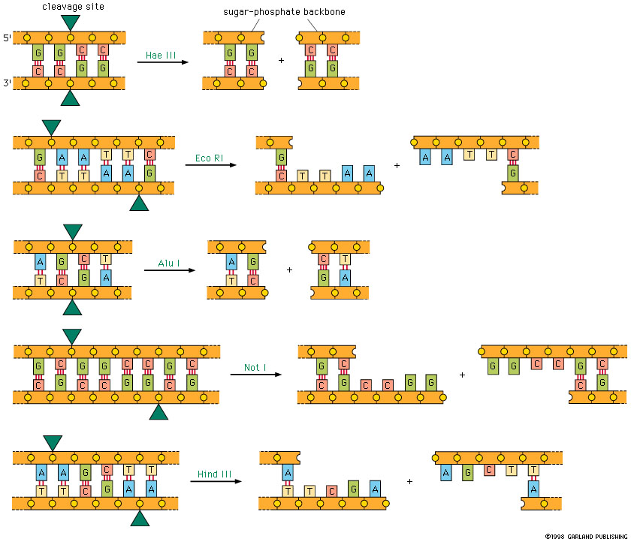

Most restriction enzymes work most efficiently at specific temperatures; if it’s too cold the enzymes are not active, if it’s too hot the enzymes are destroyed. In the lab we add buffer and enzyme to PCR product, then put it in an incubator or thermocycler set at a specific temperature and let the reaction sit for several hours. The two enzymes we will use have different optimal temperature – Sau96I works best at 37°C, while the optimal temperature for ApoI is 50°C.
In this lab, we will use two restriction enzymes to identify the species of salmon in our sample.
Species | Sau96I | Apo I
Chinook | B | A
Coho | A | A
Steelhead | A | C
Sockeye | A | B
Table 2: Restriction patterns of the two enzymes in different salmon species. A: no restriction, B: enzyme specific restriction pattern B; C: enzyme specific restriction pattern C.

Setting up a restriction enzyme reaction
Each group will set up enzyme reactions for both enzymes on their mtDNA PCR products, i.e. there will be 2x7 tubes for each group. Use the 200 µl strip tubes, which you also used for PCR. We don’t need positive or negative controls for enzyme digests, but we normally should check the PCR product before doing RFLP.

- Get 10X buffer, BSA and water out of the freezer to thaw.
- Get a bucket of ice from the icemachine. ALWAYS keep restriction enzymes on ice.
- Label micro-tubes with numbers – there isn’t enough space to write more than the tube number on each tube (each group should have a different color of strip-tubes). MAKE SURE you write down which samples are going into which tubes in your lab notebook.
- Prepare your master mix – label one 1.5 ml tube with an “M” or some other way so you know it’s for the master mix. The ingredients and the amount of each ingredient for one 15 μl reaction are listed below. You’ll need to multiply the amount of each ingredient by the number of tubes you’re preparing, plus one extra (for pipetting error). Vortex or thoroughly hand-mix the buffer prior to adding it to the master mix.
- Get your enzymes out of the freezer and add it to your master mix – remember to adjust your pipette for viscosity. Put your enzymes back in the freezer when you’re done, and keep them on ice.
- Mix your master mix by vortexing or thoroughly hand mixing.
- Aliquot master mix to each of your tubes.
- Add mtDNA PCR product to each of your tubes. Add the DNA from each of the samples in the order that you have written in your notebook.
- Put the lids on the microtubes, and place in DNA Engine for incubation overnight (at least 2 hours).

 | Enzyme | Sau 96I |  | Enzyme | ApoI
Ingredient | 1 sample | 8 samples |  | 1 sample | 8 samples
10x buffer #4 | 1.5
10x buffer #3 |  |  |  | 1.5
BSA |  |  |  | 0.15
PCR product | 5 |  |  | 5
enzyme | 0.1 |  |  | 0.125
ddH₂0 | 8.4 |  |  | 8.225

