TC310 Dreamweaver / CSS – Web site Assignment 7

This week’s assignment will not require a rationale – it is more of an exercise in becoming comfortable in CSS and how to convert your ideas into a web page. We will do an example of this assignment in class in the tutorial.

You will go to a site you like and screen cap it.
In Photoshop – replace the large content areas with blocks of color. See below for example.

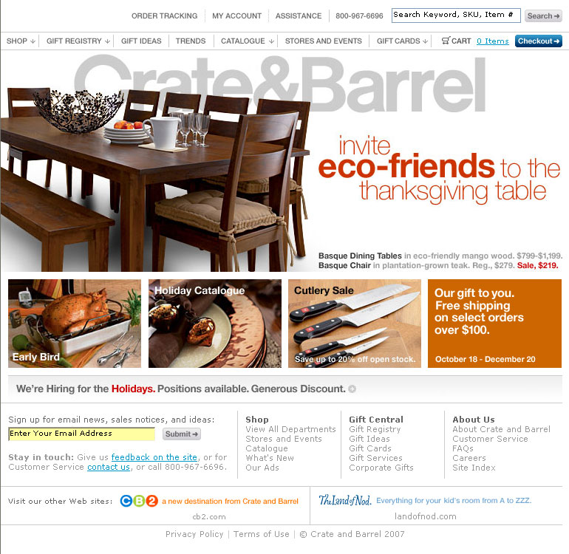 | ---------->>>> | 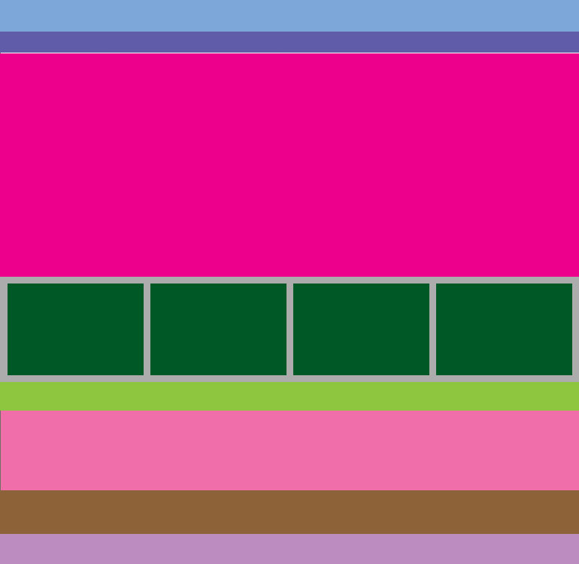

You will then build the blocked version of the site for your assignment in CSS – trying to recreate the large template layout of the site.

Then create a blocked version of your web-based professional portfolio design in Photoshop and identify the size of the blocks.

Requirements:
Your assignment is to create a single page using CSS in the Dreamweaver code window that replicates an existing site as close as possible, using blocked images.

- Technical Requirements: Each page should…
  - Created from a blocked existing site
  - Recreate at least one text area specifying fonts that match your target site as much as possible – the majority of the page can be blocked colored divs.
  - Be created using Dreamweaver and CSS
  - Primarily use relative positioning.
  - Correctly displays in Firefox and either IE 6 or IE 7.

Submission:
This assignment is due in Portfolio by the start of class on November 21. Each student will submit three items: 1) a URL to the recreated blocked version you made 2) a URL to the original site you used to screen cap 3) a Photoshop blocked version of your site with pixel dimensions of each area.

